Week 1 | Week 2 | Week 3 | Week 4 | Week 5 | Week 6 | Week 7 | Week 8:
Theme: Michael Morpurgo | Theme: Roald Dahl – 13th September is Dahl Day! | Theme: Deaf Awareness – 19th-25th September is International Week of Deaf People. | Theme: Around the World: The Himalayas | Theme: Poetry – 5th October is National Poetry Day. | Theme: Black History Month – Female Figures. | Theme: Black History Month – Space Scientists | Theme: Black History Month - Windrush
Extracts:  - My Father is a Polar Bear by Michael Morpurgo.  - Snug by Michael Morpurgo.  - Little Manfred by Michael Morpurgo. | Extracts:  - George’s Marvellous Medicine.  - James and the Giant Peach.  - The Gloriumptious World of Roald Dahl (NF). | Extracts:  - El Deafo (TV Show Trailer on YouTube).  - El Deafo.  - Tomorrow (song featured in El Deafo). | Extracts:  - The Abominables by Eva Ibbotson.  - Everest: The Remarkable Story by Alexandra Stewart (NF).  - Popcorn-eating Squirrels go Nuts on Everest by Matt Dickinson. | Extracts:  - Chocolate Cake by Michael Rosen.  - Walking With My Iguana by Brian Moses.  - The Porcupine by Roald Dahl. | Extracts:  - Fantastically Great Women who Worked Wonders (NF).  - Fantastically Great Women who Made History (NF).  - Little Leaders: Bold Women in Black History (NF). | Extracts:  - Mae Among the Stars (NF).  - Work it Girl: Mae Jemison (NF).  - Inspiring Scientists: Maddie Aderin-Pocock (YouTube video). | Extracts:  - Coming to England (full PB).  - Coming to England.  - What is the Windrush Generation Newsround article (NF).
Search: LKS2 Favourite Authors: Michael Morpurgo | Search: LKS2 Roald Dahl Week 1 | Search: LKS2 Deaf Awareness 1 | Search: Around the World: The Himalayas | Search: LKS2 Poetry Week: Male Poets | Search: LKS2 Black History Month: Female Figures | Search: LKS2 Black History Month: Mae Jemison | Search: LKS2 Black History Month: Floella Benjamin
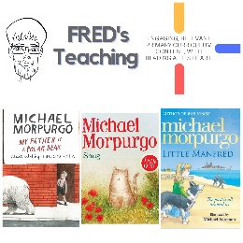 | 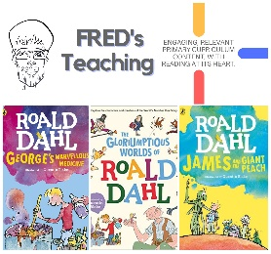 | 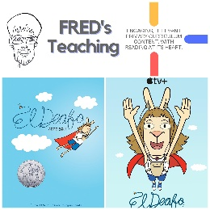 | 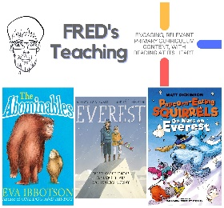 | 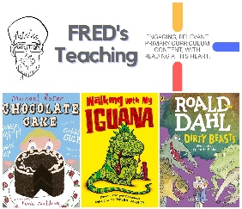 | 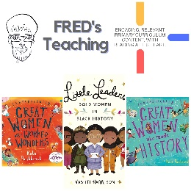 | 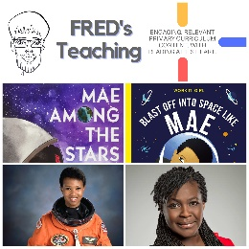 | 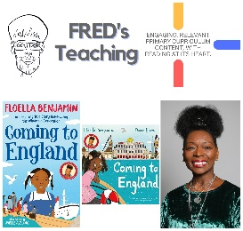

Autumn 2
Week 1 | Week 2 | Week 3 | Week 4 | Week 5 | Week 6 | Week 7 | Week 8
Theme: Halloween. | Theme: Bonfire Night. | Theme: Remembrance. | Theme: Awesome Men – 19th November is International Men’s Day. | Theme: Best Books of 2023 | Theme: Time Travel – 8th December is Pretend to be a Time Traveller Day. | Theme: Christmas. | Theme: Christmas
Extracts and TV Clip:  - The Dark (PB).  - Scary Stories for Seven-Year-Olds.  - Scary Poems to Make You Shiver (Poem). | Extracts:  - The Fire Bay Adventure.  - BBC Bitesize: Guy Fawkes (NF).  - The Bonfire at Night (Poem). | Extracts:  - You Wouldn’t Want to be in the Trenches in WW1 (NF).  - Tail-end Charlie.  - The Story of WW1 (NF). | Extracts:  - Six Dots: A Story of Young Louis Braille (NF).  - Kids Britannica: Johannes Gutenberg (NF).  - William Shakespeare: Scenes from the Life (NF). | Extracts:  - We’ve Got This (NF).  - Honey’s Hive.  - Stink: Worst Fairy Ever. | Extracts:  - Forged in Steel.  - Aldrin Adams and the Cheese Nightmares.  - Time Travelling with a Hamster. | Extracts:  - Another Night Before Christmas.  - The Christmasaurus.  - Elf (movie trailer). | Extracts:  - The Tale of the Animals Christmas in Crouch End.  - A Boy Called Christmas (movie trailer).
Search: LKS2 – Halloween Week Planning  DIRECT LINK | Search: LKS2 – Bonfire Night WCR  DIRECT LINK | Search: LKS2 – Remembrance WCR: The Story of World War One  DIRECT LINK | Search: LKS2 – Awesome Men: Braille  DIRECT LINK | Search: LKS2 – More Best Books of 2023  DIRECT LINK | Search: LKS2 – Time-Travel Themed WCR  DIRECT LINK | Search: LKS2 – Christmas WCR: The Christmasaurus and Elf  DIRECT LINK | Search: LKS2 – The Tale of the Animals’ Christmas in Crouch End  DIRECT LINK
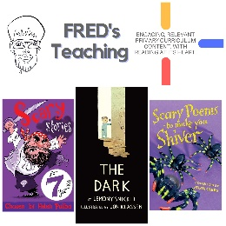 | 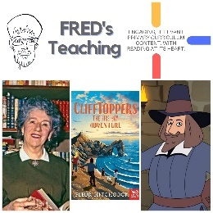 | 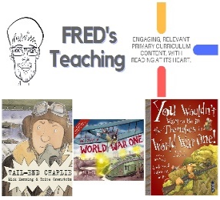 | 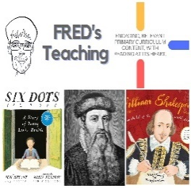 | 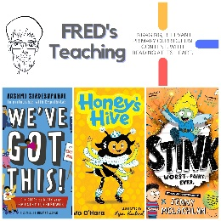 | 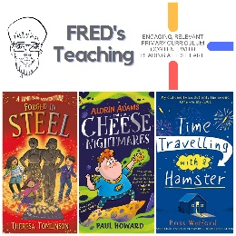 | 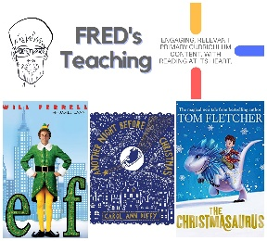 | 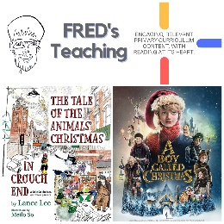

Spring One
Week 1 | Week 2 | Week 3 | Week 4 | Week 5
Theme: New Year Traditions | Theme: Chinese New Year | Theme: Awesome Series – The Accidentals | Theme: National Story-telling Week is 30th Jan – 6th Feb | Theme: Children’s Mental Health Week is 5th – 11th Feb
Extracts:  - Freedom Soup (Full PB).  - Every Month is a New Year (non-fiction).  - Newsround Article: Five New Year Traditions (non-fiction). | Extracts:  - cBeebies Chinese New Year Zodiac Story (YouTube video).  - The Great Race (PB).  - National Geographic Kids China (non-fiction). | Extracts:  - The Accidental Prime Minister.  - The Accidental Secret Agent.  - The Accidental Billionaire. | Extracts:  - Count.  - Star Cat (Graphic Novel).  - Freddy and the New Kid. | Extracts:  - Ruby’s Worry (full PB).  - Black Dog.  - Inside Out (Movie trailer #2).
Search: LKS2 New Year Planning  DIRECT LINK | Search: LKS2 Chinese New Year v1  DIRECT LINK | Search: LKS2 The Accidentals  DIRECT LINK | Search: LKS2 Best Books of 2021 v1  DIRECT LINK | Search: Ruby’s Worry  DIRECT LINK
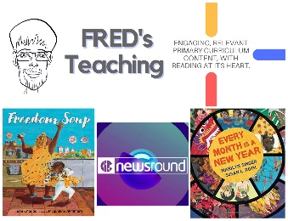 | 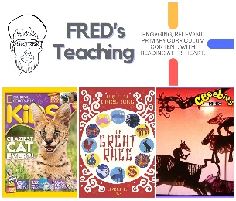 | 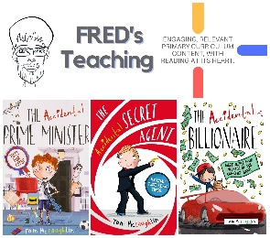 | 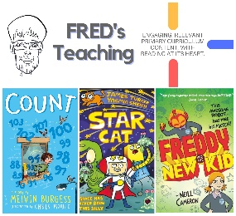 | 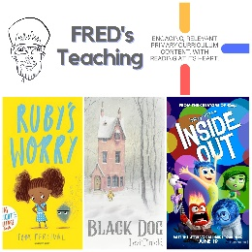

Spring Two
Week 1 | Week 2 | Week 3 | Week 4 | Week 5 | Week 6:
Theme: Book Series Beginnings | Theme: Best Books of 2022 (2nd March is World Book Day) | Theme: Awesome Women: Greta Thunberg (8th March is International Women’s Day) | Theme: British Science Week | Theme: Disability Positivity (21st March is World Down Syndrome Day) | Theme: The Human Body
Extracts:  - Isadora Moon.  - Wigglesbottom Primary.  - The Shark-Headed Bear-Thing. | Extracts:  - Leonora Bolt: Secret Inventor.  - Leonora Bolt: Deep Sea Calamity.  - Armadillo and Hare and The Flamingo Affair. | Extracts:  - Greta and the Giants (Picture Book).  - Greta’s Story (non-fiction).  - Who is Greta? (Newsround video). | Extracts:  - The World’s Most Amazing Places (non-fiction).  - Beyond Belief (non-fiction). | Extracts:  - The Boy in The Jam Jar.  - My Other Life.  - See What I Can Do. | Extracts:  - You Smell (non-fiction).  - 50 Things You Should Know About the Human Body (non-fiction).  - Health Heroes (non-fiction).
Website Link | Website Link | Website Link | Website Link | Website Link | Website Link
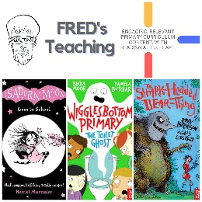 | 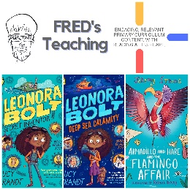 | 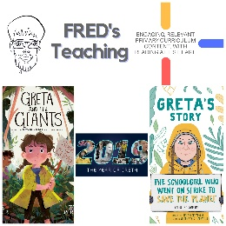 | 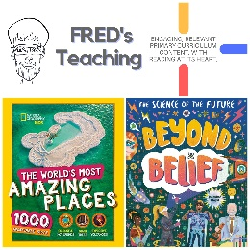 | 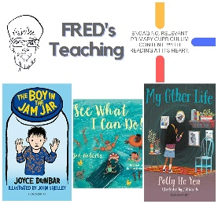 | 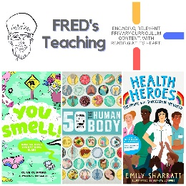

Summer One
Week 1: | Week 2 | Week 3 | Week 4 | Week 5 | Week 6 | Week 7
Theme: Books about Cats (April is National Pet Month). | Theme: Super Series – Nothing to See Here Hotel. | Theme: Books into Movies. | Theme: British History – The Stone Age (May is Local and Community History Month). | Theme: Wild Animal Week – British Animals (5th - 11th May is Be Kind to Animals Week). | Theme: Favourite Authors. | Theme: More Best Books of 2023.
Extracts:  - Magicat.  - I Am Cat (non-fiction spread).  - Captain Cat and the Treasure Map. | Extracts:  - The Nothing to See Here Hotel.  - You Ain’t Seen Nothing Yeti.  - Sea-ing is Believing. | Extracts:  - How to Train Your Dragon (movie trailer).  - The Trouble with Dragons (full PB).  - How to Train Your Dragon. | Extracts:  - Stig of the Dump.  - Stone Age Farmers by the Sea (non-fiction).  - Stone Age Science (non-fiction). | Extracts:  - How to Help a Hedgehog and Protect a Polar Bear (non-fiction).  - Attenborough Backs World’s Biggest Butterfly Count (BBC Article).  - The Animals of Farthing Wood. | Extracts:  - The Story of Matthew Buzzington.  - You’re a Bad Man, Mr Gum!  - Sterling and the Canary. | Extracts:  - The Magic of the Ballet.  - Barb the Brave: The Ghost Blade (graphic novel).  - The Bolds Go Green
Search: LKS2 Books About Cats  DIRECT LINK | Search: LKS2 The Nothing to See Here Hotel Series Planning  DIRECT LINK | Search: LKS2 How to Train Your Dragons Planning  DIRECT LINK | Search: LKS2 British History: The Stone Age  DIRECT LINK | Search: LKS2 Wild Animal Week: British Animals  DIRECT LINK | Search: LKS2 Favourite Authors: Andy Stanton  DIRECT LINK | Search: LKS2 Some More Best Books of 2023  DIRECT LINK
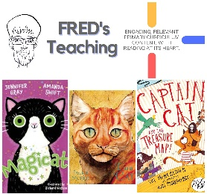 | 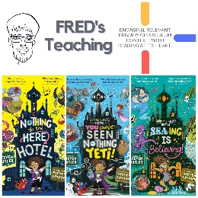 | 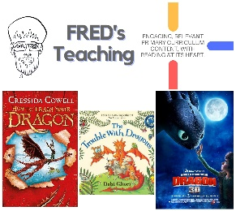 | 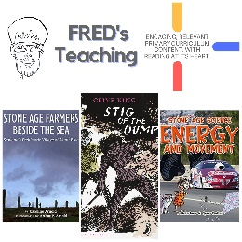 | 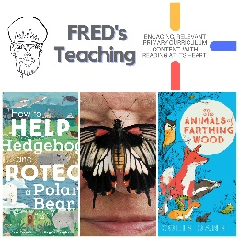 | 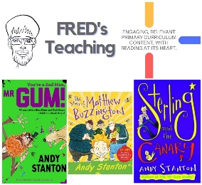 | 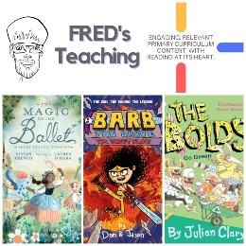

Summer 2
Week 1 | Week 2 | Week 3 | Week 4 | Week 5 | Week 6 | Week 7
Theme: Environment (5th June is World Environment Day). | Theme: Seaside & Islands (8th June is World Ocean Day). | Theme: Refugees (17th – 23rd June is Refugee Week). | Theme: British Destinations - Scotland. | Theme: Global Destinations – The North. | Theme: Space Exploration (20th July is the Moon-landing anniversary). | Theme: The Paris Olympics (Opening Ceremony is 26th July)
Extracts:  - The Promise (PB).  - Cookie and the Most Annoying Girl in the World.  Song of the Dolphin Boy. | Extracts:  - Shaun the Sheep: Flock to the Seaside.  - Clem and Crab (PB).  - Newsround article: Beach Litter. | Extracts:  - The Boy at the Back of the Class.  - Newsround article: Famous Refugees.  - Newsround article: Child Refugees. | Extracts:  - Visit Scotland promotional video.  - The Ballad of Nessie (YouTube).  - The Weather Weaver. | Extracts:  - Madame Doubtfire.  - I Never Liked Wednesdays.  - Up ‘ere by Tony Walsh (poem) | Extracts:  - Newsround article: Yuri Gagarin.  - Kids Britannica article: Valentina Tereshkova.  - The Extraordinary Life of Neil Armstrong. | Extracts:  - O is For Olympics (NF).  - Dinosaur Olympics.  - Newsround article: Where Did the Olympic Games Begin?
Search: LKS2 The Promise  DIRECT LINK | Search: LKS2 Beside the Seaside  DIRECT LINK | Search: LKS2 Refugees Week: The Boy at the Back of the Class  DIRECT LINK | Search: LKS2 British Destinations: Scotland  DIRECT LINK | Search: LKS2 The North  DIRECT LINK | Search: LKS2 The Space Race  DIRECT LINK | Search: LKS2 Olympics Planning  DIRECT LINK
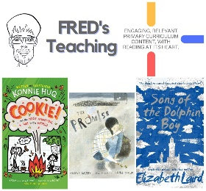 | 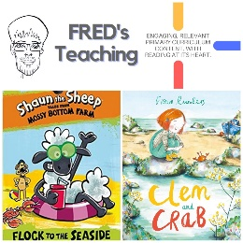 | 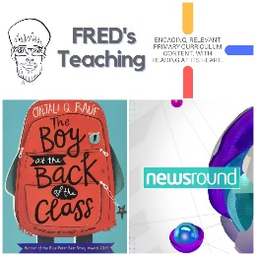 | 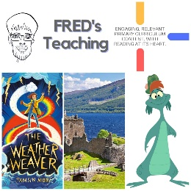 | 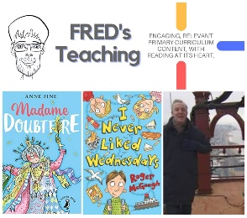 | 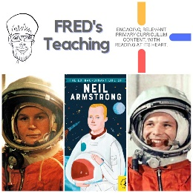 | 

