Week 1: | Week 2: | Week 3: | Week 4: | Week 5: | Week 6: | Week 7: | Week 8:
Theme: Michael Morpurgo | Theme: Roald Dahl – 13th September is Dahl Day! | Theme: Deaf Awareness – 19th-25th September is International Week of Deaf People. | Theme: Around the World: Egypt | Theme: Poetry – 5th October is National Poetry Day. | Theme: Black History Month – Katherine Johnson. | Theme: Black History Month – Black Britons and Windrush. | Theme: Black History Month – Young, Gifted and Black.
Extracts:  - Listen to the Moon by Michael Morpurgo.  - Half a Man by Michael Morpurgo.  - I Believe in Unicorns by Michael Morpurgo. | Extracts:  - The Witches.  - Charlie and the Chocolate Factory.  - The Gloriumptious Worlds of Roald Dahl (NF). | Extracts:  - Wonder Struck.  - Max and the Millions.  - Newsround article ‘Deaf Awareness Week’ (NF). | Extracts:  - Immortal Egypt (TV Clip).  - Egyptology by Dugald Steer (NF).  - Secrets of a Sun King by Emma Carroll. | Extracts:  - What You Need to be Warm by Neil Gaiman.  - The British by Benjamin Zephaniah.  - Adventures of Isabel by Ogden Nash. | Extracts:  - The Extraordinary Life of Katherine Johnson (NF).  - Hidden Figures (Young Readers Edition).  - NASA Biography of Katherine Johnson (NF). | Extracts:  - Black and British (NF).  - Windrush Generation BBC News article (NF).  - Windrush Child. | Extracts:  - 3 extracts from the book Young, Gifted and Black (NF).  - Duvernay and Coleman.  - Adichie and Freeman.  - Carver and Blackman.
Search: UKS2 Favourite Authors Michael Morpurgo | Search: UKS2 Roald Dahl Week 1 | Search: UKS2 Deaf Awareness 1 | Search: Around the World: Egypt | Search: UKS2 Poetry Week: Male Poets | Search: UKS2 Black History Month: Katherine Johnson | Search: UKS2 Black History Month: Black Britons and Windrush | Search: UKS2 Black History Month: Young, Gifted and Black
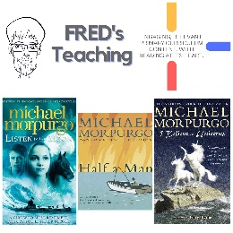 | 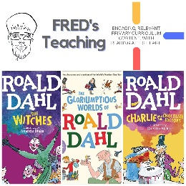 | 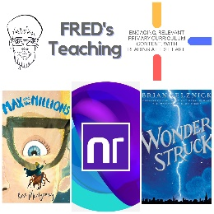 | 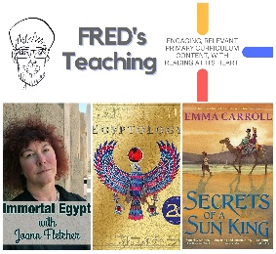 | 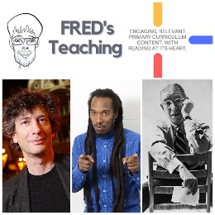 | 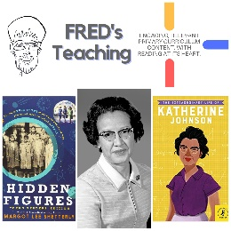 | 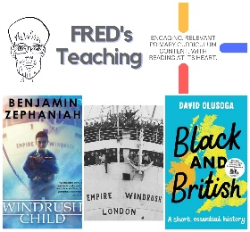 | 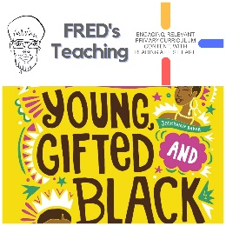

Autumn 2
Week 1: | Week 2: | Week 3: | Week 4: | Week 5: | Week 6: | Week 7:
Theme: Halloween. | Theme: Bonfire Night. | Theme: Remembrance. | Theme: Awesome Men – 19th November is International Men’s Day. | Theme: Favourite Authors – Piers Torday. | Theme: Time Travel – 8th December is Pretend to be a Time Traveller Day. | Theme: Christmas.
Extracts:  - A Dark, Dark Tale (PB).  - Room 13.  - Whitby Travel Guide (NF). | Extracts:  - Wildwitch: Wildfire.  - Newsround Article: Bonfire Night Fireworks (NF).  - It’s Bonfire Night (poem). | Extracts:  - 50 Things You Should Know About WW2 (NF).  - Wait for Me (poem).  - Newsround Article: Heroic WW2 Dog. | Extracts:  - Little People, Big Dreams: David Attenborough (PB).  - A Life on Our Planet (NF).  Newsround Article: Young People (NF). | Extracts:  - There May Be a Castle.  - The Dark Wild.  - The Frozen Sea. | Extracts:  - A Chase in Time.  - My Cousin is a Time Traveller.  - A Wrinkle in Time. | Extracts:  - A Boy Called Christmas.  - Mistletoe and Murder.  - Home Alone (film trailer).
Website Link | Website Link | Website Link | Website Link | Website Link | Website Link | Website Link
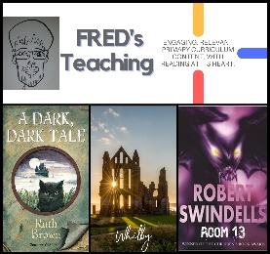 | 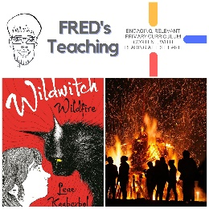 | 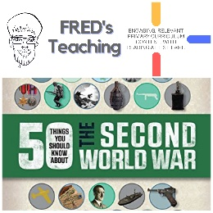 | 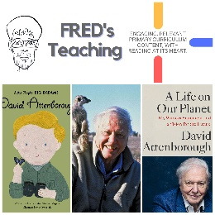 | 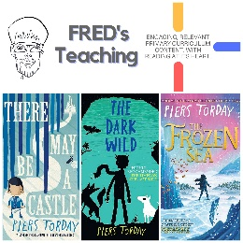 | 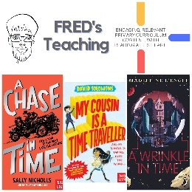 | 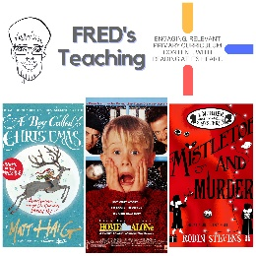

Spring One
Week 1 | Week 2 | Week 3 | Week 4 | Week 5 | Week 6:
Theme: New Year Traditions. | Theme: Destination – Ethiopia. | Theme: Best Books of 2021 v1. | Theme: Chinese New Year v1. | Theme: Awesome Series – Songs of Magic. | Theme: Modern vs Classic Adventure Story 1.
Extracts:  - Every Month is a New Year (non-fiction).  - Scholastic: New Year Traditions Around the World (non-fiction).  - Ring Out, Wild Bells (poem). | Extracts:  - The Garbage King.  - The Fastest Boy in the World.  - BBC Ethiopia Country Profile (non-fiction). | Extracts:  - The World Book (non-fiction).  - When Fishes Flew.  - The Hideaway. | Extracts:  - All About China (non-fiction).  - China Through Time (non-fiction).  - Legend of Nian: Lunar New Year for Kids (YouTube video). | Extracts:  - A Darkness of Dragons.  - A Vanishing of Griffins.  - A Thunder of Monsters. | Extracts:  - The Railway Children.  - Time Travelling with a Hamster.  - The Crackledawn Dragon.
Website Link | Website Link | Website Link | Website Link | Website Link | Website Link
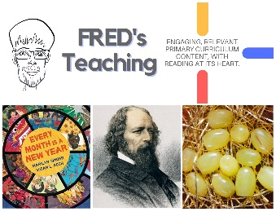 | 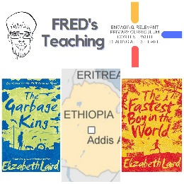 | 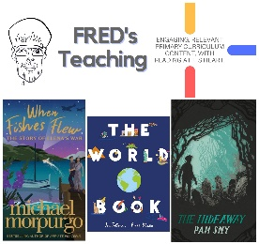 | 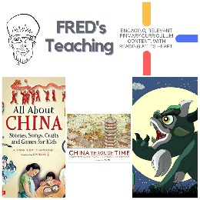 | 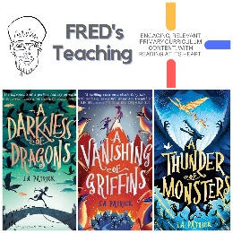 | 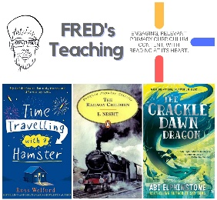

Spring Two
Week 1 | Week 2 | Week 3 | Week 4 | Week 5 | Week 6
Theme: Book Series Beginnings | Theme: Best Books of 2022 (2nd March is World Book Day) | Theme: Awesome Women: JK Rowling (8th March is International Women’s Day) | Theme: British Science Week | Theme: Disability Positivity (21st March is World Down Syndrome Day) | Theme: The Human Body
Extracts:  - Kid Normal.  - Flood and Fang.  - The Train to Impossible Places. | Extracts:  - Mia and the Lightcasters.  - Hedgewitch.  - The Cats We Meet Along The Way. | Extracts:  - Who is J.K. Rowling (biography).  - Work It Girl: J.K. Rowling.  - BBC News Article: Rare Harry Potter Book | Extracts:  - The Story of Planet Earth (non-fiction).  - This Book is Full of Brains (non-fiction).  - Extinct: Trilobite (non-fiction). | Extracts:  - Break the Mould (non-fiction).  - Scarlet Ibis.  - The Boy Who Made Everyone Laugh. | Extracts:  - Kay’s Anatomy (non-fiction).  - 50 Things You Should Know About the Human Body (non-fiction).  - Humanatomy (non-fiction).
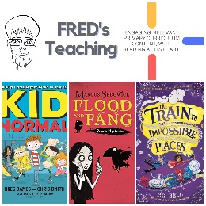 | 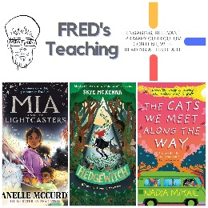 | 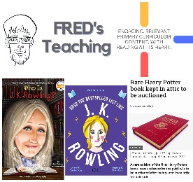 | 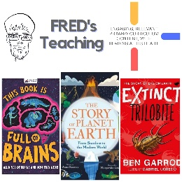 | 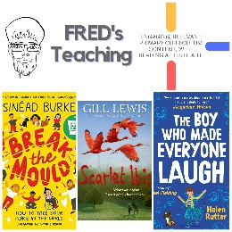 | 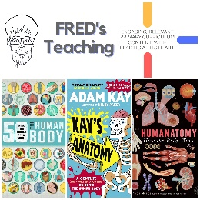

Summer One
Week 1 | Week 2 | Week 3 | Week 4 | Week 5 | Week 6:
Theme: Books about Cats (April is National Pet Month) | Theme: Books into Movies | Theme: British History - Tudors (May is Local and Community History Month) | Theme: Wild Animal Week - Giraffe (7th - 13th May is Be Kind to Animals Week) | Theme: Managing Emotions - The Invisible (15th - 21st May is Mental Health Awareness Week) | Theme: Super Series - Percy Jackson
Extracts:  - Kasper Prince of Cats.  - Malkin Moonlight.  - The Cat Who Came In Off the Roof. | Extracts:  - Lord of the Rings Filming Locations (non-fiction).  - Lord of the Rings Movie Trailer.  - Lord of the Rings. | Extracts:  - Horrible Histories: The Tudors (song).  - Treason.  - Lady Mary. | Extracts:  - The Night Zookeeper: The Giraffes of Whispering Wood.  - BBC Africa: Giraffe Fight (TV clip).  - The White Giraffe. | Extracts:  - The Invisible (full PB).  - Roar Like a Lion (non-fiction).  - The Girl With Space in Her Heart. | Extracts:  - Percy Jackson and the Lightning Thief.  - Percy Jackson and the Titan’s Curse.  - Percy Jackson and the Battle of the Labyrinth.
Website Link | Website Link | Website Link | Website Link | Website Link | Website Link
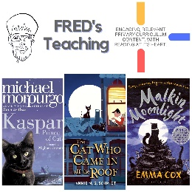 | 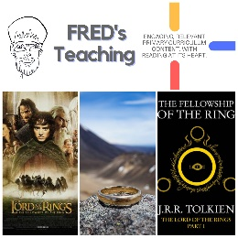 | 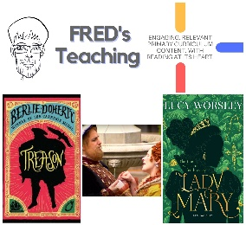 | 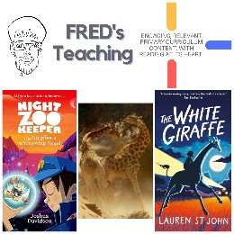 | 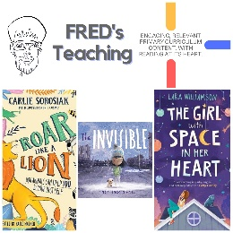 | 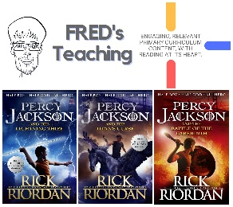

Summer Two
Week 1 | Week 2 | Week 3 | Week 4 | Week 5 | Week 6
Theme: Seaside & Islands (8th June is World Ocean Day). | Theme: Refugees (17th – 23rd June is Refugee Week). | Theme: British Destinations - Cornwall. | Theme: Global Destinations - Malawi | Theme: Space Exploration (20th July is the Moon-landing anniversary). | Theme: The Paris Olympics (Opening ceremony is 26th July).
Extracts:  - Town is by the Sea (PB).  - The Weather Weaver.  - The Good Hawk. | Extracts:  - Illegal (Graphic Novel).  - Refugees (poem).  - The Unforgotten Coat. | Extracts:  - Cornwall with Simon Reeve Trailer.  - Wreckers.  - Cornish Cliffs (poem). | Extracts:  - The Boy who Harnessed the Wind.  - The Boy who Harnessed the Wind Film Trailer.  - BBC Malawi Country Profile. | Extracts:  - Hidden Figures (Young Reader’s Edition).  - NASA Biography - Katherine Johnson (NF).  - Future Mars Walker - Alyssa Carson (YouTube clip) | Extracts:  - The Wibbly Wobbly Jelly Belly Flop.  - Outstanding Olympics (NF).  - BBC Bitesize article: Five Sports You Didn’t Know Were at the Olympics.
Search: UKS2 Beside the Seaside  DIRECT LINK | Search: UKS2 Refugees Week: Illegal  DIRECT LINK | Search: UKS2 British Destinations: Cornwall  DIRECT LINK | Search: UKS2 Destination Malawi  DIRECT LINK | Search: UKS2 Space Exploration: Hidden Figures  DIRECT LINK | Search: UKS2 More Olympics Planning  DIRECT LINK
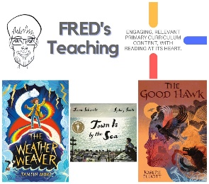 | 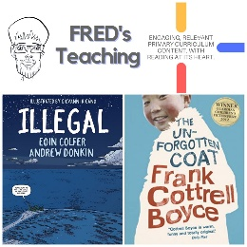 | 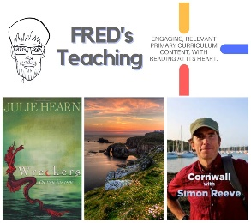 | 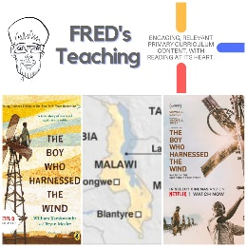 | 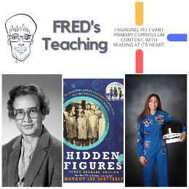 | 

