Week 1: | Week 2 | Week 3: | Week 4: | Week 5: | Week 6: | Week 7: | Week 8:
Theme: Summer Adventures. | Theme: Roald Dahl – 13th September is Dahl Day! | Theme: Best Books of 2023 | Theme: Deaf Awareness – 23rd – 29th September is International Week of Deaf People. | Theme: Poetry – 3rd October is National Poetry Day. | Theme: Black History Month – Rosa Parks and The Bristol Bus Boycotts. | Theme: Black History Month – The ‘Voices’ Series. | Theme: Black History Month – Little Leaders Series.
Extracts:  - 100 Great Walks with Kids.  - You Can Have an Outdoor Adventure.  - Adventures on Earth. | Extracts:  - The Magic Finger.  - The Twits.  - The Gloriumptious World of Roald Dahl (NF). | Extracts:  - The Other Edie Trimmer.  - Loki: A Bad God’s Guide to Being Good.  - Little Badman and the Rise of the Punjabi Zombies. | Extracts:  - Newsround article ‘International Day of Sign Language’ (NF).  - Echo Come Home.  - Harriet Versus the Galaxy. | Extracts:  - High Waving Heather by Emily Bronte.  - Zennor by Anne Ridler.  - Midday and Afternoon by Amy Lowell. | Extracts:  - Little People, Big Dreams: Rosa Parks (NF).  - Rosa Parks BBC Bitesize article (NF).  - The Story of the Bristol Bus Boycotts (YouTube video). | Extracts:  - Now or Never.  - Diver’s Daughter.  - A Victorian Story. | Extracts:  - Little Leaders: Bold Women in Black History (NF).  - Little Leaders: Exceptional Men in Black History (NF).
Search: LKS2 More Summer Adventure Planning  DIRECT LINK | Search: LKS2 Roald Dahl Week 2  DIRECT LINK | Search: LKS2 Best Books of 2023  DIRECT LINK | Search: LKS2 Deaf Awareness 2  DIRECT LINK | Search: LKS2 Poetry Week: Female Poets  DIRECT LINK | Search: LKS2 Black History Month: Rosa Parks  DIRECT LINK | Search: LKS2 Black History Month: The Voices Series  DIRECT LINK | Search: LKS2 Black History Month: Little Leaders Series  DIRECT LINK
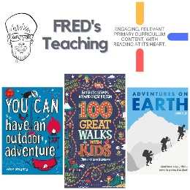 | 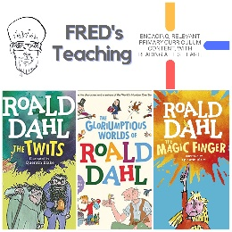 | 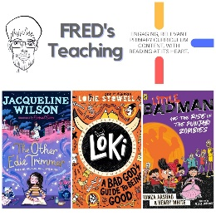 | 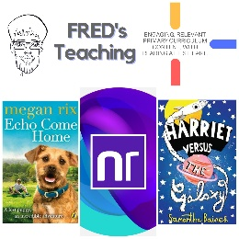 | 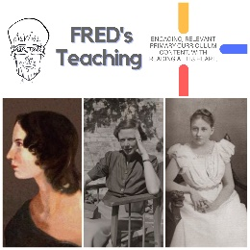 | 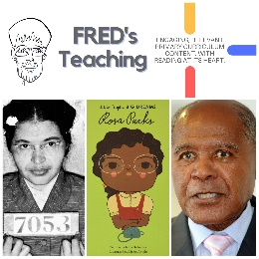 | 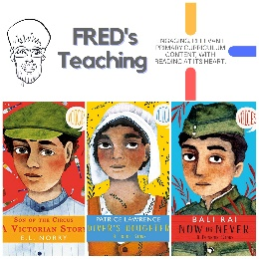 | 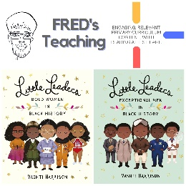

Autumn 2
Week 1: | Week 2: | Week 3: | Week 4: | Week 5: | Week 6: | Week 7:
Theme: Bonfire Night. | Theme: Remembrance. | Theme: Awesome Men – 19th November is International Men’s Day. | Theme: Non-fiction – November is Non-Fiction Month. | Theme: Time Travel – 8th December is Pretend to be a Time Traveller Day. | Theme: Christmas. | Theme: Christmas
Extracts:  - You Wouldn’t Want to be Guy Fawkes (NF).  - The Last Firefox.  - The Fire Thief. | Extracts:  - Daisy and the Unknown Warrior.  - Letters from the Lighthouse.  - Anne Frank’s Diary (Graphic Novel). | Extracts:  - Newsround article: Who Was Einstein (NF).  - Einstein’s Underpants.  - Max Einstein: The Genius Experiment. | Extracts:  - Finding Home.  - The Wild Life of Dinosaurs.  Run Like a Girl. | Extracts:  - The Accidental Time Travel.  - Tom’s Midnight Garden.  - Harry Potter and the Goblet of Fire (film clip). | Extracts:  - How Winston Delivered Christmas.  - The Night I Met Father Christmas.  - Jingle all the Way (movie trailer). | Extracts:  - The Christmasaurus and the Winter Witch.  - The Christmasaurus and the Naughty List.  - Klaus (movie trailer).
Search: LKS2 – More Bonfire Night WCR | Search: LKS2 – Remembrance WCR: Anne Frank’s Diary | Search: LKS2 – Awesome Men: Einstein | Search: LKS2 – More Non-Fiction November | Search: LKS2 – More Time-Travel Themed WCR | Search: LKS2 – Christmas WCR: The Night I Met Father Christmas | Search: LKS2 – Christmas WCR: More Christmasaurus and Klaus
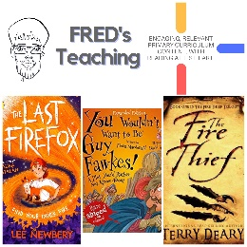 | 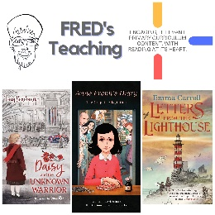 | 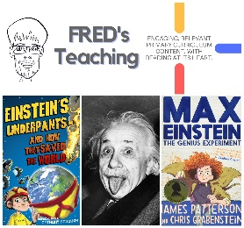 | 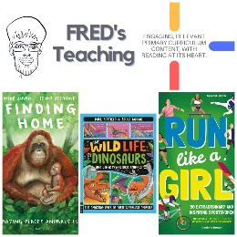 | 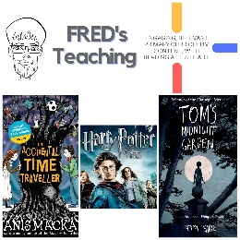 | 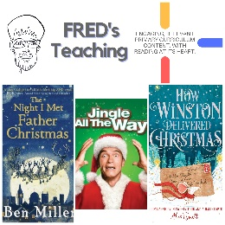 | 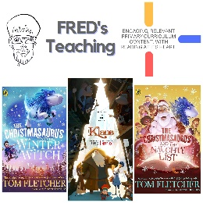

Spring One
Week 1: | Week 2: | Week 3: | Week 4: | Week 5: | Week 6:
Theme: Birds | Theme: Awesome Series – Dick Kerr Girls Football | Theme: Chinese New Year (29th Jan) | Theme: National Story-telling Week (Book Series Beginnings) | Theme: Children’s Mental Health Week is 3rd – 9th Feb | Theme: Self-Esteem (following on from Children’s Mental Health Week)
Extracts:  - Lets Look for Garden Birds (non-fiction).  - RSPB Nature Guide Birds (non-fiction).  - The Extraordinary World of Birds (non-fiction). | Extracts:  - Dick Kerr Girls: Kicking Off.  - Dick Kerr Girls: The Perfect Shot.  - Newsround Article: Lionesses Win Euro 2022 (non-fiction). | Extracts:  - All About China (non-fiction).  - The Firework-Maker’s Daughter.  - Scholastic Lunar New Year for Kids (YouTube video). | Extracts:  - How to Train Your Dragon.  - The Tail of Emily Windsnap.  - My Brother is a Superhero. | Extracts:  - Ravi’s Roar (full PB).  - What to Do When You Worry Too Much (non-fiction).  - Charlie Changes into a Chicken. | Extracts:  - The Racehorse Who Wouldn’t Gallop.  - You Are Awesome (non-fiction).  - The Book of Hopes.
Search: LKS2 Birds Topic | Search: LKS2 Dick Kerr Girls | Search: LKS2 Chinese New Year v2 | Search: LKS2 Book Series Beginnings 2 | Search: Ravi’s Roar | Search: LKS2 Self-Esteem 2
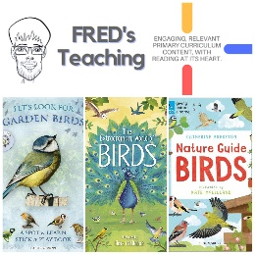 | 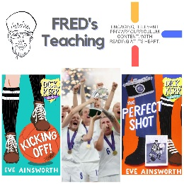 | 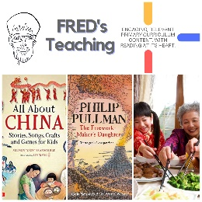 | 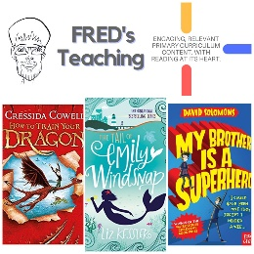 | 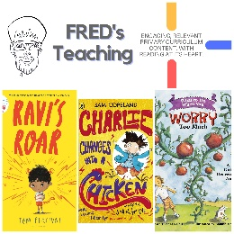 | 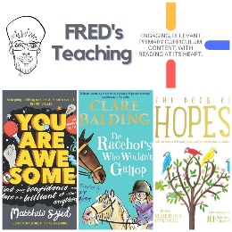

Spring Two
Week 1: | Week 2: | Week 3: | Week 4: | Week 5: | Week 6: | Week 7:
Theme: Even More Best Books of 2023. (6th March is World Book Day) | Theme: New Novelists. (6th March is World Book Day) | Theme: British Science Week (7th – 16th March) | Theme: Awesome Women – Mary Anning (8th March is International Women’s Day) | Theme: Great Graphic Novels | Theme: Autism (2nd April is World Autism Awareness Day) | Theme: More Book Series Beginnings
Extracts:  - Neon’s Secret Universe.  - The Thames and Tide Club.  - Maddy Yip’s Guide to Holidays. | Extracts:  - The Corny Scaredy-Cat Paranormal Investigation Squad.  - A Passing of Shells (poety).  - Ballet Besties. | Extracts:  - One Million Insects (non-fiction).  - Fourteen Wolves.  - Fantastically Great Women Scientists and Their Stories (non-fiction). | Extracts:  - Stone Girl, Bone Girl.  - Lightning Mary.  - Who Was The Fossil Hunter Mary Anning? (BBC Bitesize article). | Extracts:  - The Adventures of Team Pom: Squid Happens.  - Bunnicula.  - Agent 9: Flood-a-geddon. | Extracts:  - Autism, Bullying and Me.  - Me and Mister P.  - The Lost Diary of Sami Star. | Extracts:  - The Grunts in Trouble.  - Diary of a Wimpy Kid.  - The Brilliant World of Tom Gates.
Search: LKS2 – Even More Best Books of 2023 | Search: LKS2 – New Novelists 2 | Search: LKS2 – British Science Week 2 | Search: LKS2 – Awesome Women: Mary Anning | Search: LKS2 – More Great Graphic Novels | Search: LKS2 – Autism Week 2 | Search: LKS2 – Even More Brilliant Book Series Beginnings
Website Link | Website Link | Website Link | Website Link | Website Link | Website Link | Website Link
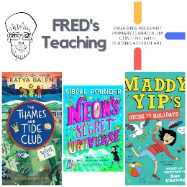 | 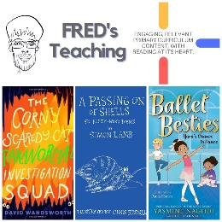 | 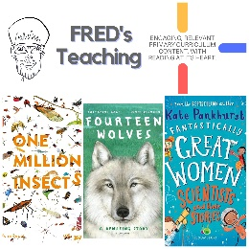 | 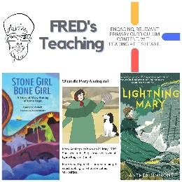 | 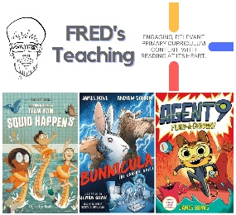 | 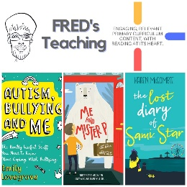 | 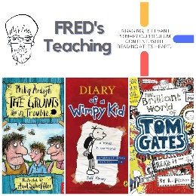

Summer One
Week 1: | Week 2: | Week 3: | Week 4: | Week 5:
Theme: Books about Cats (April is National Pet Month). | Theme: Favourite Authors – S. F. Said. | Theme: Wild Animal Week - Rabbits (4th - 10th May is Be Kind to Animals Week). | Theme: British History – The Romans (May is Local and Community History Month). | Theme: Lost Classics
Extracts:  - Super Cats.  - Super Cats vs Dr Specs.  - Why Cats Rule the Internet (Newsround Article). | Extracts:  - Varjak Paw.  - The Outlaw Varjak Paw.  - Phoenix. | Extracts:  - The Miraculous Journey of Edward Tulane.  - Rabbits (full PB).  - Rabbit in Morning (poem). | Extracts:  - Ted and his Time-Travelling Toilet: Roman Rewind.  - Why Did the Romans Invade Britain (BBC Bitesize video).  - Defenders: Dark Arena. | Extracts:  - The Little Prince.  - Pippi Longstocking.  - The Enchanted Wood.
Search: LKS2 More Books About Cats | Search: LKS2 Favourite Authors: S. F. Said | Search: LKS2 Wild Animal Week: Rabbits | Search: LKS2 British History: The Romans | Search: LKS2 More Lost Classics
DIRECT LINK | DIRECT LINK | DIRECT LINK | DIRECT LINK | DIRECT LINK
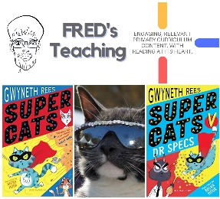 | 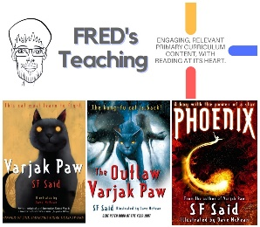 | 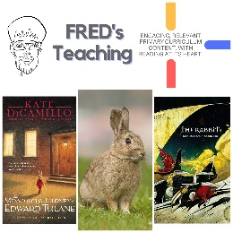 | 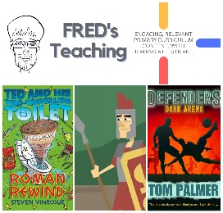 | 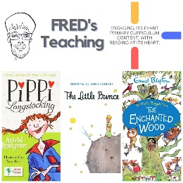

Summer 2
Week 1: | Week 2: | Week 3: | Week 5: | Week 6: | Week 7:
Theme: Environment (5th June is World Environment Day). | Theme: Seaside & Islands (8th June is World Ocean Day). | Theme: Refugees (16th – 22nd June is Refugee Week). | Theme: Global Destinations – Wales. | Theme: Space Exploration (20th July is the Moon-landing anniversary). | Theme: Friendship (30th July is International Friendship Day).
Extracts:  - The Last Wolf (PB).  - The Eye of the North.  - Blue Planet 2 Clip: The Future of the Oceans. | Extracts:  - This Way to Treasure Island (PB).  - Island of the Volcano Monkeys.  - The Storm Keeper’s Island. | Extracts:  - Oranges in No-Man’s Land.  - Welcome to Nowhere.  - A House Without Walls. | Extracts:  - The Wales Way promotional video.  - Framed.  - The Song of the Mischievous Dog (poetry). | Extracts:  - Dick and Dom Interview Helen Sharman.  - Work It Girl: Mae Jemison (NF).  - NASA: First All-Woman Spacewalk. | Extracts:  - Horton Hears a Who.  - Little Manfred.  - The Small Things
Search: LKS2 Environment-Themed WCR: The Last Wolf  DIRECT LINK | Search: LKS2 Island-themed  DIRECT LINK | Search: LKS2 Refugees Week 1: Elizabeth Laird  DIRECT LINK | Search: LKS2 British Destinations: Wales  DIRECT LINK | Search: LKS2 Space Exploration: Female Astronauts  DIRECT LINK | Search: LKS2 Friendship Week 2  DIRECT LINK
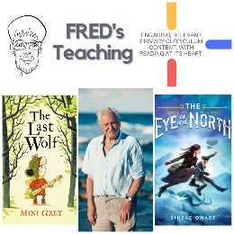 | 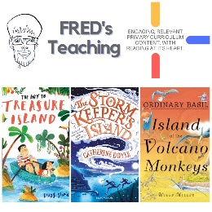 | 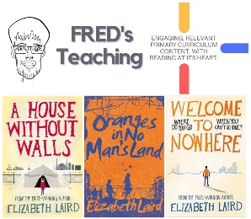 | 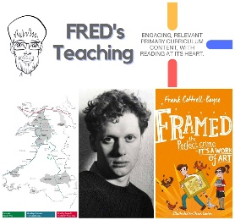 | 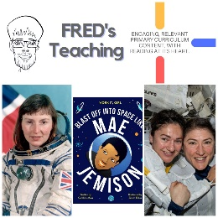 | 

