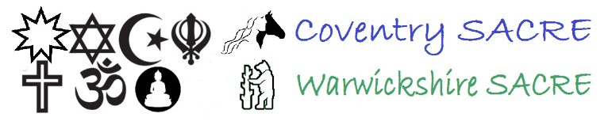
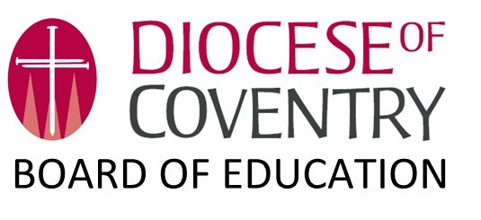

Coventry & Warwickshire Religion and Worldviews Agreed Syllabus for Religious Education

2024-2029

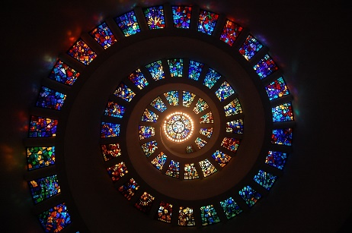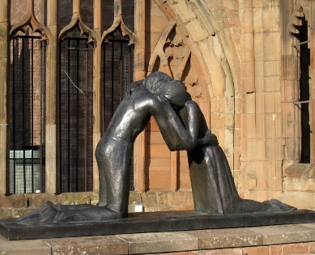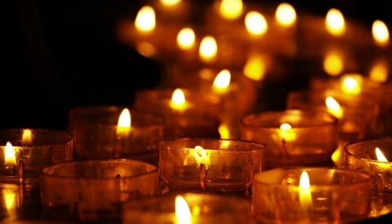
Written by RE Facilitator Jennifer Jenkins in association with teachers from the following schools:
- Blue Coat C of E School, Coventry (Gemma Hathaway and Shannon Clemo)
- George Eliot Academy, Nuneaton (Sophie Smith)
- Southam College, Warwickshire (Alice Thomas)
- Stratford Girls Grammar School, Warwickshire (Karen Steele)
- St Gabriel’s C of E Academy, Rugby (Rosie Coulson)
- Clifton-upon-Dunsmore C of E Primary School, Rugby (Alida Weeks)
- Clapham Terrace Community Primary School, Leamington Spa (Sarah Batchelor)
- Leamington Hastings C of E Academy, Warwickshire (Liz Wooldridge)
- St Andrew’s Benn C of E Primary School, Rugby (Jane Birch)

Special thanks to advisors Céline Benoit (Senior Lecturer and Associate Dean for Public Engagement at Aston University) and Tim Hutchings (Assistant Professor of Religious Ethics at University of Nottingham).
The Farmington Scholarships undertaken by Alice Thomas (assessment) and Sophie Smith (disciplinary lenses) have made a significant contribution to the formation of this syllabus.
Enormous gratitude is due also to our local faith groups and worldviews representatives - all volunteers - for the generosity they showed in sharing their time, skills and expertise to bring authenticity of belief and practice to the new Agreed Syllabus.
This syllabus is the intellectual property of Coventry and Warwickshire local authorities. Some parts have been reproduced from the Religion and Education Councils Worldviews Project and used with permission and due citation (see footnotes). This syllabus largely mirrors the framework the team submitted for the afore mentioned project.
This syllabus is also indebted to the support from Coventry Diocesan Board of Education (DBE) and this is formally recognised here by both Coventry and Warwickshire SACREs.
Permission is granted for schools in Coventry and Warwickshire to photocopy pages of this syllabus for classroom use only. No part of this publication may be used for other purposes without the prior permission of Coventry and Warwickshire local authorities.

Contents page:
Foreword | Page 4
Introduction | Page 6
What is RE for? | Page 8
What do schools need to do? | Page 9
The approach this syllabus takes | Page 16
Worldviews | Page 16
Seven Core Concepts | Page 16
Ways of knowing/disciplinary knowledge | Page 22
Learning as journey | Page 23
Disciplinary tools and methods | Page 27
Pupils as worldview explorers | Page 35
Metacognition | Page 36
What do pupils learn in RE? | Page 37
Planning from the syllabus | Page 39
Unit maps | Page 40
Layover units | Page 41
How do we assess progress? | Page 42
Assessment Grid: EYFS | Page 45
Assessment Grid: KS1 | Page 46
Assessment Grid: Lower KS2 | Page 48
Assessment Grid: Upper KS2 | Page 51
Assessment Grid: KS3 | Page 53
Additional guidance | Page 55
Spiritual, Moral, Social and Cultural (SMSC) Development and RE | Page 55
RE links with the wider curriculum | Page 59
EYFS | Page 62
RE and British Values | Page 62
Connecting with GCSE and A Level | Page 64
Special Educational Needs and RE | Page 65
Resources for this syllabus | Page 69
Enquiry Units in Recommended Teaching Order for Each Phase of Education | Page 70
Enquiry Units According to Core Concepts | Page 72
Reviewing this syllabus | Page 73
Glossary of Acronyms | Page 74

Foreword
Our new Agreed Syllabus for Autumn 2024 onwards is a very special creation.

Firstly - on the basis that ‘home cooking’ is always the best - it has been created from scratch specifically for the Coventry and Warwickshire educational scene and under the regular scrutiny of SACRE members of various faiths and none. Coventry’s work for Reconciliation at many levels, developed from the Cathedral’s reaction to the 1940 German bombings of the city, features significantly.

Secondly, the Syllabus is in the forefront of the national move to teach Religious Education not as a survey of world religions but as a “deep dive” into Religion and Worldviews of many kinds. It shifts the emphasis from simply explaining the beliefs and practices of the major world faiths to exploring through academic disciplines the complex picture of religion and non-religion in the 21st century. This necessarily involves every pupil in considering at regular intervals their own personal Weltanschauung [or worldview]. This shift in emphasis has arisen from the 2018 Final Report of the Commission on Religious Education [Religion and Worldviews: the way forward. A national plan for RE] and the subsequent 2022 Religion and Education Council document, Religion and Worldviews in the Classroom: developing a Worldviews Approach: A Draft Resource for curriculum developers.

Thirdly, the Syllabus has been a ‘labour of love’ from conception to publication by Jennifer Jenkins, our joint RE Facilitator, working for us, in theory, just one day a week, although we are grateful to the Coventry Diocesan Board of Education, her other employer, for generously granting us some of their hours for this work as well. Helping her to develop the syllabus and write unit plans and resources have been ten local primary and secondary teachers; we thank them too for their expertise and sacrifice of time, along with several schools whose expertise has been used for trialing, editing and consulting.

Fourthly, because the writing team has also been working for the Religious Education Council (REC) on a national project, the developing work has been seen and complimented at various stages by, among others, the nationally-recognised, Professor Trevor Cooling of Canterbury Christ Church University and previously Chair of the REC. The advice of two sociologists of religion has also been received throughout development.

The syllabus contains a strong statutory framework, operating spirally to introduce and re-introduce, through the education system’s Key Stages, the seven core concepts relevant to all and any worldviews - for example, Wisdom and Guidance and Personal Responsibility. Whenever a concept encounters one of the three main disciplines of RE - theology, philosophy, and the human and social sciences - an enquiry question may be raised. This technique has given rise to 31 enquiry questions engendering units of work.
The teacher is then free to use the non-statutory elements: sub-questions; worldviews case studies; individual lesson plans; and ‘layover’ units to provide extra material when relevant to the local situation. One aim has been to ensure that pupils encounter ‘people in real life’ who are inhabiting their religion or worldview through a diverse range of lived experience and expression.

We warmly commend this new Coventry and Warwickshire Agreed Syllabus to our schools and academies in the confident hope that it will foster in pupils a deeper understanding of the panorama of religion and worldviews, along with a greater self-understanding, and enhance the general reputation of the subject as interesting and deeply significant for the future of humankind.

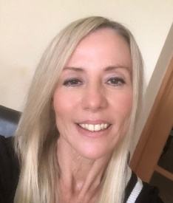
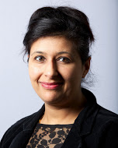
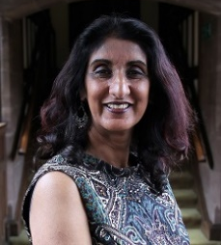

Councillor Dr Kindy Sandhu Councillor Kam Kaur Kirston Nelson
Cabinet Member for Portfolio Holder for Chief Partnership Officer
Education and Skills Education Director of Education and Skills

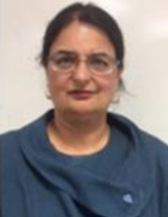
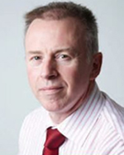
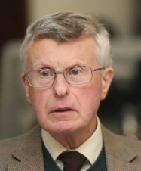

Nigel Minns Manjit Kaur Roderick Clark
Executive Director for People Co-Chair of Coventry Co-Chair of Coventry
and Warwickshire SACREs SACRE



Rocky Grove
Co-Chair of Warwickshire
SACRE

Introduction
This Agreed Syllabus for Religious Education (RE) is for use by schools in Coventry and Warwickshire and provides a vision for the basis of RE in local schools for the next five years, from 2024-2029.
The 1944 Education Act communicates the need for a locally agreed RE syllabus and the 1988 Education Reform Act redefined this through the establishing of a Standing Advisory Council for Religious Education (SACRE) in each local authority. Coventry and Warwickshire each have their own SACREs and convene their own Agreed Syllabus Conference (ASC) every five years for the purpose of creating a syllabus. As has become a historic tradition, Coventry and Warwickshire SACREs have come together to create and agree on a syllabus that promotes good, effective and thought-provoking RE, takes full advantage of the local context and is written in keeping with national developments with regards to the subject. This syllabus has also been supported by the Coventry Diocesan Board of Education. In the spirit of reconciliation, which is at the heart of this syllabus, this collaborative working builds bridges in the name of great education. Pupils are invited, through the syllabus, to explore matters of faith, spirituality, peace, reconciliation, community and morality.
This syllabus was prepared by a team of ten local teachers working with the RE Facilitator for Coventry and Warwickshire and collaboratively with SACRE members.
Some of this syllabus includes content from the Religious Education Council of England and Wales (REC) Worldviews Framework the writing team developed as part of the REC Worldviews Project. Where this is the case, it is indicated at the bottom of the page and gives due credit to the REC and Templeton World Charitable Foundation. The Worldview Project was made possible through the support of a grant from Templeton World Charity Foundation, Inc. The opinions expressed in the publications are those of the author(s) and do not necessarily reflect the views of Templeton World Charity Foundation. This syllabus was designed to meet the statement of entitlement (SOE) contained within the REC Worldviews Handbook and National Content Standard for Religious Education and the language of journey in this syllabus owes some of its creation to the Content, Engagement and Position of the SOE, reimagined as Explore, Route and Perspective.
This syllabus is established on a foundation of seven core concepts and makes use of enquiry questions that drive learning in each unit. Case studies are drawn from worldviews, including those of the six major world religions alongside less common worldviews and non-religious perspectives. The syllabus meets the requirement for content to be ‘in the main Christian’, with content drawn from Christian worldviews making up the majority of worldview case studies suggested to teachers.
Enquiry questions are in the main thematic, posing questions relevant to a range of worldviews. However, careful consideration of a potential need for more systematic study of organised worldviews, such as a deeper exploration of the major religious traditions, especially during the earliest days of the implementation of this syllabus, has led to the inclusion of ‘layover units’ that focus on enquiry questions aimed at exploring the key concepts for Christian, Islamic, Jewish, Hindu, Sikh and Buddhist worldviews.
This syllabus is designed with the pedagogies of a religion and worldviews approach in mind:
- Beginning with the particular (individual and communal worldviews), connections are then made with the general (organised and/or institutional worldviews)
- Making use of the local context and the rich resources of Coventry and Warwickshire in terms of people, places and history.
- Focusing on the diverse lived expression of embodied religion and worldviews

The syllabus requires schools to make a shift from the ‘World Religions Paradigm’. Teachers should adjust their pedagogy to ensure that the approach to teaching RE moves beyond an assumed set of beliefs and practices, to a religion and worldviews approach which recognises and explores the nuances of individual and communal worldviews which may, or may not, have some alignment with organised worldviews such as religious traditions. SACRE acknowledges that some schools may have already been teaching RE in this way prior to this syllabus.
For the purpose of this document, a worldview is understood to be the inhabited way in which a person encounters and interprets the world, understand it and engage with it. Worldviews may change over time. Individuals may be very aware of their worldview, having considered all aspects of it in a conscious and deliberate way, but others may be largely unaware of their own worldview, what shapes and influences it and how and why it has changed over time. Pupils will naturally fall on a spectrum from unconscious to well-considered worldview and this syllabus gives them the opportunity to acknowledge, explore and interrogate their own worldview. They will encounter the individual and communal worldviews of others. This syllabus recognises religions and non-religious traditions (such as Humanism) as examples of organised worldviews.
A worldviews approach acknowledges that some individuals will have a worldview that aligns with an organised worldview like a religion. The overlap or alignment may be significant (where they might identify as being a religious adherent to a particular tradition) or minor (for example, Jewish people who identify as Jewish mainly due to ethnicity rather than religious practice, or ‘nominal’ Christians who participate in certain Christian rituals or hold values mainly due to tradition or culture rather than active belief or practice).
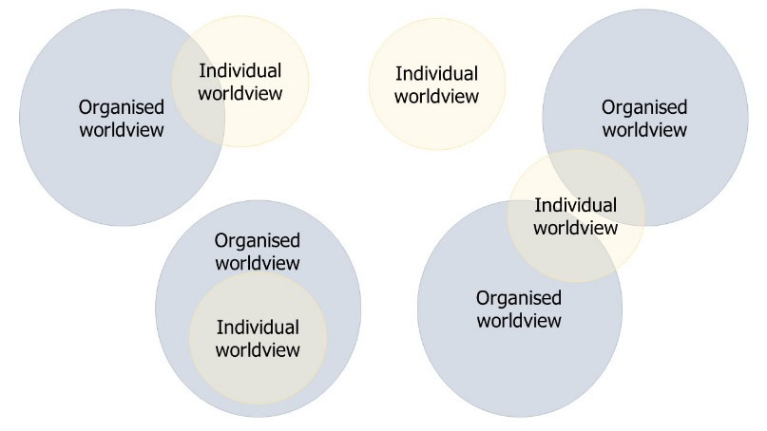
School leaders are required to ensure that staff expertise, time and resources are utilised effectively to ensure this new syllabus, with its corresponding pedagogies, is introduced effectively to staff and is well-implemented.
Changes made to the syllabus have been driven by conversations around the purpose and nature of RE at national level and take account of work undertaken by the REC and other key national RE bodies (such as NATRE- National Association of Teacher of Religious Education and Culham St Gabriel’s Trust) regarding the religion and worldviews approach to teaching RE. This syllabus also seeks to fulfil the requirements for good RE detailed in the 2021 Ofsted RE Research Review.
RE sits alongside the National Curriculum as part of the Statutory Curriculum and every child from Early Years Foundation Stage (EYFS) to Key Stage 5 has a right to have access to good quality RE lessons.
RE does not include collective worship and time allocations for RE should not include time allocated for collective worship and assembly.

What is RE for?
-Purposes of RE
In Coventry and Warwickshire, we are stating that the purpose of RE is to pose and survey answers to deeply relevant questions that individuals and groups, from religious and non-religious worldviews, pursue in their search for meaning, purpose and truth in life.

This process will be achieved through using a multi-disciplinary approach to explore a selection of core concepts that are relevant to most religion and worldviews, at increasing depth.

The desired outcome is that pupils will become aware of their own personal worldview and the positionality that shapes it. Using the skills of reflexivity and reflectivity (see page 34 for a definition of these terms), they will become increasingly able to hold conversations about their own worldview and those of others. They will be wise interpreters of the knowledge they encounter through exploration of diverse, embodied lived expressions of worldviews.

-Aims of the syllabus
The main aims of this syllabus are for pupils:
- To know about and understand a range of worldviews, both religious and non-religious, recognising both similarities and differences as part of study.
- To be familiar with possible answers to deep questions about self, others, the world and the possibility of a deity, drawn from a range of case studies from religion and worldviews.
- To become increasingly confident in the main disciplines of theology, philosophy and human and social sciences, and their associated tools and methods, to allow for rich academic study of religion and worldviews to take place.
- To have the time and space to reflect upon their own personal worldview and the personal knowledge they bring to RE lessons, considering what they might learn from religion and worldviews encountered and how these, in turn, might shape their own worldview.

What do schools need to do?
-Legal requirements
It is a requirement of all schools (with or without a religious character) and their governing bodies/Trust boards to ensure that all pupils gain their statutory entitlement of RE throughout all years of compulsory education, as well as in the sixth form. RE is a necessary part of a ‘broad and balanced’ curriculum.
Special schools should ensure that every pupil receives RE ‘as far as is practicable’.
The requirement to teach RE does not apply to all nursery classes (although many do include RE as part of good practice) but does apply to all pupils of statutory school age. Collective Worship cannot be considered as part of the recommended time for teaching RE.
It is also very important to remember that RE should not seek to convert pupils or place an expectation of beliefs from any particular traditions on them.
A locally agreed syllabus is a statutory syllabus for RE recommended by an Agreed Syllabus Conference for adoption by a local authority. Although this syllabus is a legal requirement for all Local Authority schools, it also meets the needs of Academies and Free Schools in Coventry and Warwickshire. It provides a locally-inspired and educationally rigorous basis for good RE in all schools in this area.
Voluntary aided (VA) schools with a religious character should consult their trust deed when choosing a syllabus for RE. Voluntary controlled (VC) schools with a religious character should follow this locally agreed syllabus.
Parents should receive an annual written report on their child(ren)’s progress in RE.

-Withdrawal from RE
Parents have a right to request their children are withdrawn from RE and to request that alternative arrangements be made, so long as it does not incur any additional cost to the school or the local authority. This is a law that is still in place from a time when RE was of a more confessional, Anglican nature and RE today should be non-confessional and inclusive for all pupils.
Schools can ask their SACRE for assistance or advice when talking to parents about this. The joint guidance issued by the National Association of Head Teachers (NAHT) and the National Association of Teachers of Religious Education (NATRE) is recommended.
Sufficient time and resources should be devoted to RE to enable the school to meet its legal obligations and to deliver a RE curriculum of quality that parents can have confidence in.

-RE in Academies and Free Schools
Free schools are academies in law and have the same requirement to provide RE and collective worship. When we refer to academies we are also including free schools. As indicated in their funding agreements, all academies are required to provide RE for all pupils in statutory-age schooling, from Reception to Sixth Form, except those whose parents exercise their right to withdrawal.
An academy must choose a syllabus to adopt for RE or create its own in line with government guidelines. We offer this syllabus as one they may choose to adopt. There is no requirement for an academy to adopt a locally agreed syllabus, as long as its own RE syllabus meets the requirements for a locally agreed syllabus. Any syllabus adopted must ‘reflect the fact that the religious traditions in Great Britain are, in the main, Christian while taking account of the teaching and practices of the other principal religions represented in Great Britain’.
Local academies are invited to adopt this syllabus and to take advantage of the resources and support that are offered with it.
RE is part of the Basic Curriculum, a compulsory subject and open to inspection. Ofsted inspectors frequently comment on the readiness of pupils for life in modern Britain when evaluating the impact of the RE curriculum.
The Coventry and Warwickshire Agreed Syllabus 2024–2029 fulfils the legal requirements set out above, and has its roots in the REC’s National Content Standard for RE (2023).

-What worldviews are to be taught?
When writing this Agreed Syllabus, care has been taken to ensure the best case studies from religion and worldviews have been suggested as possible answers to broader enquiry questions. These include individual and communal worldviews that have recognisable alignment with what was previously termed ‘the Big Six’, though these are now to be approached from the particular to the general, in keeping with a religion and worldviews approach, instead of the other way round. This agreed syllabus requires that all pupils learn from Christianity in each phase of education, in keeping with the requirement that agreed syllabi be ‘in the main Christian’. Care has been taken to increase the amount of suggested content from the Indic-origin faith traditions, addressing a historic imbalance and better matching the religious landscape of Coventry and Warwickshire. Humanist and other non-religious worldviews are easily traceable within the syllabus and, for the first time, pagan worldviews are also included, alongside other case studies from less well-known worldviews. Schools are at liberty to make some additions to the suggested worldviews case studies within units, including worldviews that are particularly represented in their local community if these are not suggested within a unit.
Learning in Early Years Foundation Stage (EYFS) and Key Stage One (KS1) is deliberately focused on stories and the exploration of familiar examples of embodied religion and worldviews, such as the celebration of festivals or the significance of bodily rituals. These are drawn from a range of religion and worldviews. RE in the EYFS focuses on just three of the seven concepts, allowing early years practitioners to explore these concepts in depth through good early years practice.
In KS1, three more concepts are added, exploring these through worldviews case studies that illustrate familiar themes, such as festivals and celebrations, sources of wisdom and the types of thinking that leads to choices about how people choose to act and live. At the end of the key stage, pupils explore Christianity through the specific lens of the destruction of Coventry Cathedral during WW2, using disciplinary methods and tools to explore this significant local event and story as theologians and historians.
From lower Key Stage Two (KS2) onwards, pupils engage with increasingly sophisticated enquiry questions drawing upon a range of disciplines and a diverse range of case studies drawn from religious and non-religious worldviews. They may look at familiar stories and rituals from different angles and will begin to see the similarities in the worldviews people inhabit, as well as the key differences that lead to such diversity and nuance. They will have a deeper sense of worldviews as embodied and expressive of what people do and how they act as much as they are about what people think and believe. The concept of peace and reconciliation is opened up to include perspectives from worldviews other than Christian worldviews.
In upper KS2, pupils are challenged to think deeply as they encounter some of the problematic and challenging aspects of religion and worldviews, beginning to understand how organised worldviews are also dynamic and change over time in the same way that personal and communal worldviews do.
As pupils move into Key Stage Three (KS3), they will have a greater sense of the seven core concepts relevant to all worldviews, religious and non-religious. They begin to consider the concept of religion itself, what it is and how to think critically about religion. The diversity of worldviews will be better appreciated as pupils explore challenging, and sometimes controversial, issues associated with religion and worldviews. They will consider peace and reconciliation on the world stage.

-Timetabling for RE
In order to fulfil their statutory duty of providing RE for all pupils, schools must ensure that sufficient time is allocated on the timetable for RE. This must ensure pupils are enabled to meet the expectations set out in this agreed syllabus around understanding worldviews and to develop the disciplinary knowledge and skills identified as being appropriate for their age range. Schools should ensure that the RE curriculum they provide is coherent and shows progression. This is particularly important across transitions between key stages and careful work between the primary and secondary teachers in the writing group has sought to make that a priority.
There is no single correct way of making appropriate provision for RE as long as the outcomes are met and often a flexible approach, taking account of pupil needs or what works best for certain topics, is part of good practice. RE lessons may be weekly, blocked or a combination of both. In order to deliver the aims and expected standards of the syllabus effectively, the expectation is that there is a at least 5 per cent of curriculum time allocated for RE. This must not include time that is for assemblies or Collective Worship. Similarly, RE must not become lost within ‘topic time’ or fused with other subjects to the point where RE objectives are not clearly identifiable.
The minimum allocated curriculum time for RE is set out in the table below, and based on the most recent Ofsted guidance.

Key Stage | Minimum Allocated Curriculum Time
EYFS (4-5 years) | 36 hours of RE (e.g. weekly 50-60 minute lessons or some short sessions implemented through continuous provision)
KS1 (5-7 years) | 36 hours of tuition per year (e.g. weekly hour-long lessons, or less than an hour a week plus a series of RE days)
KS2 (7-11 years) | 45 hours of tuition per year (e.g. weekly 60-75 minute lessons, or a series of RE days or weeks that cumulatively amount to 45+ hours of RE in the year)
KS3 (11-14 years) | At least 45 hours of tuition per year (e.g. weekly hour-long lessons)
At Key Stage Four (KS4) the advice of the Coventry and Warwickshire SACREs is that students follow a GCSE course for RE as much as is possible. It is advised that at Key Stage Five (KS5) A-level RE is offered to students.
Regardless of what provision is made, these are the recommended minimum allocated curriculum times for KS4 and KS5:
Key Stage | Minimum Allocated Curriculum Time
KS4 (14-16 years) | At least 5% of curriculum time, or 70 hours of tuition spread across the key stage (e.g. an hour a week for 5 terms, or weekly 50 minute lessons, supplemented with off-timetable RE days)
KS5  (16-18 years) | Allocation of time for RE for all should be clearly identifiable on the sixth form timetable. This might be weekly lessons or in the form of a series of conferences allowing students the opportunity to look in depth at controversial topics related to RE.

- Statutory and non-statutory elements of the syllabus
Statutory elements of the syllabus | Non-statutory elements of the syllabus
- Spiral coverage of the seven core concepts  - The main enquiry questions (which also serve as unit titles)  - The lead disciplines (theology, philosophy, human & social sciences and history) indicated in each unit  - The assessment model outlined in this syllabus | - The sub-questions that provide a suggested outline for the enquiry established by the main enquiry question  - The suggested worldviews case studies within the unit- these are what SACRE have determined to be the most relevant for the question(s) posed but local context may suggest another worldview case study is relevant for that particular school

Our Local Context
Local schools, both those in Coventry and surrounding areas in Warwickshire, work within the local context of the legacy of Coventry Cathedral, its experience during the Blitz of World War Two and its ongoing message of peace and reconciliation on a local, national and global scale. Many local schools ensure their pupils visit the cathedral at some stage in their primary and/or secondary education and often they visit several times, approaching the building and its theologically-significant art and architecture from varying angles. This allows pupils to engage in learning and activities which develop their own understanding of peace and reconciliation and the role they might choose to play in perpetuating these in today’s world as part of their own inhabited personal worldview, be it religious or non-religious. The cathedral’s Community of the Cross of Nails embraces three themes:

- Healing the wounds of history
- Living with difference and celebrating diversity
- Building a culture of justice and peace

These are particularly relevant themes when learning about religion and worldviews and the development of critical religious literacy in pupils. These themes allow for honest engagement with religious traditions, engaging with all that is helpful and inspiring whilst also including the troubling, and sometimes challenging, aspects of religious and non-religious worldviews of the past, alongside the difficult aspects of worldviews and conflict in today’s world. It is expected that pupils will learn how to ‘disagree well’ as they encounter worldviews different to their own, developing the skills they need as scholars to overcome ‘worldview shock’ and to use the disciplinary methods and tools available to them to really understand the worldviews they encounter. In doing so, it is hoped that conflict and disagreement can be transformative and not simply destructive in nature and our local RE classrooms will become brave yet safe spaces for academic conversations about religion and worldviews. Pupils will learn how to respect individuals whilst critiquing knowledge drawn from a range of religion and worldviews, leading to a well-developed critical religious literacy for all. Learning in RE will therefore move beyond opinions and into knowledge interpretation and critique, within a framework of respect.
This syllabus embraces a shift in teaching; moving from a focus on simply transferring knowledge of a set of beliefs and practices to pupils (as was often the case in the World Religions Paradigm) towards supporting pupils in enquiry-driven scholarship as they encounter the diverse worldviews and lived experiences of real people whose worldviews align with, or sit outside of, organised worldviews. With these changes, the importance of understanding the sociological elements of religion and worldviews has increased and pupils will need to become familiar with the ways in which embodied religion and worldviews are lived out within specific historical-social-cultural contexts.
Coventry is a very diverse city, with a 65% chance that two random people in the city will have different religions compared with a 58% in the rest of England. Mirroring the national statistics, the 2021 census showed that Christianity (in many expressions locally, including a significant Black church community, Chinese Church and Indian Church alongside Roman Catholic, Anglican, Eastern Orthodox and many other forms of Protestant Christian expressions) was the religious affiliation of 43.9% of the population and non-religious worldviews (including ‘not stated’) made up 29.6% of the population. These were the most common expressions of worldviews in the city. There is also a significant Muslim population (10.4% in 2021, up from 7.5% in 2011) and a Sikh community that is significantly larger than the United Kingdom’s average (a steady 5% between 2011 to 2021 compared with 0.9% of Sikhs nationwide). There is a recognisable Hindu community in Coventry (4% compared with 1.7% nationally) and other religious worldviews represented include Judaism, Baha’i, Zoroastrianism and Paganism.
Previously | Now
Hinduism | Sanatan Dharma
Sikhism | Sikhi
Buddhism | Buddhist Traditions
North Warwickshire is significantly less religiously diverse than Coventry, with ‘Christian’ (55.0%) and ‘No Religion’ (38.1%) being the overwhelming majority of answers to the question on religion in the 2021 census. Warwick and the southern area of Warwickshire is more diverse than the north. The percentage of people identifying as non-religious (40%) and those identifying as having Christian worldviews (44.6%) is more comparable than ever before. The significant Hindu (2.5%) and Sikh (4.2%) communities in Warwick and the surrounding areas are also obvious in the 2021 census data. This is why this syllabus pays more significant attention to Dharmic worldviews than syllabi have done previously and SACRE members and other knowledgeable academics have supported the development of this syllabus to ensure that the way in which these traditions are approached has been de-colonised and more suitable terms and vocabulary utilised. Listening to what representatives have to say regarding the study of their traditions has been another form of reconciliation for all involved. The table below represents the changes made from previous terms to current:

This syllabus allows for schools to include the religion and worldviews that enrich their immediate context, where these differ from the case studies suggested in the units of work accompanying this syllabus.
The rich array of places of worship in Coventry and Warwickshire, and their associated communities, offer the opportunity for studying religion and worldviews through various ways of knowing, utilising a range of disciplinary lenses (e.g. history, human and social sciences and lived experience, theology of art and architecture) in a locally-relevant and inspirational context. They provide excellent case studies for exploring the relationship between faith communities and the communities/members of society they seek to serve and support through their presence.
Utilising places of worship and faith communities in this way allows for pupils to see the importance of studying ‘communal worldviews; those shared by families and local faith groups gathering in places of worship’. They do not just begin to appreciate what an organised worldview might include (for example, Islam) but also individual and communal worldviews, such as that of a local family from the school community or a faith community in a local place of worship (e.g. a local masjid), showing what being Muslim might mean in that local context when it is lived out and ‘embodied’.

The approach this syllabus takes

What are worldviews?
‘Worldviews’
When using the term ‘worldviews’, we acknowledge an ongoing history of debate around what the term might mean and how it has been used in various academic disciplines. Despite the latter part of the word indicating an over-emphasis on the idea of sight and the way we ‘see’ the world, this syllabus works within a broader understanding of ‘worldview’ as not just being about seeing but also about experiencing and living in a very bodily sense. Through engaging with the units of work, pupils will come to a realisation that worldviews, including religions, are not simply about how individuals and groups ‘see’ the world but are also embodied and involve real people making decisions about what to do with their bodies, the places and spaces they want to practise and engage in ritual, and the importance that artefacts and objects might hold within a worldview. We also regard worldviews as holding spiritual significance and that, for many, beliefs in the transcendent and something supernatural and beyond themselves are of utmost importance.

How is our syllabus structured?
The Seven Core Concepts
The syllabus is structured around seven core concepts, repeatedly encountered as part of a spiral curriculum where these concepts are revisited from the different angles provided by a) case studies from a range of religions and worldviews, b) different ‘ways of knowing’ about religion and worldviews through the methods and tools of disciplines of study, c) the additional perspectives that come with age and maturity as pupils move through the education system. These seven concepts are relevant to all worldviews, including individual, communal and organised worldviews. The associated icons draw upon dual-coding theory, providing a ‘hook’ for pupils’ learning as they encounter these concepts again and again through engagement with diverse substantive content.
These are the seven core concepts, the icons and the associated disciplines for units within each concept:
 | Belonging & Believing
Disciplines: Theo HSS
 | Wisdom and Guidance
Disciplines: Theo Phil HSS
 | Personal Responsibility
Disciplines: Phil HSS Theo
 | Living Well
Disciplines: Theo Phil HSS
 | Authority & Power
Disciplines: Theo Phil HSS
 | Changes
 | Disciplines: HSS Hist Theo
 | Grand Narratives
Disciplines: Theo Phil HSS Hist

This is how pupils’ understanding within each concept develops at each phase of education:

 | Core Concept | What Pupils Need to Understand
 | Belonging and Believing  How belonging and believing are complex ideas, are not necessarily synonymous and are expressed in diverse ways  NSE Reference:  - Nature/ formation/ expression  - Organised/ individual  - Meaning and purpose  - Ways of knowing  - Lived experience  - Personal worldviews reflexivity | - How people show they belong together using case studies from religious and non-religious worldviews to explore examples of clothing, communal places and celebrations as expressions of belonging (EYFS)  - How people demonstrate and celebrate their shared worldviews, using worldview case studies to explore similarity and diversity in rites of passage/celebration of life events, ceremonies, celebration of festivals and the ritual and use of artefacts (KS1)  - How some individual worldviews may connect with organised worldviews in diverse ways, using case studies from a range of religious worldviews to explore the diverse ways individuals might feel they do, or do not, belong to communities expressing organised worldviews, as well as a range of religious and non-religious worldviews (LKS2)  - The significance of Jesus through time and for different people, investigating how Jesus is perceived by those with religious worldviews other than Christian and by those with non-religious worldviews, exploring the diversity of expression of Jesus around the world and the challenges of a dominant white western representation (UKS2)  - How those with individual worldviews aligned with organised worldviews (such as religions) embody and express religious and non-religious worldviews differently, drawing upon examples of diversity and denominations and the growth of digital worldview expressions (KS3)
 | Wisdom and Guidance  How beliefs and ideas are both shaped and expressed through text and art  NSE Reference:  - Meaning and purpose  - Values, commitments and morality  - Ways of knowing  - Lived experience  - Dialogue/ interpretation  - Personal worldviews reflexivity | - How and why individuals from sacred stories can still inspire people today, making links with appropriate concepts that give rise to the celebration of festivals in diverse expressions (EYFS)  - The various sources individuals may turn to for guidance in life, including inspiration for those with non-religious worldviews and the pervasive example of the ‘Golden Rule’ as a concept stretching across many worldviews (KS1)  - How worldviews can be both shaped and expressed through art and architecture, using Coventry Cathedral as an example of architecture communicating ideas of the divine and transcendent. Exploring case studies that illustrate the impression buildings can make on people, impacting them as embodied expressions of religious traditions and the communal worldviews of faith communities (LKS2)  - Why ancient stories are still relevant to worldviews today and how these might be interpreted differently, introducing pupils to hermeneutics (the art of skill of interpretation), the concept of revelation and interpretation and the impact of historical-social context on author, reader and community now and in the past (UKS2)  - How ideas and beliefs from sacred texts can impact upon lived expression of belief, exploring philosophy, ethics and spirituality drawn from different worldviews (KS3)
 | Personal Responsibility  How ideas about right and wrong and death and beyond can shape the ways in which people live and respond  NSE Reference:  - Organised/ individual  - Meaning and purpose  - Values, commitments and morality  - Ways of knowing  - Lived experience  - Personal worldviews reflexivity | - How concepts of friendship, kindness and how to treat others are developed within organised worldviews, often through connections with sacred texts and special stories, taking a particular focus on the ‘Golden Rule’ that is so influential in many worldviews as a guiding principle for right and wrong and the starting point of morality for many (EYFS)  - How worldviews impact and shape how people choose to live, especially through concepts of kindness, friendship and respect, using stories from sacred texts to illustrate this, as well as exploring concepts that cross many religious and non-religious worldviews, such as the ‘Golden Rule’ and ideas about right and wrong (KS1)  - How worldviews may lead people to do difficult and challenging things because of their beliefs and values, emphasising the idea of worldviews as ‘embodied’, providing challenge, embracing ritual and using case studies from a range of religious and non-religious worldviews that illustrate how choices around food, clothing, charitable action and moral behaviour might be made (LKS2)  - How ideas about death and beyond are understood and can impact upon the way in which life is lived, exploring theological and philosophical ideas about the self/soul and life after death, funeral practices and concepts that challenge these such as doubt and suffering, explored through case studies drawn from religious and non-religious worldviews (UKS2)  - How religion and worldviews can shape ideas about right and wrong and therefore how people respond in ethical and moral situations, using a range of philosophies and moral frameworks drawn from religious and non-religious worldviews (KS3)
 | Living Well  How ideas and beliefs about what constitutes a good life shape the way in which people choose to ‘live well’  NSE Reference:  - Organised/ individual  - Meaning and purpose  - Values, commitments and morality  - Ways of knowing  - Lived experience  - Personal worldviews reflexivity | - Who Jesus was in terms of his historical and spiritual significance for most Christians and those from other worldviews, exploring the significance of the incarnation for most of those with Christian worldviews and the beliefs held about Jesus as an example of ‘living well’ as moral teacher, prophet and healer by most of those with Christian and other religious and non-religious worldviews (KS1)  - How religion and worldviews can shape and express ideas about conflict, forgiveness, peace and reconciliation, beginning with the global message of reconciliation from Provost Howard in 1940 and exploring these concepts in a range of worldviews, exploring peace and reconciliation expressed in embodied religion and worldviews locally, nationally and globally (LKS2)  - How religion and worldviews may or may not help somebody to decide what living well looks like and to live in accordance with those ideas and beliefs, illustrating the concept of transformation and the outworking of morality as worldviews are inhabited (UKS2)  - The role peace and reconciliation might play within worldviews in terms of living well, how important this might be in non-religious worldviews and drawing from example worldview case studies to explore the impact on identity, morality and violence (KS3)
 | Authority and Power  How people and texts may influence belief and lived expression in diverse ways  NSE Reference:  - Organised/ individual  - Meaning and purpose  - Influence and power  - Ways of knowing  - Dialogue/ interpretation  - Personal worldviews impact | - How different things and people hold power and authority within individual and organised worldviews, using case studies from a range of worldviews with a focus on ideas about a deity/supreme being, important figures, inspiring texts and values that are often shared with those inhabiting non-religious worldviews (KS1)  - How those with theistic worldviews might understand ‘God’/the Divine in different ways, using worldviews as case studies, whilst also acknowledging the unhelpful binary of religious/non-religious worldviews (LKS2)  - How individuals from within organised worldviews might look for ‘truth’ in sacred texts in different ways, using worldviews case studies as diverse and sometimes opposing answers to the question ‘what is truth?’ (UKS2)  - How religion and worldview can be difficult to define and relevant concepts may be expressed differently through religious and non-religious worldviews, using different examples of classifying religion and worldviews from a range of case studies to illustrate this (KS3)
 | Changes  How time and space impact upon religion and worldviews  NSE Reference:  - Nature/ formation/ expression  - Organised/ individual  - Influence and power  - Ways of knowing  - Lived experience  - Dialogue/ interpretation  - Personal worldviews reflexivity | - How what happens in a place and time can shape both individual and organised worldviews, using the example of Coventry Cathedral and its reconciliation story as a local case study with a national and global impact (KS1)  - How nature, the seasons and concepts of time can shape the way in which individuals and communities live and how organised religion and worldviews express belief and meaning (LKS2)  - How shifts in culture and society impact on religion and worldviews at individual and community level (UKS2)  - How personal worldviews can express ideas from organised worldviews differently and the contribution identity can make, taking the impact of diversity on expressed and embodied worldviews (KS3)
 | Grand Narratives  How history and world narratives have both impacted on and been shaped by religion and worldviews in both positive and problematic ways  NSE Reference:  - Nature/ formation/ expression  - Organised/ individual  - Influence and power  - Ways of knowing  - Dialogue/ interpretation  - Personal worldviews impact | - How history and religion have entwined and influenced each other in the area in which we live, using the impact of Henry VIII’s Dissolution of the Monasteries locally through lost places of worship, the conflict of two Christian worldviews in the struggle of the Gunpowder Plotters, the worldviews of Shakespeare and George Eliot and the insight these can bring to religious life and worldviews of the past in Coventry and Warwickshire, as well as more modern impact of the arrival of places of worship on communities, (lower KS2)  - How ideas and beliefs about the land and the lived environment can shape individual and organised worldviews and how people choose to act, using worldviews case studies, the concept of pilgrimage to sacred sites in different worldviews and the impact of conflicting worldviews and ownership and the concept of ‘lands of belonging’ (LKS2)  - How religion and worldviews are not necessarily always a force for good and that ideas about beliefs and practices can become distorted and misunderstood throughout history, using approaches to religion drawn from sociology, as well as case studies of the negative impact of religion drawn from a range of worldviews historically and in the present day (KS3)  - How ideas about the presence of evil and suffering in the world can mean people embrace worldviews which are non-theistic, using the latest census data, a range of philosophical positions and case studies of individual worldviews expressing a range of reasons for rejecting theistic worldviews (KS3)

Ways of Knowing/Disciplinary Knowledge
Each of the core concepts above is linked with specific disciplines so that the concept can be approached through nuanced and varied enquiry built around the different ‘ways of knowing’ about religion and worldviews. This might include the recognisable methods and tools associated with the main disciplines of study (e.g. theology, philosophy, and human and social sciences) but also engagement with the ongoing ancient conversation about humans, the transcendent and why that may or may not matter in the lived experience of individuals and communities. History has also been identified as a key discipline for this syllabus, as pupils examine the ways in which religion and history have entwined in our geographical area. This allows for study of ‘worldviews of the past’, engaging with the means by which previous generations ‘knew’ about their own worldviews, for example through stained glass windows or the passing on of stories and knowledge through the oral tradition and religious plays.
Not all seven of the core concepts come into play immediately in the early years. In EYFS, the syllabus envisages teachers beginning with the most suitable concepts for the youngest pupils’ age and ability: Wisdom & Guidance, Belonging & Believing, and Personal Responsibility. This will allow for the continuation of good early years practice focused on story/narrative, practices and rituals and the very starting point of consideration of ethics and morality in worldviews through exploration of what is right and wrong and the unifying concept of the ‘Golden Rule’, central to many worldviews, both religious and non-religious. In KS1, all the other concepts are added in except Grand Narratives, the challenging nature of which is reserved until pupils enter KS2. The concepts therefore build in this way:
Concept Spiral Curriculum 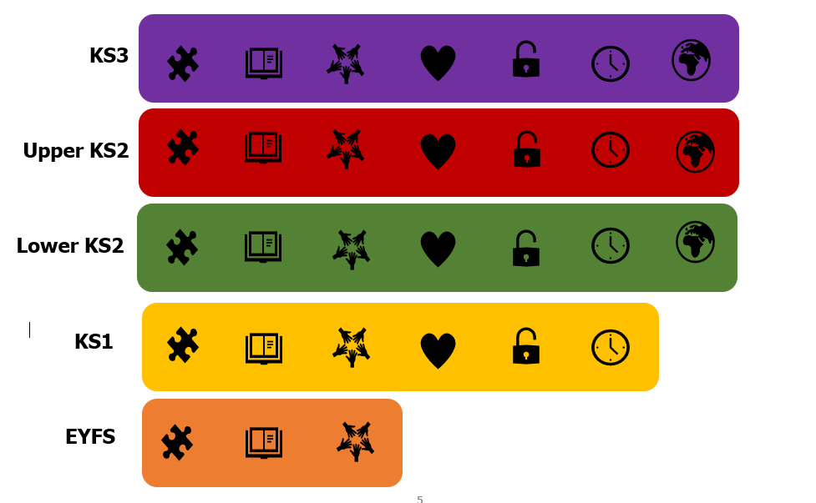
-Learning as Journey: Explore, Route, Perspective
The syllabus combines three essential aspects to create a comprehensive learning journey for pupils:
Explore (substantive knowledge content drawn from religion and worldviews, explored as case studies in response to each enquiry question)- What?
Route (disciplinary lenses and their associated methods and tools, dialogue and debate around worldviews and lived experience and embodiment of worldviews)- How?
Perspective (personal knowledge: the positionality, reflexivity, reflectivity and metacognition of the pupil as learner and worldview explorer in RE) – Who?
These three aspects are built on the Content, Engagement and Position sections of the REC’s statement of entitlement in the REC Worldviews Handbook.
Pupils are invited to engage in enquiry that will allow them to develop critical religious literacy as they study religion and worldviews. They will function as ‘explorers’ in the learning process, encountering worldviews other than their own through the series of enquiry units that make up learning at each phase of education. They will develop as ‘wise interpreters’ of knowledge about the world and how others choose to live in it.
As they progress through the units of study, pupils will embrace disciplinary knowledge and learn to use associated disciplinary methods, tools and skills with increasing understanding and effectiveness. They will develop as theologians, philosophers and social scientists as they study the worldviews case studies selected as the most relevant for exploring each enquiry question.
Explore (Substantive knowledge as case studies drawn from religion and worldviews)
Below is a visual summary of the ‘compass’ teachers and pupils will employ when approaching religion and worldviews. Pupils are expected to become familiar with the idea of the transcendent as well as the universality of some human experiences and the questions and quests this inevitably throws up for individuals and communities.
Pupils will explore worldviews that are religious and non-religious. Pupils will encounter the messiness and fluidity of those concepts and what they might mean and will begin to understand that individual worldviews can encompass and express organised and institutional worldviews in diverse ways. The syllabus aims to resist the notion of religious and non-religious as binary concepts.
Pupils will develop their understanding of what it means to ‘believe’ and what ‘faith’ is and the role these play in some worldviews. They will begin to understand that some worldviews encompass a relationship with a god/deity whilst some do not. Pupils will explore the concept of ‘belonging’ and why that is important for so many people, no matter what their worldview is.
Transcendent
Human
Theology
Philosophy
History
Human & Social Sciences

Whilst thoroughly exploring the local worldviews landscape and the historical-social impact of this particular geographical location, the syllabus also seeks to engage with the study of religion and worldviews at national and global level. In fact, the seven core concepts reflect this wider thinking, in particular the concepts of ‘Authority and Power’ and ‘Grand Narratives’, which shape the global world in which we all live.
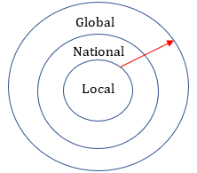

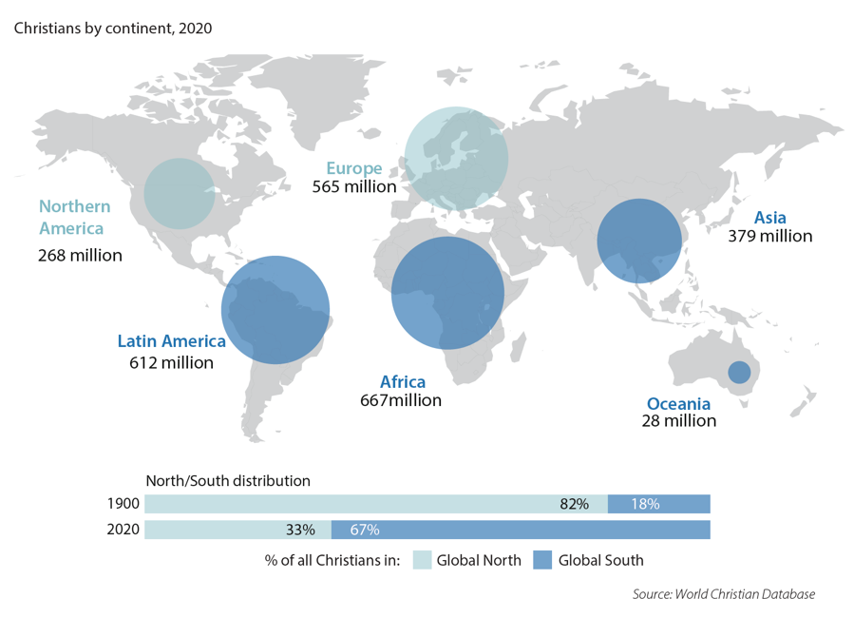
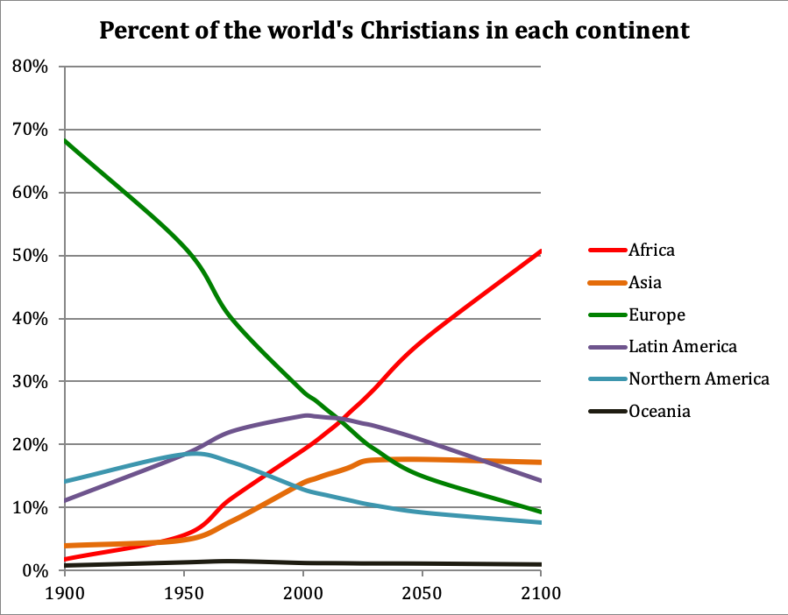

Graphics used with permission of Gordon Conwell Theological Seminary
Another distinctive characteristic of the Coventry and Warwickshire syllabus is that it seeks to redress historic imbalances seen in previous RE syllabuses. These are:
a) the presentation of a Eurocentric version of Christianity and
b) a concentration on Abrahamic faiths (Christianity, Islam and Judaism) at the expense of Dharmic traditions (Buddhism, Sanatan Dharma, Sikhi and any others that are represented locally).
This syllabus requires teachers to explore with pupils Christianity in its global context, and give a greater place to the study of Dharmic traditions.
This syllabus draws attention to organised religion and worldviews through the study of individual worldviews and the seven core concepts. In a manner typical of religion, this syllabus is signposting to something beyond itself. The worldviews studied are the most relevant case studies as decided through academic criteria, however, there will always be a huge array of other ways in which the enquiry questions might be answered. What the syllabus does is provide pupils with the tools to make that application of learning for themselves in time, making them ready for life in modern Britain.
The syllabus endeavours to support pupils in seeing the familial worldviews traits they encounter in individual and communal worldviews affiliated and aligned with the same organised worldview (e.g. religion). The retention of knowledge of these is supported through the cumulative knowledge organisers (CKO); designed like public information boards at places of beauty (in keeping with the concept of journey), these collect those traits into one place as pupils undertake their learning journey and move from key stage to key stage.
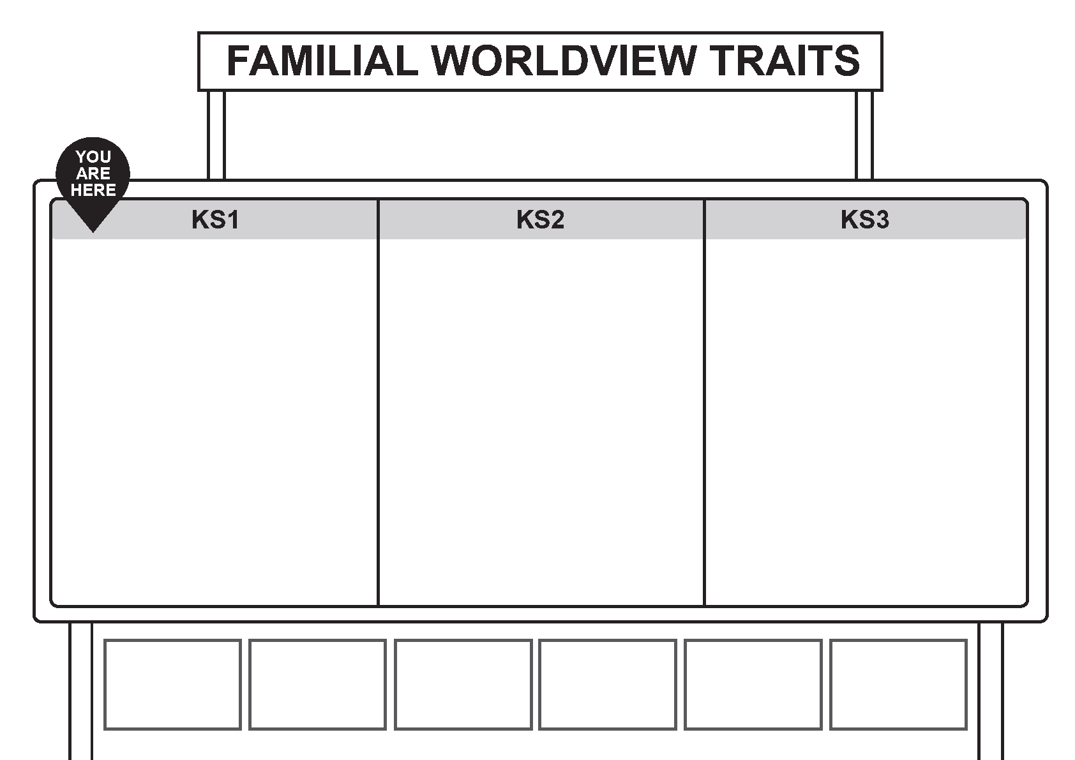
Example of cumulative knowledge organiser (blank)

As pupils study, common beliefs and embodied practices/rituals are encountered which make a worldview distinct. However, pupils also begin to understand that the ways in which worldviews interact with each other, and how worldviews develop and change as a result of time, place and context, also play their part in the diversity of their lived expression. The syllabus utilises specific theological interpretations (through the study of hermeneutics) and philosophical ideas as apertures through which pupils can encounter and study the world, understanding that positionality will always play a part in that.

Route (Engagement: Disciplinary Knowledge)
Pupils will be inducted as scholars within the different disciplines which comprise Religious Education/Religious Studies; primarily theology, philosophy, human and social sciences and, in some instances, history. One could also argue that literary and art criticism are also relevant disciplines for the understanding of religion and worldviews and these are certainly included in the syllabus, alongside ways of knowing in the past that can illuminate how religion was understood in this locality in different time periods. As M. Oakeshott said: “We are the inheritors, neither of an enquiry about ourselves and the world, nor an accumulating body of information, but of a conversation, begun in the primeval forests and extended and made more articulate in the course of centuries. It is a conversation which goes on both in public and within each of ourselves .” This syllabus supports the induction of pupils into that ancient conversation, provides the questions to engage them in enquiry and the disciplinary lenses through which they can participate.
Each concept is linked to at least two disciplines and therefore each unit within a concept will utilise the relevant disciplinary lenses for exploring the overarching enquiry question. Unit plans are presented as maps that begin with entry through ‘disciplinary doors’ which explain to teachers which of the disciplinary lenses they will be employing with their pupils for this part of their ongoing journey of encounter with religion and worldviews. During a unit teachers and pupils will look at the substantive content drawn from worldviews case studies through the lenses of one or more discipline. ‘Disciplinary diversions’ are also provided, where teachers may choose to employ a different disciplinary lens altogether and pose a new question based on the main enquiry question and suggested substantive content. Within the ‘Route’ there is scope for professional judgment and autonomy. Although each main enquiry question is broken down into sub-questions on the first page of the unit plan and approaches and resources are suggested on subsequent pages, teachers may choose to remove some sub-questions or add new ones in. They may choose to spend several lessons exploring one sub-question (often times this is suggested in the planning) and less on others, responding to their own unique school contexts.
As pupils encounter different disciplines through units of study, they will build up both disciplinary knowledge and disciplinary skills, employing methods and utilising tools as they move through the key stages, employing these thoughtfully as the skills required to put disciplinary knowledge into practice for themselves. They will be able to do more with the knowledge they obtain. For example:

Discipline | Disciplinary Methodology
Theology | - Hermeneutics (the art or skill of interpretation)  - Exegesis (analytical study and explanation of text)  - Historical theology (origins of theology and doctrines)  - Systematic theology (how it all fits together and makes sense as a system e.g. the way the doctrine of the Trinity developed over time and how it links with incarnation)  - Liberation/Feminist theology (ways of interpreting that challenge traditional interpretations)  - Art criticism (how sacred art communicates belief and worldviews)
Philosophy | - Logic (formulating arguments that make sense and reach valid conclusions)  - Reasoning (organising thoughts and ideas to justify positions)  - Epistemological questioning (the ‘How do we know…? type questions)  - Engaging with thought experiments (e.g. The Trolley Problem)  - Philosophy of religion (important philosophers and their ideas and how these relate to theology)  - Metaphysics (the ideas about abstract concepts e.g. peace, truth, love, beauty, etc)  - Theories of morality (ideas about right/wrong, good/bad and how we decide these things)  - Ethical theory (applying morals to specific situations e.g. abortion)
Human & Social Sciences | - Classification and meaning of words such as ‘worldviews’ and ‘religion’ and the exploration of how concepts such as identity and belonging are expressed in societies  - Lived religion (exploring how religion is lived in everyday life, and enabling ordinary people - not just religious elite - to shape how religion is understood  - Quantitative and qualitative data and analysis of such  - Ethnographic studies (observation of religious practice in action, learning through participation e.g. trips, film clips)  - Interactions with individuals/groups (e.g. interviews, case studies, surveys)  - Encounter with adherents (e.g. visitors, film clips)  - The roles positionality, reflectivity and reflexivity play in helping the scholar of religion to understand their own biases.
Discipline | Disciplinary Tools
Theology | - Translations of sacred texts  - Sacred art  - Original languages (e.g. lexicons, Arabic recitations etc)  - Interpretations/commentaries by others  - Theological scholarship
Philosophy | - Thought experiments  - Philosophical arguments (premise & conclusion)  - Logical structures of reasoning (e.g. syllogisms)  - Debates and discussions around proposed epistemological questions or statements
Human & Social Sciences | - Living library: people/adherents of religion and worldviews  - Places of worship/local faith communities  - Census and other data about religion and worldviews

The progression of disciplinary knowledge and skills is contained in the assessment section later on in this document. The identified knowledge and skills are incorporated into the units of work at each phase of education to ensure there is progression.
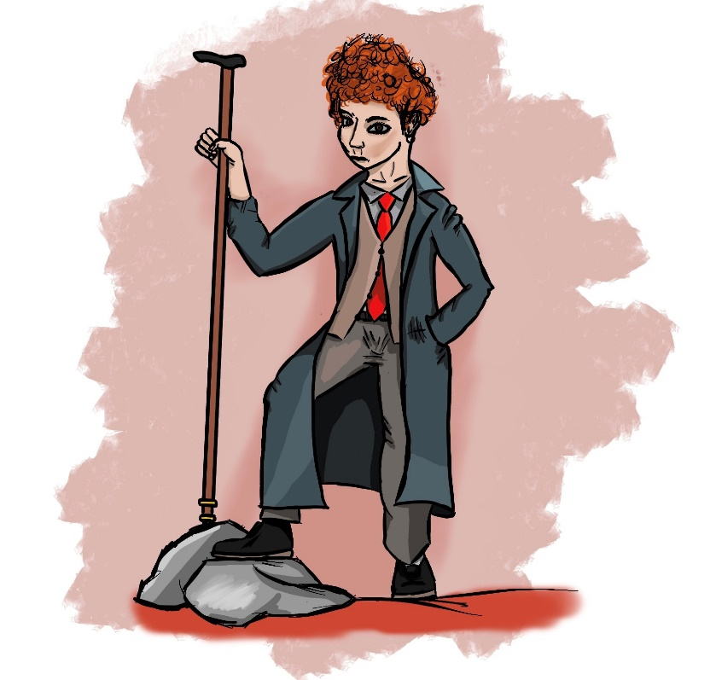
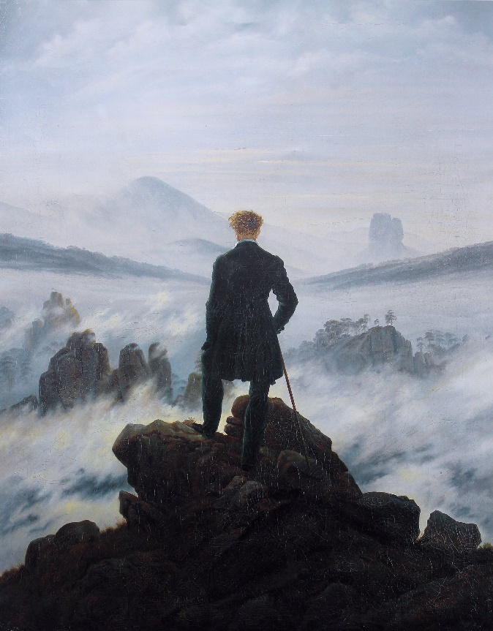
The development of this syllabus included the genesis of a character for teachers to use in RE lessons at primary level (although teachers at KS3 are also welcome to use these graphics also if deemed appropriate and useful) called DK Drew. This is based on the figure in the Wanderer above the Sea of Fog, a painting by German Romantic artist Caspar David Friedrich from 1818. Here the unknown explorer looks across the fog, where recognisable shapes of crags and rocks are beginning to emerge from what might otherwise appear to be an indeterminable landscape. Having imagined pupils as explorers of this syllabus, encountering worldviews not their own, the parallels with this figure and the imagined tools they might be carrying on their journey into the unknown (the fog below) are obvious.
Various explorer ‘tools’ (each with its own symbol) can be used by the teacher as part of the study of religion and worldviews through different disciplinary lenses for younger pupils. Whilst teachers might choose to add to these, here are the list of basic tools:

Tools for Study | Purpose
Cookie Cutter   | A reminder of the pupil’s own worldview which shapes the way they see and live in the world, how it is being shaped by a range of influences and a reminder that they bring their own worldview into each lesson as the place from which they ‘look’, experience and learn about the worldviews of others.
Magnifying Glass   | Working theologically: looking closely at sacred text and art and remembering the importance of hermeneutics so that they are becoming wise interpreters and critical narrators.
View Finder   | Working sociologically: focusing in on individual/ communal worldviews and lived expressions as a means for pupils to increase their understanding of organised worldviews, including analysing data, acting as interviewer, watching as observer and participating where appropriate.
Compass   | Working philosophically: considering ultimate questions such as what might the world, humans, God/the transcendent be like? What shapes the thinking & beliefs of individuals and communities? Where does our knowledge about these things come from? Developing as critical thinkers who can use reason and logic and justify conclusions reached.
Map  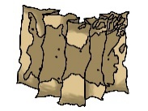 | Exploring lived religion: What shapes lived religion and how religion and worldviews are embodied? Thinking about what impact time and place have on how beliefs are lived out and practices/rituals are embodied.
Visa   | Thinking about how this learning might help them in the future, signposting to units of work still to come and ultimately beyond the curriculum.
Passport  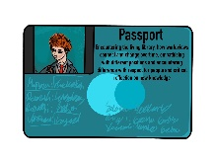 | Encountering the living library, how worldviews connect and change over time, empathising with different positions and encountering difference with respect for people and critical reflection on new knowledge.
Camera   | Personal knowledge: considering their own positionality, reflexivity and reflectivity as scholars and identifying and analysing their own personal worldviews as worldview explorers (taking worldview ‘selfies’ on their journey)

Teachers may choose to use DK Drew and these tools in the following ways:
- Adding them to the unit plans (page 1) at relevant points and reminding pupils about their purpose.
- Adding them to classroom presentations and resources.
- Using them in individual RE books when recording learning.
- Using them in RE floor books/scrap books where whole class or group discussion and learning is captured.
- Displaying them in the classroom for specific lessons in each unit (a set of slides with the images on is provided for classroom use).
- Using them in conjunction with the Pupil Worldviews Passport.

This syllabus recognises ‘ways of knowing’ as being more than just disciplinary knowledge. There is an acknowledgement, and an expectation, that pupils will be engaging in a dialogue with those holding worldviews and the academic work of those who have conducted research and provide powerful insights into understanding religion and worldviews.
There is an expectation that pupils will develop their understanding of epistemic knowledge (where knowledge comes from): what knowledge is, how it is formed and the important questions classrooms of community need to pose when considering knowledge in relation to reliability, validity, credibility and truth.
Lived experience is at the centre of this syllabus, as is pertinent and relevant to the religion and worldviews approach, which foregrounds the study of the diversity of lived religion. The syllabus recognises the roles belief and faith play in the lives of individuals as the impact of beliefs shape lives and lived experience in a diversity of practice and ritual. The disciplines do not exist in silos but instead inform and flow into each other in different ways and at different times.


People
Beliefs
Practices
Examining religion and worldviews



Instead of beginning with a list of beliefs and/or practices associated with religions, pupils will routinely encounter individuals and small communities (families or local faith communities), who will help them to better understand what those beliefs and practices mean in everyday living. They will still develop an understanding of the typicality of organised/institutional worldviews through initially having their attention drawn to certain elements expressed by individuals as they share their worldview.

Perspective- Personal Knowledge & Personal Worldviews
Whilst learning about religion and worldviews, it is important that pupils begin to understand that all their learning takes place from their own positionality. When they approach the content selected and presented by the teacher, they do so from a position of their own unique body of knowledge. For this reason, every learner in the classroom of enquiry is engaging with knowledge in their own unique way. Each pupil has their own schema which is employed when they learn anything. In the Ofsted RE Research Report this was referred to as ‘personal knowledge’ and it forms one of the three types of knowledge discussed within the paper (the other two forms of knowledge being substantive and ways of knowing, or disciplinary knowledge).
Schema is a term employed by Swiss psychologist Jean Piaget to refer to a cognitive framework or concept web that helps humans to organise and interpret information. Each person’s schema is unique. For example, ‘dog’ will mean something different to each person and will be shaped by the individual’s experiences, as well as knowledge they have gained through study. Piaget believed that schema could be shaped and changed through the processes of accommodation and assimilation. Accommodation is when what we already know is shifted around so that new information can fit in better and alongside existing information. Assimilation occurs when our knowledge within our existing schema is significantly modified or replaced with new information. This is not about adopting Piaget's cognitive framework but using his schema analogy. Through this model, it is easy to see that new learning requires one of these processes to occur and that process will be unique for each pupil. Therefore, as Jonathan Mountstevens says through his learning-as-river metaphor: “The river does not bring the landscape into existence, but shapes what is already there” and “We can select the content but we cannot determine the course”. How curriculum plays out for individual pupils, and the learning it ultimately leads to, is partly dependent on personal knowledge, so the greater thinking given to that and the more time allocated to helping pupils become aware of their own personal knowledge, will better determine overall success for the intentions set out in this syllabus regarding the acquisition, and retention, of knowledge and skills.

Positionality, Reflexivity and Reflectivity
Within the syllabus, these important concepts linked with personal knowledge are defined as such:
Positionality | Pupils will develop an understanding of their own positionality as they undertake learning, so that the social and political context that creates their identity in terms of race, class, gender and sexuality is better understood by themselves as individuals. Positionality also describes how identity influences, and potentially biases, your understanding of the world, so is inherent to any worldviews approach to learning in RE.
Reflexivity | Reflexivity is a type of learning through which an individual explores their own experiences as a learner to become more conscious, open-minded, and self-critical. It is about reflecting on your own positionality and how that might inform the way you engage with the content taught in RE. Researchers must undertake this learning all the time and so this aspect of personal knowledge is integral to the pedagogy of sociology.
Reflectivity | Reflectivity, or the act of being reflective, encourages pupils in thinking about what they have read, watched, listened to, learned and encountered so that they can relate their learning in the lesson to their own life and begin to make meaning from it. The main purpose of promoting reflectivity is to support pupils in developing critical thinking.

It is important to note that positionality and personal worldview are not the same thing. Positionality is about recognising all the factors that have and do influence personal worldview and personal approaches to scholarship with regards to worldviews.
To support teachers in developing their own skills of positionality, reflexivity and reflectivity, a Teachers Reflective Journal has been developed alongside this syllabus that seeks to support educators in the transition from World Religions Paradigm to a Religion and Worldviews Approach with multidisciplinary scholarship.

Pupils as Worldview Explorers
The Hero's Journey is an archetypal story pattern. It is common in ancient myths and can also be seen in modern stories and movies e.g. Star Wars, Harry Potter, The Matrix, The Lord of the Rings, The Hunger Games, Wizard of Oz, Hercules and Howl's Moving Castle etc. Initially outlined by mythologist Joseph Campbell in his book, and further refined by Christopher Vogler, the three principle stages are as follows:

- Departure: The Hero leaves the familiar world behind and embarks on an adventure into the unknown and less familiar
- Initiation: The Hero learns to navigate the unfamiliar world for themselves
- Return: The Hero returns to the familiar world, bringing the knowledge and experiences with them

Using the Hero’s Journey as a useful reference point, the journey of the learner as worldviews explorer is captured here as ‘The Explorer’s Journey’:

The Explorer ’s Journey
Transformational Learning:

- Worldview checkpoint
- Reflectivity
- Assessment: responding to the enquiry question: how would I answer it & how else could it be answered?
- Sharing knowledge with others
- Learning as increased understanding
Positionality of the Pupil:
- Personal worldview
- Prior Learning (links with prior units of work)
- Metacognition: how could we learn about this?
Worldview Checkpoint:
- Personal worldview
- Where do my ideas come from?
- How is my learning impacting my personal worldview?

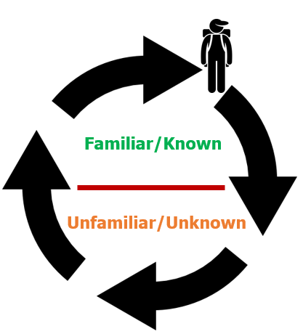
Teacher as Facilitator:

- Drawing attention to possible answers to enquiry questions through worldviews case studies
- ‘Border Crossing’ from own personal worldview to the worldviews of others
- Disciplinary lenses for studying worldviews

Personal Knowledge:
- How is this influencing my individual worldview, if at all?
- Personal knowledge: positionality, reflexivity & reflectivity
- Metacognition for RE: how do I learn best?

Worldview Encounter:
- Who are you, who am I?
- Overcoming ‘worldview shock’
- Disagreeing well
- Recognising familiar traits of organised worldviews and religious traditions

At the start of their journey of study for each unit of work, pupils consider their own worldview, what influences it and how it relates to the worldviews of others. They ponder the enquiry question from their own perspective. During the process of learning, they develop the skills of reflexivity and reflectivity to consider their own positionality and where the ideas that make up their worldview come from, for instance through engaging with a scaffold such as this:
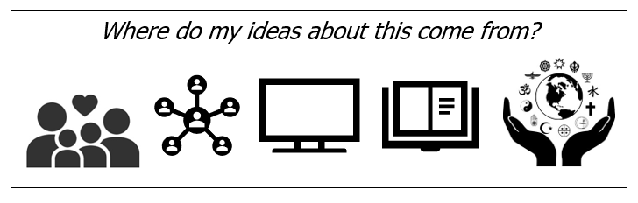
Through enquiry, they are provided with opportunities to reflect on, analyse and adapt the schema they have regarding religion and worldviews through accommodation and assimilation and to consider how their current understanding prepares them for life in a diverse world.
They begin to understand that they are ‘interpreters’ of the world and that, through their acknowledgement and understanding of hermeneutics (the art or skill of interpretation), they too approach the world from an inhabited mesh of conceptual understanding and must do the hard work of becoming ‘wise interpreters’. They will increasingly understand that their worldview impacts the way in which they engage with the subject matter in RE and how their learning about other worldviews also impacts upon their own worldview.

Metacognition
The employment of disciplines, and their associated methods and tools for the study of religion and worldviews, presents pupils with a range of ways of learning about the worldviews of others. Over time, pupils will begin to acknowledge the ways of knowing they find most helpful and may recognise their own pull towards a particular discipline. They will begin to recognise when they are being theologians, philosophers and sociologists of religion and the differences between the different ways of studying. They will recognise when doing ‘engaged looking’ at religious art helps them with understanding a concept more than a paragraph from a religious text might, or that interviewing people with worldviews aligned to organised worldviews in a variety of ways gives them a deeper understanding of the breath of lived expression of that organised worldview than simply reading in a textbook might. The Pupil Worldviews Passport also supports pupils in developing metacognition in RE.

Reconciliation
Peace and reconciliation function as a focal point for this locally agreed RE syllabus.
The Reconciliation statue in the grounds of Coventry Cathedral ruins also offers a visual metaphor with regards to exploring religion and worldviews. This is a statue that is found in several areas of conflict, including Hiroshima, Belfast and Berlin and is not an exclusively Christian motif.
The following insights regarding the ‘Reconciliation’ statue are relevant to the approach to religion and worldviews outlined in this syllabus:
- The concept of ‘leaning in’- as leading shame researcher and international speaker, Brene Brown, states: ‘People are hard to hate close up. Move in’. As the two figures lean towards each other, they are prepared to become intimately aware of the other person’s perspective, priorities and position. Though another person’s worldview may be alien to us, may even appear unappealing or problematic, through this position of ‘academic humility’, another person and their worldview can be encountered. ‘Worldview shock’ is overcome.
- The solid stance of the two figures, with their knees apart offering them a secure base through which to lean towards the other, is a reminder of the importance of positionality, reflexivity and reflectivity in the worldviews approach. Pupils are invited to explore their own worldview, to understand what influences it and what has shaped it, the situatedness and context-specific nature of it, and to grasp that it is from this position that they approach the learning of substantive content (e.g. worldviews case studies) offered to them during the enquiry process.
- The embracing of the heads of each figure serves as a reminder that pupils will develop important personal skills as they explore the worldviews of others:
  - Empathy born out of dialogic conversation characterised by curiosity and bestowing attention.
  - Wise interpretation of what is encountered, be it text, art or lived experience through recognition of their own unique positioning and lenses through which they may unconsciously or deliberately (as with disciplinary lenses) be choosing to ‘look’.
  - Imagination of what it is like to see the world through the eyes of another and approach life from the inhabited space of another person, recognising that this involves bodies as much as minds, souls and spirits.

What do pupils learn in RE?
The units for each phase of education with each enquiry question can be found on pages 72 and 73. These are organised in the suggested order in which they should be taught in one chart and organised by core concept on the other. The colour-coding on each unit shows the lead discipline, not the only discipline for studying within that unit. The chart below provides an overview of the disciplines within the syllabus:

Theology as Lead Discipline | Theology as Secondary Discipline
F2- EYFS  K1.2- KS1  K1.4- KS1  L2.2- lower KS2  L2.3- lower KS2  L2.5- lower KS2  K3.7- KS3  K3.8- KS3 | F1- EYFS  F3- EYFS  K1.1- KS1  K1.3- KS1  K1.6- KS1  L2.6- lower KS2  U2.5- upper K2  K3.1- KS3  K3.2- KS3  K3.3- KS3  K3.4- KS3  K3.5- KS3  K3.6- KS3

Philosophy as Lead Discipline | Philosophy as Secondary Discipline
F3- EYFS  K1.5- KS1  U2.4- upper KS2  U2.6- upper KS2  U2.7- upper KS2  K3.2- KS3  K3.5- KS3 | K1.2- KS1  L2.1- lower KS2  L2.3- lower KS3  L2.4- lower KS2  L2.5- lower KS2  K3.7- KS3

Human & Social Sciences as Lead Discipline | Human & Social Sciences as Secondary Discipline
F1- EYFS  K1.1- KS1  K1.3- KS1  L2.1- lower KS2  L2.4- lower KS2  L2.6- lower KS2  K3.1- KS3  K3.3- KS3  K3.4- KS3  K3.6- KS3 | F2- EYFS  F3- EYFS  K1.4- KS1  K1.5- KS1  L2.2- lower KS2  L2.3- lower KS2  L2.7- lower KS2  K3.7- KS3  K3.8- KS3

History as Lead Discipline | History as Secondary Discipline
K1.6- KS1  L2.7- lower KS2 | K3.6- KS3  K3.8- KS3

An additional document (Unit Pathways EYFS to KS3) sets out the suggested route through the units and gives details of how each unit connects with prior and future learning. Schools may choose to deviate from this suggested route but all documents associated with the syllabus assume this route is normative in Coventry and Warwickshire schools.

Mixed age classes
Some schools will have mixed age classes and often these follow two or even three year cycles where some units can be done in cycle a and some in cycle b etc, with some repeated units using different worldview case studies each time. This would especially be possible in the early years where different sacred stories and festivals could be studied alongside different worldviews and religious traditions if units are repeated.
But SACRE recognises some schools have much more complex arrangements and pupils might be grouped based on a range of factors including: age, ability, phonics needs, special education needs or class size. These schools will need to consider what is essential and what they have capacity for in terms of space, resources and staffing. A one-size-fits-all solution to this issue is not possible but schools might consider splitting classes when a teaching assistant is available to allow for different units to be taught simultaneously.
Teachers might also simplify learning for younger or less able pupils within a unit or add additional challenge for pupils who are older or more able, considering the disciplinary knowledge and skills they are developing as they do so. SACRE is committed to working with small schools to find suitable adaptations and solutions to make this syllabus impactful in small schools moving forward.
If possible, SACRE recommends that unit L2.7 should ideally be done at the end of Year 4 to allow for sufficient pupil maturity. Likewise, U2.5 and U2.6 at the end of Y6 due to the subject matter.

Planning from the Syllabus
Maps of Enquiry
Throughout this syllabus, the metaphor of curriculum as journey has been utilised and the first pages of each unit of work appear as a map. These ‘maps’, joined end-to-end in the pathway we have prescribed (see Unit Pathways EYFS to KS3 document), plot a journey through religion and worldviews that should equip pupils with the critical religious literacy to study any worldview and to hold effective conversations with those inhabiting diverse worldviews; an academic skill and a life skill. In words typically attributed to J.R.R Tolkien but probably not his, ‘little by little, one travels far’.
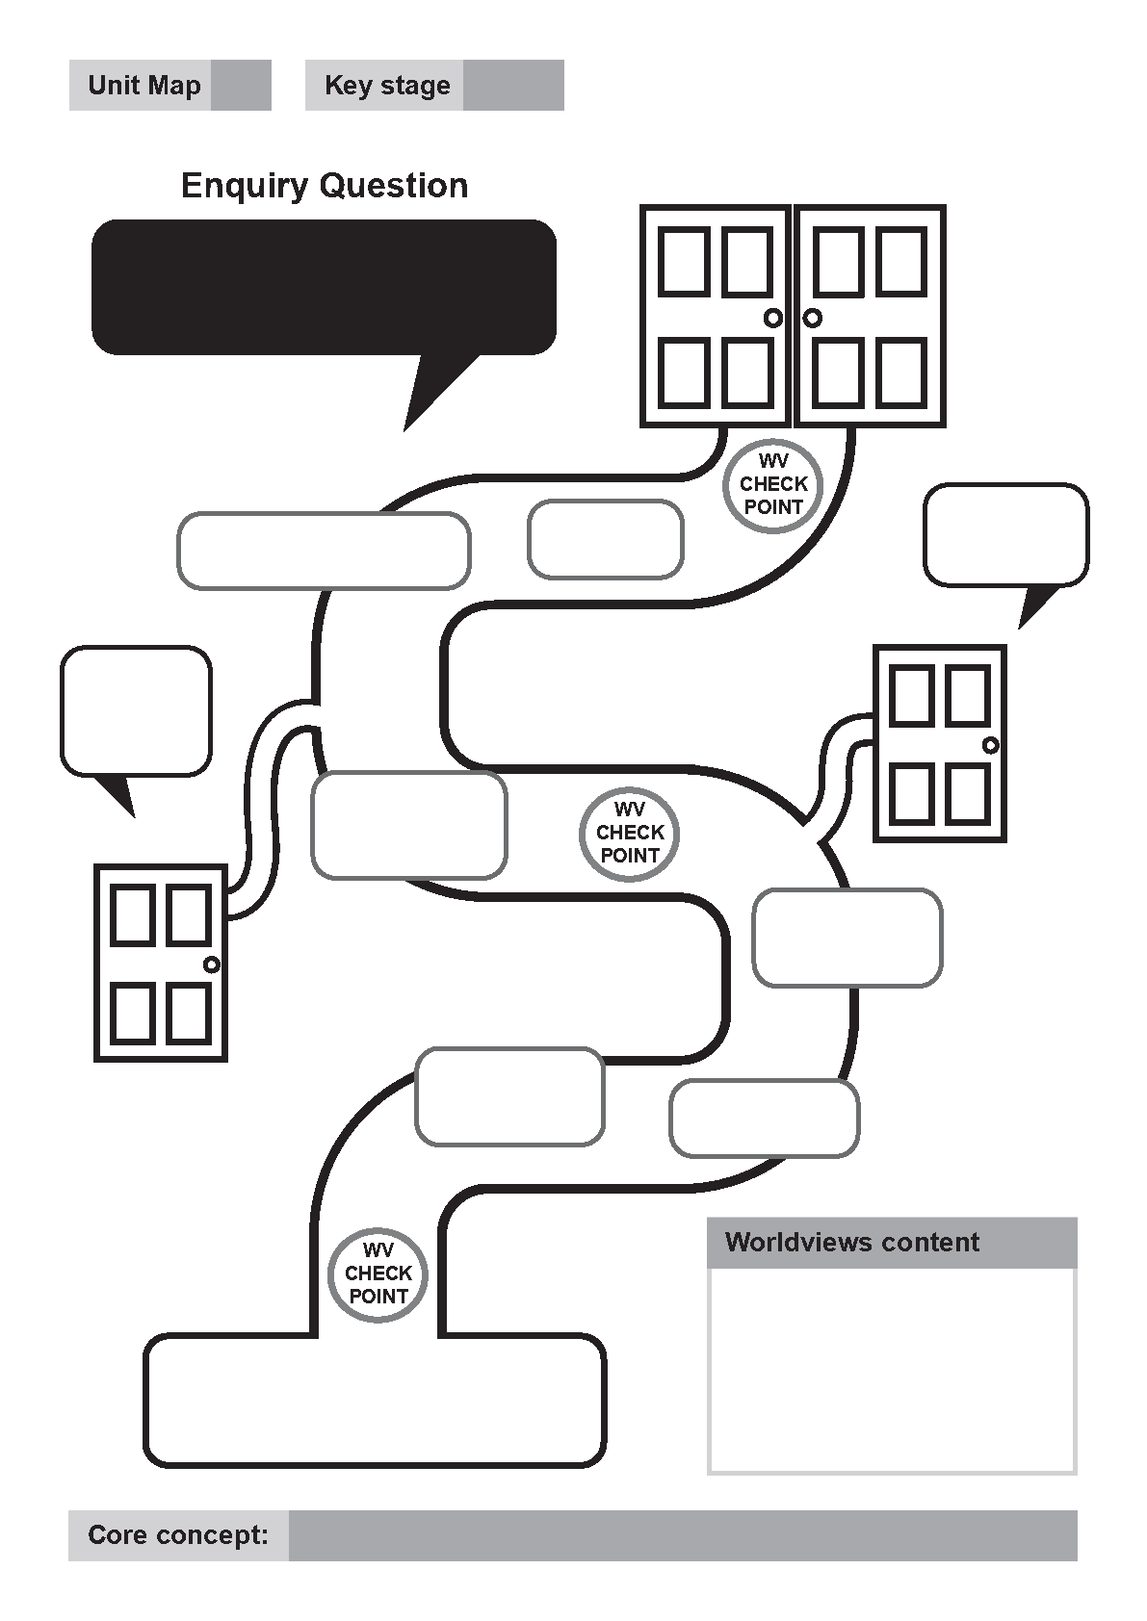
Through these unit maps, teachers and pupils navigate their way towards greater understanding, enhanced disciplinary knowledge and expertise and increased critical religious literacy. As Mountstevens points out, “We can select the content but we cannot determine the course”; meaning we have established the syllabus but how that transpires and the impact it has in the classroom will be very much shaped by the professional judgement of the teacher and the personal knowledge the pupil brings into the learning space. For this reason, teacher reflectivity and pupil positionality are integral to the effective implementation of this syllabus and are exemplified in the Teacher Reflective Journal and the pupil worldviews checkpoints in the unit maps, as well as the Pupil Worldviews Passport. For a worldviews approach to be effective it must be accompanied by adequate teacher CPD that explains the difference between this and teaching within the World Religions Paradigm (WRP); this syllabus’s success rests on paperwork and pedagogy. Teachers are encouraged to access SACRE training past and present to support them in implementing this syllabus and utilising the pedagogy of the Religion and Worldviews (RWV) approach. Through the encounter and enquiry proposed in each unit map, we expect intellectual change to take place.
Page one of the unit plans look like this:
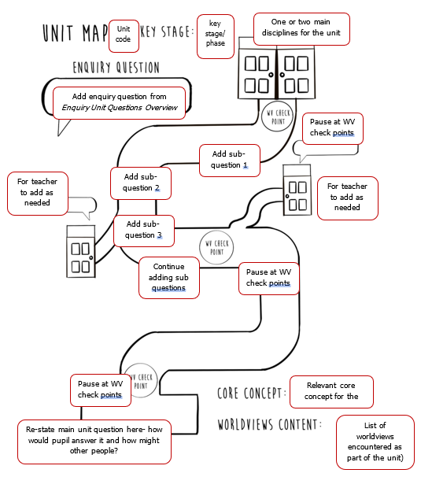
From page two onwards the unit plans are more conventional. Vocabulary and substantive knowledge are listed at the top of the planning format and it is expected that schools will make use of these in retrieval practice activities particular to the school, so that pupils know more and can remember more about religion and worldviews. This is also reflected in the cumulative knowledge organisers offered alongside the syllabus.
The disciplinary knowledge and skills are recorded in the two right-hand side columns of the unit plans. Not every suggested approach or activity is going to be disciplinary in nature; sometimes we are advocating for just good learning activities that we know work well in RE. Disciplinary knowledge and skills ensure pupils can do more with the learning they undertake in RE. This is reflected in the assessment system for this syllabus.

The unit plans take each sub-question at a time, stating the most relevant worldviews case stories for teachers to use and suggesting possible teaching approaches and resources. Teachers may wish to adapt or omit sub-questions or may add in their own sub-questions, pertinent to their own context. As the sub-questions are not statutory, this is permitted. They may also substitute the worldviews case studies so that they are relevant to their own school context if that differs significantly (i.e. a faith group is more represented in that area, such as Baha’i adherents or the Gurkha community, as is the case in some local schools).

Layover Units
One of the concerns regarding the RWV Approach is that pupils may leave school (primary or secondary) without a proficient understanding of organised worldviews such as religious traditions. Therefore, the concept of taking a ‘layover’ on the proposed learning journey through worldviews to focus in depth on one organised worldview (in this case, one of the major world religions), has been included in this syllabus. These units are shaped differently, taking account of the focusing on just one worldview, and ‘rooms’ are used to pose important questions that will help pupils to access the most important concepts within that organised worldview. There is no uniformity to the questions asked about each major religion as there might have been in the World Religions Paradigm, but instead each religious tradition is explored uniquely and on its own terms, which is intended to be naturally decolonising with regards to the Dharmic traditions. SACRE members representing different faith traditions have helped to shape these units focused on organised worldviews.
In addition to the ‘disciplinary diversions’ in the unit maps and the ability to choose alternative worldviews as case studies within the units, the ‘layover’ units are a further opportunity for schools to make the learning journey their own. Knowing their pupils best, and in particular the needs of year group cohorts, schools can decide if and when they wish to add the ‘layover units’ into their curriculum pathway. They may choose to use some or all of them. They may choose to look at all or some of the questions posed. Each unit offers approaches at KS1, KS2 and KS3 so that they can be used at any appropriate point on the learning journey and they can be used several times as needed. This is not skirmishing back into the WRP but instead uses a worldviews approach for learning about religion. Alongside the cumulative knowledge organisers for each worldview, this should help to make secure pupils’ knowledge regarding organised worldviews.

Teacher Positionality, Bias & Professional Reflection
The Teacher Reflective Journal has been developed out of recognition that teachers are also going through similar cognitive experiences to pupils when approaching worldviews through a RWV approach. They too bring a worldview into the classroom (of which they may be unaware or may be only just beginning to recognise their worldview, its influences and origins) and they too will hold disciplinary biases (preferred ways of working in RE e.g. theology). The RWV approach asks teachers to change the way they teach, adapting new pedagogies and framing what may be familiar substantive content in new and different ways. A paradigm shift, as this has been often called, is no small ask of a busy teacher. The Teacher Reflective Journal aims to help teachers to reflect on all of these aspects as they begin to teach using the RWV approach.
As pupils are being nurtured to develop the skills of recognising their positionality, being reflexive and reflective, so teachers are being invited to do the same through this carefully-scaffolded document.

How do we assess progress?
Little by little, one travels far…
This syllabus assumes the ‘curriculum as progression’ model and the proposed assessment system encourages teachers to assess whether their curriculum is working (e.g. 80% of pupils know and can do as the curriculum intends). It seeks to allow for a lengthy amount of time for learning to take place before summative assessments are undertaken e.g. at least two terms. Substantive knowledge is identified in each unit and this syllabus assumes that such knowledge is being regularly assessed through formative assessment and retrieval and recall activities. Disciplinary knowledge and skills for assessing linked with appropriate substantive content from the unit are outlined at the end of each unit so that teachers are clear on what they are assessing.
The assessment system associated with this syllabus focuses on progression of disciplinary knowledge and skills as laid out in the syllabus units. It also allows for teachers to make a general assessment on the effectiveness of the curriculum in terms of the development of understanding of pupils in regards to a religion and worldviews education. The statements at the top of each grid are for the purpose of teachers making that judgement. The disciplinary knowledge and skills outlined are for the purpose of assessing pupils’ progress in ‘ways of knowing’.
The assessment system does not seek to assess ‘personal knowledge’ as this has been deemed inappropriate but ample and regular opportunity for pupils to reflect on the development of their own personal knowledge is provided through the worldview check points on unit maps and the Pupil Worldview Passport accompanying this syllabus.
Rationale for assessment in this syllabus
The rationale of assessment for this model is an indicator of what good progression might look like. The focus is on making progress in terms of the process of engagement, for example, assessing how pupils examine and engage with the content which has been delivered and covered as part of a spiral curriculum, including ‘ways of knowing’ (or disciplinary knowledge and skills). We acknowledge that progress will fluctuate and will look different for different pupils and educational settings.
By the end of each key stage, pupils are expected to know, apply, and understand the matters, skills and processes specified in the relevant programme of study. Tracking the progress of key ‘concepts’ throughout all Key Stages will ensure there is consistent development and assessment of pupils’ substantive knowledge. We are aware substantive knowledge and disciplinary knowledge do not equate to ‘knowledge and skills.’ When tracking disciplinary knowledge and skills progression we recognise the diverse lenses through which religion and worldviews are studied. By ‘multi-disciplinary’ we recognise that RE involves studying religion and worldviews using all these different disciplinary lenses, sometimes more than once. Throughout each Key Stage, pupils will be consistently assessed on disciplinary knowledge, ‘ways of knowing’ and disciplinary skills, using a progressive and spiral model. This will ensure pupils are able to revisit, recall and remember ‘substantive’ knowledge through the application of disciplinary lenses and skills. As a result, assessing the disciplines will ensure our pupils are able to demonstrate ‘how to know’ about religious and non-religious worldviews.
Pupils will reflect on and will develop their own personal worldviews and make scholarly judgements in the light of their study of religious and non-religious worldviews. We acknowledge that it is evident that not all attitudes can or ought to be assessed as part of a Religion and Worldviews curriculum. Therefore, our rationale and methodology of assessment ensures this syllabus provides ample opportunities for reflection and the development of the individual pupil. We have therefore planned for opportunities within our curriculum for our students to be able to reflect on their own position considering the content covered.
Different types of assessments are used appropriately, including formative and summative assessments:
Formative assessments can help teachers identify which pupils have misconceptions or gaps in their knowledge, and what those specific misconceptions or gaps are. This can inform teachers about common issues, so they can review or adapt the curriculum as necessary. We do acknowledge formative assessments are less useful in making judgements about how much of the whole curriculum has been learned and remembered by a class and individual pupils. Teachers may use formative assessments to keep track of substantive knowledge they wish pupils to remember, as well as to provide a ‘snapshot’ regarding how effectively disciplinary knowledge and skills are being acquired.
Where summative assessments are used, we emphasise leaders ensure that they are sufficiently implemented within the curriculum, considering time pupils have had to remember and recall substantive and disciplinary knowledge. We also emphasise that the purpose of the assessment should guide the type of assessment, the format of the task and when the assessment is needed. We also acknowledge the assessment needs to clearly relate to the curriculum, which sets out what it means to ‘get better’ at RE.
If for any reason you identify pupils have misunderstood or have not fully grasped key concepts or have not grasped disciplinary knowledge and skills this therefore may be telling you the depth to which a unit has been implemented has not been reached and a revisit to a key part may be required. You may wish to use the layover units as a guide and the check points for support.
For all RS GCSE specifications, it has been the practice of the department for Education, under its influence, the Examination Awarding Bodies, to use contemporary academic and professional thinking in setting the specifications for RS qualifications. These specifications emphasise the acquisition of a rich knowledge of two religions, and the process of critical thinking. Candidates learn about the internal diversity of religions and develop reasoned responses from their own perspectives to evaluation points. As a result, our methodology of assessment ensures students continue to develop rich knowledge of a wide range of religion and worldviews, developing both disciplinary methodology and skills.
Assessment expectations at each phase of education are shown on pages 46-55, from EYFS through to KS3. Each grid outlines:
- Developing understanding of worldviews
- Disciplinary knowledge to be obtained (knowing more)
- Disciplinary skills to be mastered (being able to do more)

Understanding of Worldviews: EYFS
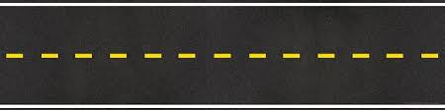

Pupils begin to understand what a worldview is and whether they and their family have one |  |  | Pupils know how people with similar worldviews might connect with each other e.g. festivals, rituals and ceremonies |  |  |  | Pupils begin to understand how stories can be important for worldviews |  |  |  |  |  |  |  | Pupils begin to understand how worldviews can influence behaviour e.g. kindness, right and wrong, Golden Rule
 |  | Disciplinary Knowledge |  |  |  |  |  |  | Disciplinary Skills
  Theology |  | - Pupils begin to know some special stories from ancient texts that still hold value for many people today.  - Pupils begin to know those stories often have links to what people do (e.g. ritual) and what they celebrate (e.g. festival). |  |  |  |  |  |  | - Pupils are starting to read simple texts with their adults and are beginning to talk about what they might mean.  - Pupils are starting to apply what is learned from sacred texts and are beginning to understand these as offering guidance for some people in real life situations.
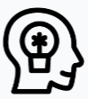  Philosophy |  | - Pupils begin to know that people have different sources for their ideas about right and wrong but that these often line up and show agreement on how to treat each other. |  |  |  |  |  |  | - Pupils are starting to engage in simple reasoning, using ‘because’ to justify some conclusions.
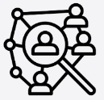  Human & Social Sciences |  | - Pupils begin to know there are different ways that human beings can show they belong together and hold similar beliefs, and that these may differ depending on space and time. |  |  |  |  |  |  | - Pupils are starting to explore specific expressions of what it might mean to be part of a community and what ‘belonging’ might mean.
Understanding of Worldviews: Key Stage One

Pupils begin to understand whether or not you can ‘see’ somebody else’s worldview through their actions |  | Pupils begin to understand what might shape a worldview |  |  | Pupils begin to understand how worldviews might be celebrated and shared |  |  | Pupils begin to understand that people with different worldviews can have differing ideas about the same thing |  |  |  |  | Pupils begin to understand the important questions a worldview might seek to answer |  |  | Pupils begin to understand how a local area can shape a communal worldview
 |  | Disciplinary Knowledge |  |  |  |  |  |  |  |  |  | Disciplinary Skills
Theology |  | - Pupils know that sacred texts are sources of beliefs and are beginning to understand the authority and power these can hold for some people.  - Pupils know that people may interpret sacred texts differently and that the way in which sacred texts are understood can change over time.  - Pupils know that religious art and symbols can have theological and spiritual meanings. |  |  |  |  |  |  |  |  |  | - Pupils can read simple passages from sacred texts and engage in simple exegesis (annotating and analysing) to explain what a sacred text might mean.  - Pupils are beginning to make links between passages from sacred texts and examples of ritual and practice.  - Pupils can make simple interpretations of sacred/religious art and symbols- simply thinking about what art might be showing to the viewer.
Philosophy |  | - Pupils know that people give different reasons (including logic) for what is important to them, in answer to the ultimate questions about life.  - Pupils know that ideas about right and wrong/good and evil often come from ancient texts or the ideas of philosophers of the past. |  |  |  |  |  |  |  |  |  | - Pupils are beginning to ask ultimate questions and sharing their own possible answers to these.  - Pupils are beginning to use simple frameworks for logic and justifying their own position/beliefs.  - Pupils can engage in simple debates and discussions, using statements as a focus for talk and the formulation of reasons.
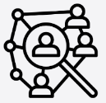  Human & Social Sciences |  | - Pupils know that people can have similar beliefs but may live them out in different ways.  - Pupils know that asking individuals questions about their practices/lived expressions can reveal more about their beliefs and why they do things and are beginning to understand the benefits and limitations of questioning methods (e.g. surveys and interviews).  - Pupils know that observing worldviews in action (e.g. a ritual or festival or the actions of a communal worldview in a specific place of worship) can help them to better understand what is happening and why it is important for believers. |  |  |  |  |  |  |  |  |  | - Pupils can develop a simple survey (2-3 questions) to better understand the lived expression and beliefs of different worldviews.  - Pupils can summarise and compare data by making simple conclusions, often with the support of the teacher.  - Pupils can observe individual and communal worldviews in action within the context of a local place of worship and use this to better explain phenomena from organised worldviews (e.g. prayer) and comment on what this might mean to individuals and the community.
History   |  | - Pupils begin to understand that religion and history can often entwine and what happens in the past can still be significant in the present. |  |  |  |  |  |  |  |  |  | - Pupils can explain historical events simply, making connections with their significance and meaning today.
Understanding of Worldviews: Lower Key Stage Two

Pupils understand that worldviews are often expressed within seasons and cycles | Pupils understand that there are different ways a worldview can be shown to other people |  |  | Pupils understand that peace and reconciliation might be important in different worldviews |  | Pupils understand that worldviews aren’t just made up of good, easy things |  |  |  |  | Pupils understand the roles beliefs and faith might play in worldviews |  |  | Pupils understand that people with similar worldviews often want to find people with worldviews like their own in order to live a happy life |  |  | Pupils understand that the evidence of worldviews from the past can be seen in the present day
 | Disciplinary Knowledge |  |  |  |  |  |  |  |  | Disciplinary Skills
Theology | - Pupils know that sacred texts are interpreted by individuals and communities (hermeneutics= art or skill of interpretation) and this can be literally, symbolically, metaphorically, analogically, spiritually.  - Pupils know that important concepts and beliefs can be drawn from several different places in a sacred text.  - Pupils know that sacred texts contain ideas about God/the Divine that are often hard for those outside of the faith community to understand and may be metaphorical or built on images.  - Pupils know that sacred art and architecture can communicate theological and spiritual ideas and that artists can communicate their own worldviews through art, the ‘situatedness’ of which matters. |  |  |  |  |  |  |  |  | - Pupils are able to engage in simple exegesis of sacred texts, making simple interpretations of what they may mean.  - Pupils are able to make links between different passages within a sacred text and summarise some beliefs (e.g. beliefs about God/the Divine).  - Pupils are able to make links between sacred texts and the contexts in which people live  - Pupils are able to do ‘engaged looking’ at sacred/religious art to explore its theological significance and the manner in which the historical-social-geographical context of the art/architecture shapes its meaning.
Philosophy | - Pupils know that some important ideas about life are abstract (metaphysical) in nature but no less important e.g. love, forgiveness, peace.  - Pupils know that the reasons for belief in God and the supernatural can vary and that people may turn to logic, reason, revelation and tradition as they talk about and try to justify those beliefs. |  |  |  |  |  |  |  |  | - Pupils can develop simple metaphors and similes for metaphysical philosophical ideas e.g. ‘Peace is like…’, ‘Love is…’ etc  - Pupils are beginning to explain simple philosophical arguments for/against …
Human & Social Sciences | - Pupils know that routine and repetition are often important to worldviews and can be observed (e.g. the cycle of festivals, the routine of ritual) via ethnographic study.  - Pupils know that an individual worldview may deviate from an organised worldview as life is lived out.  - Pupils know that places can encourage actions and reactions from people’s bodies in response to the ideas they encounter.  - Pupils know that ritual is an important aspect of many festivals and may include clothing, food and the use of artefacts. |  |  |  |  |  |  |  |  | - Pupils can create longer surveys (e.g. 5-6 questions) that ask questions aimed at exploring lived expressions of worldviews and how beliefs may be interpreted.  - Pupils can ask questions when interviewing individuals that will help them to better understand the connection between belief and lived practice.  - Pupils can explain how communal worldviews might differ from or express organised worldviews differently, using ethnographic study as a method.  - Pupils are beginning to summarise and question data related to religion more independently.
History | - Pupils are beginning to understand that religion and history can often entwine and what happens in the past can still be significant in the present.  - Pupils know that history and religion can combine to be expressed in specific ways in specific geographical areas. |  |  |  |  |  |  |  |  | - Pupils can explain historical events simply, making connections with their significance and meaning today.

Understanding of Worldviews: Upper Key Stage Two

Pupils understand that worldviews can understand the same things in different ways | Pupils understand how and why worldviews today are shaped by ancient stories | Pupils understand how a worldview might change over time | Pupils understand how worldviews are more than just how you ‘see’ the world |  | Pupils begin to understand whether an individual worldview can make a difference in the world | Pupils begin to understand worldviews are not just about the here and now | Pupils understand people may not be absolutely certain about their worldview
 | Disciplinary Knowledge |  |  | Disciplinary Skills
Theology | - Pupils know that there are ways of interpreting texts that are held as authoritative within institutional worldviews and that some ways sacred texts were interpreted and used by institutions have been rejected over time.  - Pupils know that interpretations of sacred texts can be- and often are- still applied to situations today to justify the actions of adherents and institutions.  - Pupils know that the same stories with the same figures can be told differently in different sacred texts and that those in religious stories can be seen as important in different ways and for different reasons.  - Pupils know that religious art can interpret sacred texts and stories in different ways, revealing the worldview of the artist. |  |  | - Pupils are increasingly confidently applying hermeneutics – exploring different interpretations of texts and beginning to take the historical-social situations into account.  - Pupils can engage in religious art criticism through ‘engaged looking’ for interpreting religious art work, taking religious texts into account.  - Pupils can make simple links between sacred (and other) texts and today’s world, exploring how texts are used in both religious and non-religious worldviews.
Philosophy | - Pupils know that all knowledge comes from somewhere and that ideas from worldviews can be debated and discussed  - Pupils know that the ideas of philosophers past and present may provide a basis upon which people choose to live their lives.  - Pupils know that what it means to live well can and will be interpreted differently and that people will draw upon different types of knowledge, values and ethics  - Pupils know that people have different ideas and beliefs about the self (e.g. soul/spirit and its relationship with the body), death, life after death and the supernatural/ spiritual. |  |  | - Pupils can debate and discuss ideas from organised worldviews that are applied to current issues.  - Pupils are increasingly able to put forward alternative ideas and statements, taking account of a variety of positions and arranging arguments and counterarguments in an increasingly logical manner.  - Pupils are developing an awareness of morality – gaining knowledge of values, ethics and deciding what these mean for them and for others.
Human & Social Sciences | - Pupils increasingly know and understand that worldviews are ‘embodied’.  - Pupils knowing that religions and worldviews change over time and are shaped by people, places, the time/era, significant events and power dynamics.  - Pupils know that positionality, place and time influence the beliefs and practices of those with religious and non-religious worldviews.  - Pupils know that surveys and polls can reveal certain things about worldviews but not the complexities of individual worldviews  - Pupils know that lived expressions of worldviews can be accessed via ethnography (observation and participation) and that people can play an important role in shaping organised and institutional worldviews. |  |  | - Pupils can confidently examine their own positionality in order to be reflective and reflexive when exploring other worldviews (through text, art and encounter).  - Pupils can engage in more confident quantitative and qualitative data analysis.  - Pupils can plan for and execute sociological methods such as simple polling/surveying and interviewing.  - Pupils can engage in ethnographic studies based on local communal worldviews (e.g. through visits and visitors).

Understanding of Worldviews: Key Stage 3

Students securely understand that defining what a worldview is or isn’t is difficult | Students securely understand what difference a worldview really makes in terms of how you live | Students securely understand how and why worldviews with the same name look so different when they are lived out | Students securely understand what can happen when worldviews are in conflict and whether or not that can be overcome |  | Students securely understand a worldview often includes a philosophy for life | Students securely understand people may or may not be aware of the power of worldviews in society | Students securely understand some worldviews include the supernatural/ spiritual whilst some don’t | Students securely understand how diversity might shape a worldview
 | Disciplinary Knowledge |  |  | Disciplinary Skills
Theology | - Students securely know that sacred texts can be interpreted in different ways by different members of the same organised worldview.  - Students securely know that factors impacting on identity have led to a range of interpretations of sacred texts.  - Students securely know that sacred texts are often used to justify belief in God/a deity. |  |  | - Students can confidently use hermeneutics – exploring the implications of interpretations of texts by different members of the same organised worldview/religious tradition.  - Students can engage confidently in exegesis of sacred texts.  - Students demonstrate liberation theological skills – identifying how interpretations of some sacred texts may have led to freedom from oppression.  - Students demonstrate historical theological skills – exploring the history of beliefs and practices.
Philosophy | - Students securely know about certain philosophies and ethical theories and applying these to modern day contexts and scenarios.  - Students securely know about philosophies of religion from several religious traditions, how these are applied to life now and how they have been in the past. |  |  | - Students confidently apply philosophies and ethical theories to current contexts and situations.  - Students more confidently employ reasoning as applied to different situations and scenarios of life.  - Students respond with growing confidence to epistemological questioning e.g. where does this knowledge come from and how reliable is it?  - Students demonstrate a developing understanding of Philosophy of Religion – knowing, understanding and applying a wide range of philosophies of religion from a variety of religious traditions
Human & Social Sciences | - Students securely know that religion is hard to define and that all religions do not look the same nor are expressed in the same way.  - Students securely know that individuals and communities might identify with organised worldviews such as religious traditions, but their lived experience may be incredibly diverse.  - Students securely know that some ideas can stretch beyond local and national expressions and into global significance (such as peace and reconciliation).  - Students securely know that religion may not always be a force for good but can also be a source of conflict and oppression.  - Students securely know that when a religious worldview is inhabited and lived out identity factors such as gender, sexuality and ethnicity can significantly impact upon that lived expression. |  |  | - Students engage confidently in ethnographic studies – developing knowledge and understanding that in practice, religion and worldviews are hard to define and look different to all people.  - Students make effective use of encounter – making good use of visits and visitors that reveal the connection between individual and organised worldviews and these can be articulated by students with growing clarity.  - Students know how to ask questions ethically without causing harm/upset to recipients.

Additional Guidance:
Spiritual, Moral, Social and Cultural (SMSC) Development and RE
The Ofsted Handbook 2023 states “Inspectors will evaluate the effectiveness of the school’s provision for pupils’ spiritual, moral, social and cultural education. This is a broad concept that can be seen across the school’s activities, but draws together many of the areas covered by the personal development judgement.” This syllabus aims to provide schools with one means through which the SMSC development of pupils can be met. RE offers many opportunities for pupils to develop life skills alongside academic ones, such as imagination, moral courage and empathy.
RE is not the only vehicle for SMSC development although it does make a sizeable and significant contribution. SMSC is a whole school responsibility and requires a whole school approach. RE lessons can effectively support this considered and widespread approach. Consideration of SMSC development supports the development of moral education and the accumulation of cultural capital, as well as providing the means through which pupils can become citizens ready for life in modern Britain.

Spiritual Development: Relational Consciousness and this syllabus
This syllabus is designed to incorporate what religions and worldviews, the social sciences, history and psychology might be able to teach about what it means to be fully human. Part of considering what it might mean to be fully human involves engaging with, and reflecting on, the potential of the spiritual aspect of human nature and how we might be attentive to its development.

What is meant by the term spiritual development?
There is no one, simple answer to this question. For some it is intrinsically linked with religion and faith, for others it is not. In 1995, a SCAA discussion paper described it in the following way:
“The term needs to be seen as applying to something fundamental in the human condition which is not necessarily experienced through the physical senses and/or expressed through everyday language.
It has to do with relationships to other people and for believers, with God.
It has to do with the universal search for individual identity - with our responses to challenging experiences, such as death, suffering, beauty and encounters with good and evil.
It is to do with the search for meaning and purpose in life and for values by which to live." (SCAA, 1995, p3).

This is a wide-ranging description of spiritual development, with and without reference to a deity. This is an important distinction to note in terms of inclusivity. What it provides is an understanding that spiritual development is relevant for all pupils; for those with a religious affiliation or faith, and those without.
This definition aims to be inclusive of all worldviews, including Humanists and others with non-religious worldviews who might describe spirituality as a sense of awe and wonder, developed through a connection to, and interaction with, the living world.

Pupil entitlement to spiritual development
Pupils aged 5-16 years have a legal entitlement to provision for spiritual development (Education Act 1988). All aspects of the curriculum, not just RE; and all schools, not just church and faith schools, and all staff who work in schools should be promoting:
“…the spiritual, moral, cultural, mental and physical development of pupils…”
Ofsted has inspected schools’ provision for spiritual development, including looking for characteristics and attitudes in pupils that demonstrate spiritual development, since 1992.
The Ofsted School Inspection Handbook (updated July 2022) states:
“All schools are also required to promote the spiritual, moral, social, cultural, mental and physical development of pupils at the school and of society; and prepare pupils at the school for the opportunities, responsibilities and experiences of later life.”
In addition to Ofsted inspections, church schools and faith schools are inspected with regard to their provision for spiritual development and identify characteristics and attitudes in pupils that demonstrate spiritual development, as part of their Section 48 inspections.

Provision for the spiritual development of pupils
The Ofsted School Inspection Handbook (updated July 2022, paragraph 300) suggests the following as some of the ways in ways spiritual development might be nurtured:

“This includes developing pupils’:
- ability to be reflective about their own beliefs (religious or otherwise) and perspective on life
- knowledge of, and respect for, different people’s faiths, feelings and values
- sense of enjoyment and fascination in learning about themselves, others and the world around them
- use of imagination and creativity in their learning
- willingness to reflect on their experiences”
Measuring spiritual development
The word ‘development’ in this context should be interpreted carefully. It is not being suggested that pupils might develop or ‘progress’ through a sequence of activities or experiences, from one form of relationship with self and others to another in a particular order, or in in a single direction. Spiritual development is not about every pupil developing at the same rate or responding to a particular experience in the same way.
It might be helpful to consider development in terms of being able to see a gradual change in something for example the way petals on a flower open, or a photograph in a darkroom gradually reveals itself.
Hence it is not considered desirable to try to measure or assess individual pupils’ spiritual development. Instead, spiritual development should be seen as part of a holistic approach to education, where schools consider organic, rather than manufactured, opportunities for spiritual growth in the experiences they provide.
Defining Spiritual Development
Within this syllabus, a ‘relational consciousness’ model of spiritual development is envisaged, based on the work of Dr David Hay and Dr Rebecca Nye. This model anticipates pupils asking, pondering and reflecting on the big questions in life as they deepen their understanding, or consciousness, of what it means to be fully human. The model is relational in terms of the way pupils relate to themselves, others, the world and nature, and beyond themselves. The fourth element of this model can include a relationship with a deity, and / or a relationship with, and to, the universe.
It almost goes without saying, that each pupil will bring their own unique experiences and understanding of what spiritual and spiritual development means, whether they can recognise or identify it as such or not.
The units of enquiry within each key stage offer opportunities to ask and try to answer the big reflection questions of life. Reflection questions linked to a developing understanding of worldviews provide an invaluable starting point for spiritual development (see Figure 1 below). Pupils may be given opportunity to think about these types of questions within RE lessons, in formal or informal ways, involving writing, drawing or talking.

Myself | Spiritual Development   | Others
- Who am I? (identity, belonging, intersectionality)  - What is my personal worldview? (what do I believe and how do I see the world and why?)  - Where do I stand? (positionality, reflexivity and reflectivity) |  | - Who are you? (individual and communal worldviews)  - How do you see the world and why?  - How are we different?  - How are we the same?  - What can we do when we don’t agree? (reconciliation)  - How can we live and work together peacefully? (morals and ethics)
Nature and the World |  | Beyond Ourselves (including God/the divine for some)
- What is my relationship with my community? My country? The wider world?  - Who is responsible for what happens in the world?  - Where do I stand on different issues?  - What can I do to change things in our world? |  | - Is there something beyond what I can experience with my five senses?  - Is there anything beyond our reach? What might that be?  - What makes me wonder?  - Why am I here?  - Am I connected to something bigger than me?  - Is there a God/deity/supreme being?
Relational Consciousness in the Coventry & Warwickshire Agreed Syllabus

Age, ability and context of pupils will decide at school level how these questions are explored and the manner in which they are approached. Schools may make use of the Pupil Worldviews Passport for this purpose or may already have a whole-school approach to spiritual development embedded.
Some examples of the way in which the units of work belonging to this syllabus can be mapped according to spiritual development are given here:

Myself | Spiritual Development in the Syllabus | Others
- F1 How can people show they belong together?  - K1.1 How might your worldview be seen in the choices you make?  - L2.4 How might your worldview lead you to do hard things for good reasons?  - U2.4 What might it mean to live well?  - K3.8 How does diversity impact upon the way a worldview is expressed? |  | - F3 How do people know how to treat each other?  - L2.3 What can worldviews tell us about conflict, peace, forgiveness and reconciliation and is that important?  - L2.6 Do you have to be part of a faith community to hold an organised worldview?  - K3.4 Are peace and reconciliation essential for living well both locally and globally?
Nature and the World |  | Beyond Ourselves (including God/the divine for some)
- K1.6 Why has the Coventry Blitz shaped Christian worldviews locally and globally?  - L2.1 Why are nature and the seasons significant for religion and worldviews?  - L2.2 How are worldviews expressed through art and architecture?  - U2.5 How do beliefs and ideas about the land shape the way human beings live?  - K3.6 Is religion always a force for good? |  | - K1.4 & U2.1 Who is Jesus?  - L2.5 What or who is ‘God’ and how is the divine understood in theistic worldviews?  - U2.6 How might your worldview impact on the way you understand death and beyond?  - K3.7 Why do some people inhabit a theistic worldview whilst others reject it?

RE and links with the wider curriculum
This syllabus seeks to make thoughtful, meaningful connections with other aspects of the wider curriculum. The main disciplines of RE (theology, philosophy and human & social sciences) integrate with further disciplines, including: history, art criticism, literary criticism and maths (through data analysis).
Some examples of the way units in this syllabus connect with the wider curriculum are:

 | KS1 | Lower KS2 | Upper KS2 | KS3
History | K1.6 Why has the Coventry Blitz shaped Christian worldviews locally and globally?- local history and WW2 | L2.3 What can worldviews tell us about conflict, peace, forgiveness and reconciliation and is that important?- local history and WW2  L2.6 Do you have to be part of a faith community to hold an organised worldview?- arrival of Jewish migrants (watchmakers) and building of Coventry synagogue)  L2.7 How have religion and history entwined in this area?- Tudors (Henry VIII and impact of dissolution of the monasteries locally), Gunpowder Plotters, Shakespeare’s worldview, George Eliot’s worldview | U2.5 How have ideas about the land shaped the way human beings have lived together?- Doctrine of Discovery & colonialism | K3.1 What is religion and can we define it?- historical time periods’ impact on religion & impact of colonialism  K3.7 Is religion always a force for good?- impact on history on religion e.g. Crusades, Windrush, Holocaust
English | K1.2 Where do people turn for guidance in life? - sacred texts and stories | L2.7 How have religion and history entwined in this area?- Shakespeare’s worldview & George Eliot’s worldview (links to literary works) | U2.2 Why might ancient stories still be so important for some worldviews today?- Creation & Flood stories and the myth genre, hermeneutics and interpreting texts in different ways | K3.7 Is religion always a force for good?- hermeneutics of suspicion (Black Liberation and Feminist theology)  K3.8 How does diversity impact upon how worldviews are expressed?- hermeneutics of suspicion (understanding sacred texts through lenses of gender, sexuality & neurodiversity)
Art | K1.4 Who is Jesus? (1)- artistic representations of Jesus | L2.2 How are worldviews shaped and expressed through art and architecture?- art criticism | U2.1 Who is Jesus? (2)- political implications of artwork (representing Jesus)  U2.6 How might your worldview impact on the way you understand death and beyond?- art that captures philosophical ideas e.g. heaven/after life
Maths |  | L2.6 Do you have to be part of a faith community to hold an organised worldview?- analysing census data | U2.3 Do religions change or do they stay the same?- analysing census data and data from the ‘None’s Report’  U2.5 How have ideas about the land shaped the way human beings have lived together?- analysing data on visits to Jerusalem | K3.1 What is religion and can we define it?- analysing the 2021 Census data
Science | K1.1 How might your worldview be seen in the choices you make?- climate change | L2.1 Why are nature and the seasons significant for religion and worldviews?- seasons and lunar cycle | U2.5 How have ideas about the land shaped the way human beings have lived together?- science and faith regarding Creation/the earth e.g. Big Bang Theory and Theory of Evolution or Galileo’s work with a telescope which showed that Earth was not the centre of the Universe.  U2.7 What is truth and where might it be found?- religion’s role in human development (cognitive science) | K3.5 How might philosophies drawn from sacred texts impact on the way people choose to live today?- the interactions of science and faith e.g. Professor John Polkinghorne
MFL |  | L2.5 What or who is ‘God’ and how is the divine understood in theistic worldviews?- Pentecost and different languages
Geography |  | L2.3 What can worldviews tell us about conflict, peace, forgiveness and reconciliation and is that important?-local geographical area (Coventry Religious Square Mile/Coventry Sacred Space)  L2.4 How might your worldview lead you to do hard things for good reasons?- pilgrimage to places globally | U2.5 How have ideas about the land shaped the way human beings have lived together?- places of pilgrimage
Computing |  | L2.6 Do you have to be part of a faith community to hold an organised worldview?- digital Christianity (e.g. apps and networks for believers) |  | K3.3 If it is the same worldview why does it look so different?- digital expressions of religion (in Christianity and Sikhi)

EYFS
The EYFS units connect with the EYFS Framework, specifically Understanding the World and Early Learning Goal E14: People, Culture and Communities. The units for EYFS will support the youngest pupils in exploring time, place and communities within a local context and using EYFS-friendly approaches, such as through story, role-play and drama, exploration of artefacts and experiential learning linked with the celebration of festivals.
Speaking to visitors and asking questions on RE visits supports Early Learning Goals E01 and E02. The exploration of stories and texts from religion and worldviews supports Early Learning Goals E08, E09 and E10.
With a focus on personal knowledge and pupils exploring their own personal worldview with its influencing factors (including family worldviews) the Early Learning Goals focused on Personal, Social and Emotional Development (E03, E04 & E05) are supported.
Creative activities in RE support pupils in working towards the Early Learning Goals for Expressive Arts and Design (E16 and E17).

RE and British Values
Since 2014, British Values have been part of what schools are aiming to impart as part of the education of the children and young people in their care. RE makes a significant contribution to the exploration of British Values and what these might mean. Excellent RE allows for pupils to consider these for themselves and to contribute to ongoing and thoughtful discussion around the roles these values play in society, not least whether these are simply ‘British’ values or also universal human values which they will encounter again and again within the religion and worldviews case studies recommended to fulfil the requirements of this syllabus.
Values education and moral development are two essential aspects of school ambitions when considering the impact they hope a curriculum will make on pupils. Whilst this is a whole school endeavour, RE taught through the religion and worldviews approach can support this ambition in the following ways:
Mutual tolerance | Encountering, embracing and exploring worldviews other than one’s own through an attitude of mutual tolerance and respect that recognises the protected characteristics of the Equality Act 2010. Pupils are encouraged to move beyond tolerance and celebrate diversity and the right of all to ‘be their unique selves’.
Respectful attitudes | Exploring topics that are often controversial and trigger disagreement is one of the things that makes RE such a unique and necessary subject. Through the enquiry questions posed in this syllabus, pupils are encouraged to learn how to ‘disagree well’ and the case studies around peace and reconciliation help to highlight the possibility of this even in challenging circumstances. Knowledge can be evaluated and critiqued but persons should always be respected and their dignity maintained. Pupils are challenged to recognise and champion diversity through developing open hearts and broad minds.
Democracy | The discipline of philosophy so integral to this syllabus introduces pupils to the significance of different ways of thinking and interpreting the world through methods of debate and discussion. Pupils encounter ‘big questions’ central to human existence and learn how to examine and explore these through democratic means, where each has a voice and can demonstrate the power of engaged listening.
The rule of law | Part of what RE does is to facilitate exploration of the rules and codes that human beings afford power and authority to as part of their lived worldviews. The interpretation and living out of such rules and codes can differ between communities and within organised worldviews like religious traditions. These rules and codes often help individuals and groups navigate ideas of right and wrong and good and evil and communities may express unique understandings of fairness and justice. Irrespective of these differences, pupils learn that individuals and communities in this country live under a law that is equal for all.
Individual liberty | The religion and worldviews approach adopted by this syllabus offers ample opportunities for pupils to consider their own worldview and to consider their own answers to questions around belonging, identity and diversity. The enquiry questions allow for a depth of study around how individual worldviews can interact with organised worldviews in a myriad of ways, allowing for pupils to develop their own lived expressions of belief, values and virtues.

Connecting with GCSE and A-Level RE
Coventry and Warwickshire SACREs recommend that all pupils move from studying this syllabus to the end of KS3 on to a course of study that will lead them to a GCSE qualification in RE. Where possible, schools are encouraged to also offer the opportunity for studying RE at A-Level to pupils in Sixth Form.
If formal qualifications are not deemed possible for some students, they must still study religion and worldviews in both KS4 and KS5 as part of their legal entitlement and the school’s legal duty, taking account of recommended curriculum timings
This religion and worldviews syllabus will support GCSE/A Level in the following ways:
- Through exploring different ways of knowing and disciplines associated with studying religion and worldviews, the syllabus continues to support the teaching required for GCSE.
- The skills students will develop across the agreed syllabus will support the completion of GCSE and A Level study. It encourages pupils to develop knowledge and understanding about how worldviews work within EYFS and KS1, in order for them to be able to apply, analyse and evaluate case studies from religion and worldviews at KS2 and KS3.
- The agreed syllabus is a spiral curriculum built on seven core concepts, meaning students are able to consistently revisit key concepts and building on conceptual knowledge each year helps them to gain an in-depth understanding of key beliefs from a worldviews approach. This allows substantive knowledge to be gained alongside disciplinary knowledge and skills.
- Students will experience a consistent opportunity to express their personal knowledge and share their own beliefs and ideas. This will support the teaching of GCSE and A Level, where students are given opportunities to express their beliefs and opinions on key ethical issues. Moreover, at A-Level students are required to develop their own line of argument, using their knowledge and understanding of exam topics. The skills developed from EYFS to KS3 will facilitate students being able to create a thorough and detailed argument.
- Assessment is consistent across all key stages, which will also support success at GCSE. Skills developed during the course of this syllabus will allow students to be given the opportunity to master these skills.

In addition:
- Most GCSE schemes have a thematic section where students need to consider different views, for example on abortion. Having utilised the approach of ‘possible’ answers to enquiry questions drawn from worldviews case studies, students will be more used to this approach.
- Reconciliation is part of some exam board specifications for Christian practices; Coventry Cathedral, and its associated story and symbolism, provides a fantastic case study.
- There are parts of the A level specifications for Christianity that would require a deeper knowledge of worldviews and lived diversity, which is inherent to the worldviews approach.
- The syllabus will help students to have a better understanding of diversity in the religious traditions they study and will enable them to employ the disciplinary knowledge they have gained to the traditions and issues they study at GCSE & A-level. They will be more skilled in their approach to texts, for example, and have a more developed knowledge of key concepts.
- To achieve in the higher band at GCSE and A Level, students need to be able to demonstrate a breadth of disciplinary knowledge drawing upon a variety of scholars and scriptural context. Taking the multi-disciplinary approach at the centre of this syllabus will allow students access to scholarship and theories that will provide them with more opportunities to showcase the skills and analysis needed to achieve at the highest level. It will help support, reinforce and raise the profile of cross curricular links so that there is an internal sequencing and collaboration of the curriculum across different subject areas

RE for those with SEND in mainstream schools and for pupils in special schools
RE is an important subject for all pupils and that includes pupils who have special educational needs or a disability (SEND). Some of the ways in which RE can benefit SEND pupils are:
- Understanding the self- own worldview and beliefs and values, spiritual development and self-confidence.
- Understanding family- the culture and traditions that surround them and make up part of their experience of belonging.
- Understanding others and wider society- how the world works and why difference and diversity are part of that and something to be celebrated.
- Developing a sense of identity and belonging towards something beyond themselves.

RE helps pupils to begin to widen their perspectives beyond the personal and to engage with the stories, symbols, rituals and images of religion and worldviews. The religion and worldviews approach is deliberately focused on understanding how the worldviews inhabited by others are embodied and that the body, as well as the soul, mind and spirit, are of ultimate concern to many religious traditions.
Legally, all teachers must take responsibility for the provision of pupils with SEND. They must help pupils overcome any barriers to participating and learning and ‘make reasonable adjustments’ to their teaching, in accordance with the Equality Act 2010. Modifying the curriculum might include:
- Ensuring learning challenges SEND pupils in the right ways
- Responding to diverse needs of SEND pupils
- Overcoming any barriers to learning and participation in lessons
- Modifying learning tasks in accordance to needs
- Using images and objects appropriately to support and scaffold learning
- Using additional adult support to rephrase or ask questions that scaffold thinking
- Engage pupils in discussion and group work rather than focusing on solely written outcomes
- Avoiding activities in RE that involve lots of copying
- Making resources and displays for RE accessible and using these to support the linking of learning together, including dual-coding or sensory approaches
- Pre-teaching for visits and visitors, and new vocabulary, so that the unfamiliar becomes familiar more quickly

There are some challenges that RE as a specific subject poses for pupils with SEND. Neurodiverse pupils in particular might find the concept of another person seeing the world in a different way to themselves hard to accept or understand. This can often be overcome through the use of multi-sensory approaches, such as the use of drama and role-play, persona dolls, visits and visitors or invitational experiential RE (such as aspects of celebrating festivals).
RE often focuses on abstract concepts, such as spirituality, belief, opinion, friendship, justice, love, empathy, peace, conflict and reconciliation. These can be made more concrete for pupils through the use of story books, role play and drama and engagement with moral dilemmas for discussion. Pre-teaching these concepts with visuals and concrete examples can often make a difference for pupils with SEND.
Artefacts linked with different worldviews can help pupils to develop observation and language skills and a better understanding of the flexible concept of ‘special’ or ‘sacred’ when applied to items unfamiliar to them or their own family.
Teachers can support the writing process in RE with IT, adding speech and thought bubbles to photographs to capture thinking and scaffolding writing with frames and images.
Vocabulary associated with RE should be taught explicitly to SEND pupils, using explanations tailored to pupil understanding and approaches such as dual-coding to support retention. SEND pupils may have difficulty with the concept of metaphor, so this should be anticipated when approaching sacred texts and stories. Teachers of SEND pupils may find that presenting the same information in different ways, such as through visuals or using actions, will help pupils to grasp concepts related to religion and worldviews.
Other strategies that can make RE accessible to SEND pupils include:
- Thinking time
- Talk partners
- Music for reflection
- Socratic questioning
- Sharing learning with parents or in assemblies
- Recording the learning as a visual journey so that the symbols, images, quotes and objects they have encountered are accessible and retrievable
- Discussing misconceptions with pupils e.g. teacher modelling their own difficulties in understanding or what you ‘might’ think before addressing misconceptions
- Explaining that there are no ‘right’ answers but instead belief and opinion are being discussed
- Drawing on the personal experience of pupils e.g. the personal worldviews of pupils or the communal worldviews of the families or faith communities they belong to
- The use of visual maps of identity and belief so that pupils can add to these and begin to understand themselves and their own personal worldview
- Encouraging families to engage with religion and worldviews via ‘talk homework’ that invites them to consider what ‘we’ think and believe and how ‘we’ live

The Education Endowment Foundation (EEF) blog references five evidence-based strategies for supporting pupils with SEND. They have been contextualised for RE here:
Strategy for Supporting SEND Pupils | Implications for RE
Scaffolding | - Temporary support given in RE lessons to allow pupils to complete tasks they could not do independently  - Using visual, verbal or written scaffolds  - Making use of writing frames, knowledge organisers, prompts and sentence starters in pupil activities  - Scaffolding discussions of sacred texts and stories, such as using questioning linked to colour-coding of specific lines, phrases or words
Explicit Instruction | - Teacher-led guided practice leading to independent practice, such as Rosenshine’s Principles e.g. worked modelled examples or visual aids to prompt discussion (a SACRE document on this can be accessed here)
Cognitive & Metacognition Strategies | - Memorisation techniques for concepts and vocabulary e.g. actions or mnemonics  - Chunking material together e.g. all words associated with prayer  - Dual-coding for vocabulary and abstract concepts
Flexible Grouping | - Small groups based on needs of pupils in a specific lesson e.g. for looking at a sacred text together  - Pre-teaching the vocabulary for the next RE lesson or to prepare pupils for a visit or visitor
Use Technology | - To assist teacher modelling of thinking or unpicking a concept e.g. using a visualiser  - Online quizzes for simple recall  - Adding speech and thought bubbles to images to capture pupils’ learning

Adapting the Agreed Syllabus in Special Schools
The law requires that this agreed syllabus be taught to pupils with SEND ‘as far as it is practicable’. One of the challenges of the worldviews approach is to help pupils to appreciate and understand that other people will see the world differently and live in diverse ways in accordance with that. This can be difficult for SEND pupils. However, the religion and worldviews approach also makes more use of individual and communal worldviews from the immediate local context, which brings a greater degree of familiarity that can help pupils with SEND to access the subject. Learning about their own worldview or that of their family or a faith community they belong to is arguably more accessible than lists of beliefs and practices of religions as was the usual starting point for the World Religions Paradigm.
Nearly all the enquiry questions can be personalised to be meaningful for pupils in special schools and their families. The worldviews case studies special schools choose to use as possible answers to those questions can be drawn from the immediate context of the school, taking into account the families and their faith communities served by the school. The approach encourages the engagement of these communal worldviews in the RE curriculum.
The sub-questions in each unit are not statutory, which means that teachers in special schools can take the main enquiry question and break it down in a way that works for their pupils and their own context. SACRE recognises that staff working in special schools are highly skilled and hold deep knowledge and expertise about how to make learning accessible for the pupils in their own contexts.
SACRE encourages teachers in SEND pupils to make use of the pupil worldview check points, in order to encourage pupils to make a connection with their own lives and experiences. They will be given the opportunity to consider their own beliefs and values.
The spiritual development section of this syllabus is also relevant to all pupils with SEND and can be given careful thought when the curriculum is being planned in special schools.
Pupils at KS3 in special schools may respond better to the questions posed in the primary phases, allowing for teachers to reach a depth of discussion and engagement with their pupils whilst still engaging with the authentic and central concepts of religion and worldviews. Through engaging with these core concepts, SEND pupils will be guided towards the most important aspects of religion and worldviews whilst removing what is unnecessary and peripheral.
The religion and worldviews approach’s integration of sociology of religion provides the chance for special schools to study religion and worldviews with pupils through ethnographic study (visits that engage the senses, as well as exploration of artefacts associated with religion and worldviews) and interviews (engaging with the ‘living library’ through visitors). It also enables teachers and pupils to focus on the embodied experiences (how one feels, moves, dresses, eat, etc) which can be explored through sensory activities (e.g. listening to music, contemplating silence, etc).
The discipline of theology provides the opportunity to explore stories and art from religion and worldviews and to consider together what they might mean. Philosophy allows for debate and discussion around things that really matter; those ultimate questions that pupils often want to talk about but don’t know how.
The ‘Layover Units’ can be used and adapted to pupil needs, again taking account of the pupils and their families in their immediate school context.
Whilst pupils may be unable to engage in GCSE study for RE (some pupils in special schools will be able to do this and schools are encouraged to make this possible when appropriate), other qualifications, such as the Award Scheme Development and Accreditation Network (ASDAN) Beliefs and Values Short Course, are available and SACRE encourages special schools to consider this option for pupils wherever possible.

Resources for this syllabus
There are a number of additional resources that go with this syllabus. These include:
- Unit Pathways EYFS to KS3 (order to teach units from EYFS to KS3 with prior and future knowledge)
- 31 unit plans (from EYFS to KS3)
- ‘Mood Board’ presentations for each unit plan
- Resource sheets and additional resources for each unit plan
- 6 ‘Layover’ units (based on the six major world religions)
- Cumulative knowledge organisers (CKO)
- Pupil Worldview Passport
- Teacher Reflective Journal

You will find these units here: Religion and Worldviews Agreed Syllabus for RE
You will also find videos for use with this syllabus on the Coventry SACRE YouTube channel: https://www.youtube.com/channel/UCffPoYcgj0e3cpIRa0jmG6Q
A collection of documents that remain useful for this syllabus can be found on the Warwickshire SACRE website: https://schools.warwickshire.gov.uk/education-resources/standing-advisory-council-religious-education-sacre/5

Unit Pathways for Each Phase of Education | Phase of Education
Unit Pathways for Each Phase of Education | EYFS | KS1 | Lower KS2 | Upper KS2 | KS3
Unit Pathways for Each Phase of Education | F1 How can people show they belong together?  HSS | K1.1 How might your religion or worldview be seen in the choices you make?  HSS | L2.1 Why are nature and the seasons significant for religion and worldviews?  HSS | U2.1 Who is Jesus? (2)  Theo | K3.1 What is religion and can we define it?  HSS
Unit Pathways for Each Phase of Education | F2 Who are the people in sacred (special) stories and why might they still be important today?  Theo | K1.2 Where do people turn for guidance in life?  Theo | L2.2 How are religion and worldviews shaped and expressed through art and architecture?  Theo | U2.2 Why might ancient stories still be so important for religion and worldviews today?  Theo | K3.2 How might your worldview give you a sense of right and wrong and where might that come from?  Ph
Unit Pathways for Each Phase of Education | F3 How do people know how to treat each other?  Ph | K1.3 How do people with similar religion and worldviews share and celebrate their beliefs?  HSS | L2.3 What can religion and worldviews tell us about conflict, peace, forgiveness and reconciliation and is that important?  Ph | U2.3 Do religions change or do they stay the same?  HSS | K3.3 If it is the same worldview why does it look so different?  HSS
Unit Pathways for Each Phase of Education |  | K1.4 Who is Jesus? (1)  Theo | L2.4 How might your worldview lead you to do hard things for good reasons?  HSS | U2.4 What might it mean to ‘live well’?  Ph | K3.4 Are peace and reconciliation essential for living well both locally and globally?  HSS
Unit Pathways for Each Phase of Education |  | K1.5 What is most important for different people?  Ph | L2.5 What or who is ‘God’ and how is the divine understood in theistic worldviews?  Theo | U2.5 How do beliefs and ideas about land shape the way human beings live?  HSS | K3.5 How might philosophies drawn from sacred texts impact on the way people choose to live today?  Ph
Unit Pathways for Each Phase of Education |  | K1.6 Why has the Coventry Blitz shaped Christian worldviews locally and globally?  Hist | L2.6 Do you have to be part of a faith community to express an organised worldview?  HSS | U2.6 How might your worldview impact on the way you understand death and beyond?  Ph | K3.6 Is religion always a force for good?  HSS
Unit Pathways for Each Phase of Education |  |  | L2.7 How have religion and history entwined in this area?  Hist | U2.7 What is truth and where might it be found?  Ph | K3.7 Why do some people inhabit a theistic worldview whilst others reject it?  Theo
Unit Pathways for Each Phase of Education |  |  |  |  | K3.8 How does diversity impact upon how religion and worldviews are expressed?  Theo
Unit Pathways for Each Phase of Education | 3 (over 1 year) | 6 (over 2 years)  +Layover Units | 7 (over 2 years)  +Layover Units | 7 (over 2 years)  +Layover Units | 8 (over 3 years)  +Layover Units
Lead Discipline: Theology Philosophy Human & Social Science History

Seven Core Concepts | Enquiry Units According to Core Concepts
Seven Core Concepts | EYFS | KS1 | Lower KS2 | Upper KS2 | KS3
Belonging & Believing  Theo HSS | F1 How can people show they belong together?  HSS | K1.3 How do people with similar religion and worldviews share and celebrate their beliefs?  HSS | L2.6 Do you have to be part of a faith community to express an organised worldview?  HSS | U2.1 Who is Jesus? (2)  Theo | K3.3 If it is the same worldview why does it look so different?  HSS
Wisdom and Guidance  Theo HSS Ph | F2 Who are the people in sacred (special) stories and why might they still be important today?  Theo | K1.2 Where do people turn for guidance in life?  Theo | L2.2 How are religion and worldviews shaped and expressed through art and architecture?  Theo | U2.2 Why might ancient stories still be so important for some religion and worldviews today?  Theo | K3.5 How might philosophies drawn from sacred texts impact on the way people choose to live today?  Ph
Personal Responsibility  Ph HSS | F3 How do people know how to treat each other?  Ph | K1.1 How might your religion or worldview be seen in the choices you make?  HSS | L2.4 How might your worldview lead you to do hard things for good reasons?  HSS | U2.6 How might your worldview impact on the way you understand death and beyond?  Ph | K3.2 How might your worldview give you a sense of right and wrong and where might that come from?  Ph
Living Well  Theo Ph HSS | n/a | K1.4 Who is Jesus? (1)  Theo | L2.3 What can religion and worldviews tell us about conflict, peace, forgiveness and reconciliation and is that important?  Ph | U2.4 What might it mean to ‘live well’?  Ph | K3.4 Are peace and reconciliation essential for living well both locally and globally?  HSS
Authority & Power  Theo Ph HSS | n/a | K1.5 What is most important for different people?  Ph | L2.5 What or who is ‘God’ and how is the divine understood in theistic worldviews?  Theo | U2.7 What do organised worldviews have to tell us about what truth is and where it might be found?  Ph | K3.1 What is religion and can we define it?  HSS
Changes  HSS Hist Theo | n/a | K1.6 Why has the Coventry Blitz shaped Christian worldviews locally and globally?  Hist | L2.1 Why are nature and the seasons significant for religion and worldviews?  HSS | U2.3 Do religions change or do they stay the same?  HSS | K3.8 How does diversity impact upon how religion and worldviews are expressed?  Theo
Grand Narratives  Ph Theo Hist HSS | n/a | n/a | L2.7 How have religion and history entwined in this area?  Hist | U2.5 How do beliefs and ideas about land shape the way human beings live?  HSS | K3.6 Is religion always a force for good?  HSS | K3.7 Why do some people inhabit a theistic worldview whilst others reject it?  Theo
Total | 3 (over 1 year) | 6 (over 2 years)  +Layover Units | 7 (over 2 years)  +Layover Units | 7 (over 2 years)  +Layover Units | 8 (over 3 years)  +Layover Units

Reviewing This Syllabus
This syllabus will be implemented by schools between September 2024 and July 2029. It will then be formally reviewed at the end of this five year period.
During the first year of implementation (2024-2025) SACRE will invite informal feedback, asking questions such as:
- How easy is this syllabus and associated documents to use?
- What is going well and what do schools really appreciate about the new syllabus/
- What is being left out by schools and why?
- Is anything considered too challenging?
- Is anything missing? If so, what?
- Have schools taken the opportunity to add worldview case studies relevant to their own context?
- Are any particular sub-questions being avoided by schools and if so, why?
- Is the assessment system working?
- Are pupils developing disciplinary knowledge and skills in the ways we expected them to?

This informal feedback might be obtained via evaluations during/after CPD sessions or informal online surveys. Ongoing CPD will be planned to respond to these findings to offer continued support to schools in implementing the syllabus.
Two years after the implementation date (during academic year 2026-2027) SACRE will engage in more formal monitoring and evaluation to scrutinise the impact of the implementation of this syllabus. They will engage in the following:
- Supportive monitoring and evaluation school visits for RE, including scrutiny of assessments made in RE.
- Scrutinising comments made about RE in Ofsted and SIAMS reports and following up with schools.
- Reviewing exam entry and results data for GCSE and A-Level RE.
- Monitoring the number of schools choosing Dharmic faiths as the second religion for study at GCSE and A-Level.
- Any other means of formal monitoring that is appropriate and not burdensome for schools.

This formal review process will feed into the syllabus review which should take place during academic year 2028-2029 and any changes suggested by the findings will support any changes made to this syllabus from September 2029.
During the five years this syllabus is in use, SACRE are committed to developing new worldview case studies and resources in response to the enquiry questions as the world changes locally, nationally and globally.

Glossary of Acronyms
Acronym | Meaning
ASC | Agreed Syllabus Conference
ASDAN | Award Scheme Development and Accreditation Network
CKO | Cumulative knowledge organisers
EEF | Education Endowment Foundation
ELG | Early Learning Goal
EYFS | Early Years Foundation Stage
KS1 | Key Stage One
KS2 | Key Stage Two
KS3 | Key Stage Three
KS4 | Key Stage Four
KS5 | Key Stage Five
MFL | Modern Foreign Languages
NAHT | National Association of Head Teachers
NATRE | National Association of Teachers of Religious Education
NSE | National Statement of Entitlement
REC | Religion Education Council (of England and Wales)
RWV | Religion and Worldviews approach
SACRE | Standing Advisory Council on Religious Education
SEND | Special Educational Needs and Disabilities
SMSC | Spiritual, Moral, Social and Cultural
SOE | Statement of Entitlement
VA | Voluntary Aided
VC | Voluntary Controlled
WRP | World Religions Paradigm

https://religiouseducationcouncil.org.uk/resource/worldviews-resource-draft/
https://religiouseducationcouncil.org.uk/resource/national-content-standard-1st-edition-2023/
Pages 18-19 of the REC Handbook
1944 Education Act
https://www.gov.uk/government/publications/research-review-series-religious-education
School Standards and Framework Act 1998, Schedule 19; Education Act 2002, section 80.
The Education (Special Educational Needs) (England) (Consolidation) (Amendment) Regulations 2006 Regulation 5A.
Education Act 1996 Schedule 31.
https://www.natre.org.uk/uploads/Free%20Resources/NATRE%20Guidance%20dealing%20with%20withdrawal%20from%20RE%20sample%20pages.pdf
https://www.gov.uk/government/publications/re-and-collective-worship-in-academies-and-free-schools/religious-education-re-and-collective-worship-in-academies-and-free-schools
This is set out in section 375(3) of the Education Act 1996 and paragraph (5) of Schedule 19 to the School Standards and Framework Act 1998
https://www.legislation.gov.uk/ukpga/1988/40/part/I/chapter/I/crossheading/religious-education/enacted
https://religiouseducationcouncil.org.uk/resource/national-content-standard-1st-edition-2023/
https://www.legislation.gov.uk/ukpga/1988/40/part/I/chapter/I/crossheading/religious-education/enacted
https://www.gov.uk/government/publications/research-review-series-religious-education/research-review-series-religious-education#:~:text=Reception%20and%20primary%20years,and%20primary%20years%20are%20localised.&text=Most%20locally%20agreed%20syllabuses%20recommend,week%20at%20key%20stage%202.
This part of the syllabus reproduces much of what was included in the framework that was submitted as part of the REC Worldviews Project and is reproduced here with the permission of the REC and Templeton World Charitable Foundation. The Worldview Project was made possible through the support of a grant from Templeton World Charity Foundation, Inc. The opinions expressed in the publications are those of the author(s) and do not necessarily reflect the views of Templeton World Charity Foundation.
A term used by Ruth Flanagan in her academic paper: Worldviews: overarching concept, discrete body of knowledge or paradigmatic tool? https://link.springer.com/article/10.1007/s40839-020-00113-7
Coventry in Data: http://coventryindata.com/index.php
All census 2021 religious data taken from: https://www.ons.gov.uk/peoplepopulationandcommunity/culturalidentity/religion/bulletins/religionenglandandwales/census2021
https://religiouseducationcouncil.org.uk/rec/wp-content/uploads/2020/10/20-19438-REC-Worldview-Report-A4-v2.pdf
This part of the syllabus reproduces much of what was included in the framework that was submitted as part of the REC Worldviews Project and is reproduced here with the permission of the REC and Templeton World Charitable Foundation. The Worldview Project was made possible through the support of a grant from Templeton World Charity Foundation, Inc. The opinions expressed in the publications are those of the author(s) and do not necessarily reflect the views of Templeton World Charity Foundation.
This part of the syllabus reproduces much of what was included in the framework that was submitted as part of the REC Worldviews Project and is reproduced here with the permission of the REC and Templeton World Charitable Foundation. The Worldview Project was made possible through the support of a grant from Templeton World Charity Foundation, Inc. The opinions expressed in the publications are those of the author(s) and do not necessarily reflect the views of Templeton World Charity Foundation.
This part of the syllabus reproduces much of what was included in the framework that was submitted as part of the REC Worldviews Project and is reproduced here with the permission of the REC and Templeton World Charitable Foundation. The Worldview Project was made possible through the support of a grant from Templeton World Charity Foundation, Inc. The opinions expressed in the publications are those of the author(s) and do not necessarily reflect the views of Templeton World Charity Foundation.
https://religiouseducationcouncil.org.uk/resource/worldviews-resource-draft/
This part of the syllabus reproduces much of what was included in the framework that was submitted as part of the REC Worldviews Project and is reproduced here with the permission of the REC and Templeton World Charitable Foundation. The Worldview Project was made possible through the support of a grant from Templeton World Charity Foundation, Inc. The opinions expressed in the publications are those of the author(s) and do not necessarily reflect the views of Templeton World Charity Foundation.
This part of the syllabus reproduces much of what was included in the framework that was submitted as part of the REC Worldviews Project and is reproduced here with the permission of the REC and Templeton World Charitable Foundation. The Worldview Project was made possible through the support of a grant from Templeton World Charity Foundation, Inc. The opinions expressed in the publications are those of the author(s) and do not necessarily reflect the views of Templeton World Charity Foundation.
M. Oakeshott The Voice of Poetry in the Conversation of Mankind: An essay (1962)
Designed by Finn Jenkins © 2023
This part of the syllabus reproduces much of what was included in the framework that was submitted as part of the REC Worldviews Project and is reproduced here with the permission of the REC and Templeton World Charitable Foundation. The Worldview Project was made possible through the support of a grant from Templeton World Charity Foundation, Inc. The opinions expressed in the publications are those of the author(s) and do not necessarily reflect the views of Templeton World Charity Foundation.
Nobody Stands Nowhere animation from Theos Think Tank https://youtu.be/AFRxKF-Jdos?si=85223TnSzYow9gXr
https://www.gov.uk/government/publications/research-review-series-religious-education
https://occamshairdryer.wordpress.com/2022/06/11/knowing-richly/
This part of the syllabus reproduces much of what was included in the framework that was submitted as part of the REC Worldviews Project and is reproduced here with the permission of the REC and Templeton World Charitable Foundation. The Worldview Project was made possible through the support of a grant from Templeton World Charity Foundation, Inc. The opinions expressed in the publications are those of the author(s) and do not necessarily reflect the views of Templeton World Charity Foundation.
Available alongside this syllabus - see website
This part of the syllabus reproduces much of what was included in the framework that was submitted as part of the REC Worldviews Project and is reproduced here with the permission of the REC and Templeton World Charitable Foundation.
Joseph Campbell, The Hero with a Thousand Faces (1949)
Christopher Vogler, The Writer's Journey (1992)
The term ‘worldview shock’ is used with permission from Ruth Flanagan, https://link.springer.com/article/10.1007/s40839-020-00113-7
Available alongside this syllabus - see website
Brene Brown, Braving the Wilderness (2017)
Available alongside this syllabus - see website
This part of the syllabus reproduces much of what was included in the framework that was submitted as part of the REC Worldviews Project and is reproduced here with the permission of the REC and Templeton World Charitable Foundation. The Worldview Project was made possible through the support of a grant from Templeton World Charity Foundation, Inc. The opinions expressed in the publications are those of the author(s) and do not necessarily reflect the views of Templeton World Charity Foundation.
https://occamshairdryer.wordpress.com/2022/06/11/knowing-richly/
The videos here from University of Nottingham may support teachers in adapting: https://mediaspace.nottingham.ac.uk/playlist/dedicated/1_naafl56b/1_qdl2vxca
https://www.gov.uk/government/publications/school-inspection-handbook-eif/school-inspection-handbook#evaluating-personal-development
https://link.springer.com/chapter/10.1007/978-1-4020-9018-9_43
Ofsted School Inspection Handbook July 2022, paragraph 208
Education Act 2005
Ofsted School Inspection Handbook July 2022, paragraph 300
The Spirit of the Child by David Hay (2006)
Children's Spirituality: What it is and Why it Matters by Rebecca Nye (2009)
Jennifer Jenkins and Jane Birch (2022) based on the Relational Consciousness Model of Spirituality developed by David Hay and Rebecca Nye
https://www.gov.uk/government/publications/early-years-foundation-stage-framework--2
https://www.gov.uk/government/news/guidance-on-promoting-british-values-in-schools-published
https://www.gov.uk/guidance/equality-act-2010-guidance
EEF Blog: Five evidence-based strategies to support… | EEF (educationendowmentfoundation.org.uk)
https://www.asdan.org.uk/beliefs-and-values-short-course/

