Week 1: | Week 2: | Week 3: | Week 4: | Week 5: | Week 6: | Week 7 | Week 8:
Theme: Summer Adventures. | Theme: Roald Dahl – 13th September is Dahl Day! | Theme: Best Books of 2023. | Theme: Deaf Awareness – 23rd – 29th September is International Week of Deaf People. | Theme: Poetry – 3rd October is National Poetry Day. | Theme: Black History Month – Michelle Obama. | Theme: Black History Month – Abolition of Slavery. | Theme: Black History Month – Inspirational novels.
Extracts:  - Atlas of Adventures: Wonders of the World.  - The Ordnance Survey Kids’ Adventure Book.  - Adventures on Earth. | Extracts:  - Matilda.  - The BFG.  - The Gloriumptious Worlds of Roald Dahl (NF). | Extracts:  - Tyger.  - Stolen History (NF).  - Away With Words. | Extracts:  - The Silent Striker.  - The Salt-Stained Book.  - Newsround article ‘Being a Deaf Ally’ (NF). | Extracts:  - One Vote by Aimee Nezhukumatathil.  - Resurrection by Sally Wen Mao.  - The Hill We Climb by Amanda Gorman. | Extracts:  - Work it Girl: Michelle Obama (NF PB).  - Becoming TV Trailer.  - Becoming (NF). | Extracts:  - Abolition of the Slave Trade Newsround article (NF).  - Freedom.  - Five Black Heroes of the Abolition Movement in Britain (NF). | Extracts:  - Respect.  - Journey to Jo’burg.  - How High the Moon.
Search: UKS2 More Summer Adventure Planning  DIRECT LINK | Search: UKS2 Roald Dahl Week 2  DIRECT LINK | Search: UKS2 Best Books of 2023  DIRECT LINK | Search: UKS2 Deaf Awareness 2  DIRECT LINK | Search: UKS2 Poetry Week: Female Poets  DIRECT LINK | Search: UKS2 Black History Month: Michelle Obama  DIRECT LINK | Search: UKS2 Black History Month: The Abolition of Slavery  DIRECT LINK | Search: UKS2 Black History Month: Inspirational Novels  DIRECT LINK
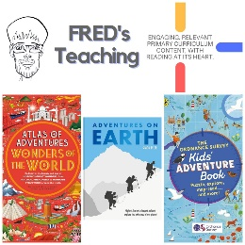 | 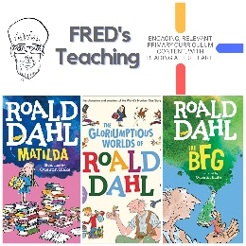 | 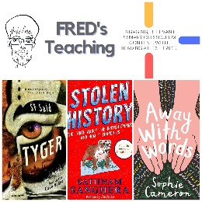 | 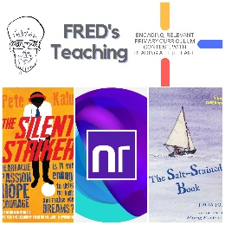 | 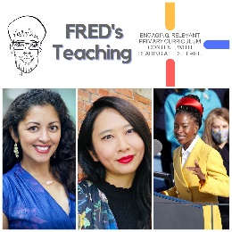 | 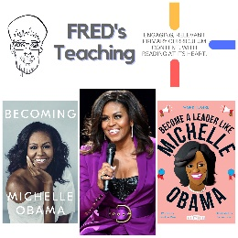 | 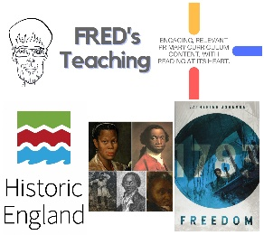 | 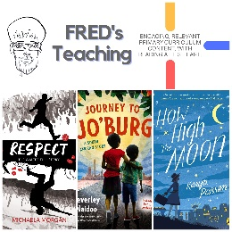

Autumn 2
Week 1: | Week 2 | Week 3 | Week 4 | Week 5 | Week 6 | Week 7
Theme: Bonfire Night. | Theme: Remembrance. | Theme: Awesome Men – 19th November is International Men’s Day. | Theme: Non-fiction – November is Non-Fiction Month. | Theme: Time Travel – 8th December is Pretend to be a Time Traveller Day. | Theme: Christmas. | Theme: Christmas
Extracts:  - History of Bonfire Night Article (NF).  - Fire Spell.  - Fire Witch. | Extracts:  - Code Name Kingfisher.  - When the Sky Falls.  - The Secret of Splint Hall. | Extracts:  - Charles Darwin Day Newsround Article (NF).  - Charles Darwin and the Beagle Adventure.  - On the Origin of Species (NF). | Extracts:  - Atlas of Record-Breaking Adventures.  - Extinct: Dunkleosteus.  - Atlas of Adventures: Wonders of the World. | Extracts:  - The Time Machine.  - Time Travelling with a Hamster.  - The Reluctant Time Traveller. | Extracts:  - The Miracle on Ebenezer Street.  - A Christmas Carol.  - The Muppet’s Christmas Carol (movie trailer). | Extracts:  - Tinsel.  - The Christmas Carrolls.  - How the Grinch Stole Christmas (movie trailer).
Search: UKS2 – More Bonfire Night WCR | Search: UKS2 – World War Two WCR | Search: UKS2 – Awesome Men: Sir Charles Darwin | Search: UKS2 – More Non-Fiction November | Search: UKS2 – More Time-Travel Themed WCR | Search: UKS2 – Christmas WCR: A Christmas Carol | Search: UKS2 – Christmas WCR: Tinsel and How the Grinch Stole Christmas
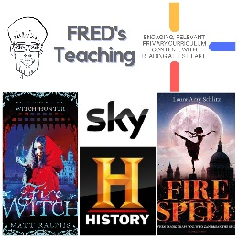 | 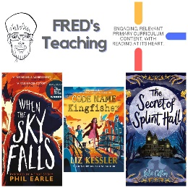 | 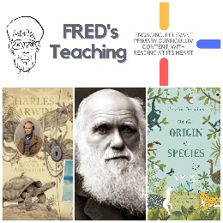 | 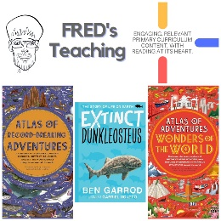 | 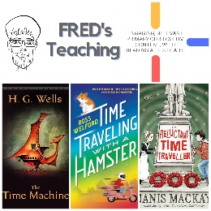 | 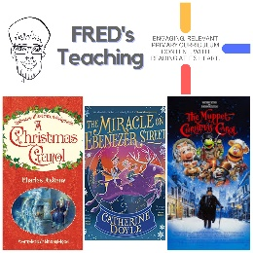 | 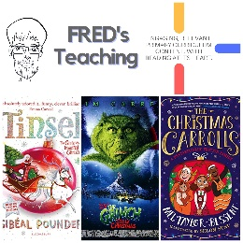

Spring One
Week 1: | Week 2: | Week 3: | Week 4: | Week 5: | Week 6:
Theme: Birds | Theme: Awesome Series – The Inheritance Cycle | Theme: Chinese New Year (29th Jan) | Theme: National Storytelling Week (Book Series Beginnings) | Theme: Children’s Mental Health Week is 3rd – 9th Feb | Theme: Self-Esteem (following on from Children’s Mental Health Week)
Extracts:  - Birds (non-fiction).  - Magnificent Birds (non-fiction).  - Extraordinary Birds (non-fiction). | Extracts:  - Eragon.  - Eldest.  - Brisingr. | Extracts:  - All About China (non-fiction).  - The Kite Runner.  - Chinese New Year: Lets Celebrate (YouTube video). | Extracts:  - Artemis Fowl.  - Saffy’s Angel.  - Wildwood. | Extracts:  - Perfectly Norman (full PB).  - How to Take the Grrrr Out of Anger (non-fiction).  - A Monster Calls. | Extracts:  - Jemima Small Versus the Universe.  - Tsunami Girl.  - Create Your Own Happy (non-fiction).
Search: UKS2 Birds Topic | Search: UKS2 The Inheritance Cycle | Search: UKS2 Chinese New Year v2 | Search: UKS2 Book Series Beginnings 1 | Search: Perfectly Norman | Search: UKS2 Self-Esteem 2
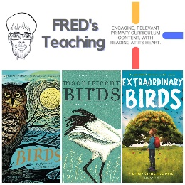 | 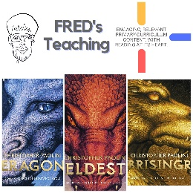 | 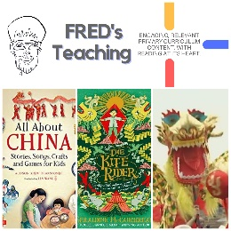 | 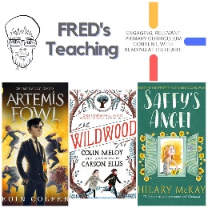 | 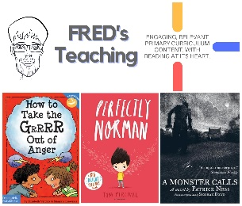 | 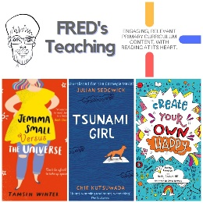

Spring 2
Week 1: | Week 2: | Week 3: | Week 4: | Week 5: | Week 6: | Week 7:
Theme: Even More Best Books of 2023. (6th March is World Book Day) | Theme: New Novelists. (6th March is World Book Day) | Theme: British Science Week (7th – 16th March) | Theme: Awesome Women – Malala Yousafzai (8th March is International Women’s Day) | Theme: Great Graphic Novels | Theme: Autism (2nd April is World Autism Awareness Day) | Theme: More Book Series Beginnings
Extracts:  - Where the River Takes Us.  - Being You (poetry).  - Rosie Raja: Mission to Cairo. | Extracts:  - Dark Flood.  - Saffiyah’s War.  - Cowgirls and Dinosaurs (graphic novel). | Extracts:  - The Story of Planet Earth (non-fiction).  - This Book is Full of Brains (non-fiction).  - Extinct: Lisowicia (non-fiction). | Extracts:  - First Names: Malala Yousafzai (non-fiction).  - Malala: The Girl who Stood Up for Education and Changed the World.  - Malala Yousafzai Nobel Prize Acceptance Speech. | Extracts:  - Mega Robo Bros: Robot Revenge.  - No Country.  - Frankie’s World. | Extracts:  - Perfectly Weird, Perfectly You.  - Frankie’s World (graphic novel).  - How to Look For a Lost Dog. | Extracts:  - The Dreamsnatcher.  - Kat Wolfe Investigates.  - Murder Most Unladylike.
Search: UKS2 – Even More Best Books of 2023 | Search: UKS2 – New Novelists 2 | Search: UKS2 – British Science Week 2 | Search: UKS2 – Awesome Women: Malala Yousafzai | Search: UKS2 – More Great Graphic Novels | Search: UKS2 – Autism Week 2 | Search: UKS2 – Even More Brilliant Book Series Beginnings
Website Link | Website Link | Website Link | Website Link | Website Link | Website Link | Website Link
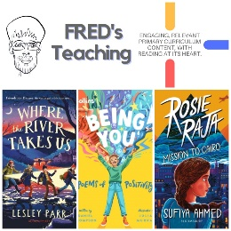 | 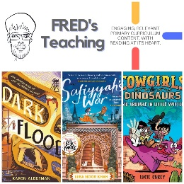 | 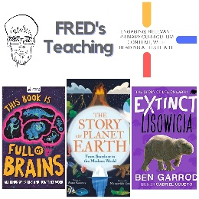 | 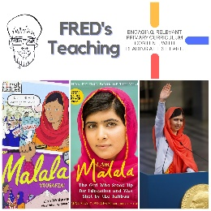 | 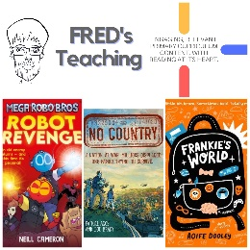 | 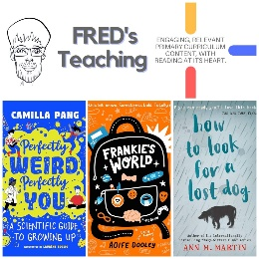 | 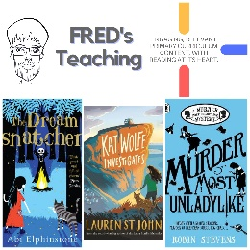

Summer 1
Week 1: | Week 2: | Week 3: | Week 4: | Week 5:
Theme: Books about Cats (April is National Pet Month). | Theme: Favourite Authors – Piers Torday. | Theme: Wild Animal Week - Wolves (4th - 10th May is Be Kind to Animals Week). | Theme: British History – The Victorians (May is Local and Community History Month). | Theme: Lost Classics
Extracts:  - The Dragon Detective Agency: The Case of the Missing Cats.  - Maggie Blue and the Dark World.  - My Life as a Cat. | Extracts:  - There May be a Castle.  - The Dark Wild.  - The Frozen Sea. | Extracts:  - The Wolf, the Duck and the Mouse (full PB).  - A Wolf Called Wander.  - Run Wild. | Extracts:  - Queen Victoria: The Ultimate Victorian (BBC Teach article).  - Cogheart.  - Gaslight. | Extracts:  - Mrs Frisby and the Rats of Nimh.  - Ballet Shoes.  - What Katy Did.
Search: UKS2 More Books About Cats | Search: UKS2 Favourite Authors: Piers Torday | Search: UKS2 Wild Animal Week: Wolves | Search: UKS2 British History: The Victorians | Search: UKS2 More Lost Classics
DIRECT LINK | DIRECT LINK | DIRECT LINK | DIRECT LINK | DIRECT LINK
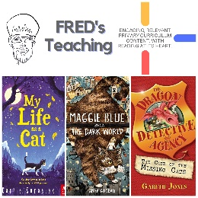 | 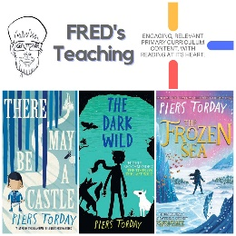 | 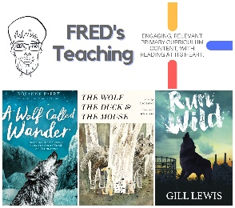 | 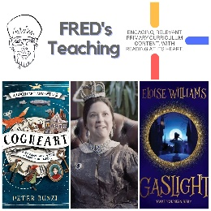 | 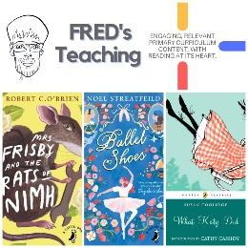

Summer 2
Week 1: | Week 2: | Week 3: | Week 4: | Week 5: | Week 6: | Week 7:
Theme: Environment (5th June is World Environment Day). | Theme: Seaside & Islands (8th June is World Ocean Day). | Theme: Refugees (16th – 22nd June is Refugee Week). | Theme: Pride (June is Pride Month) | Theme: Global Destinations – Malawi. | Theme: Space Exploration (20th July is the Moon-landing anniversary). | Theme: Friendship (30th July is International Friendship Day).
Extracts:  - The Last Wild.  - Guardians of the Planet (NF).  - Climate Change - The Facts Trailer. | Extracts:  - Town is by the Sea (PB).  - The Weather Weaver.  - The Good Hawk. | Extracts:  - Illegal (Graphic Novel).  - Refugees (poem).  - The Unforgotten Coat. | Extracts:  - Just Like Everyone Else.  - Love Frankie.  - Glitter Boy. | Extracts:  - The Boy who Harnessed the Wind.  - The Boy who Harnessed the Wind Film Trailer.  - BBC Malawi Country Profile. | Extracts:  - Hidden Figures (Young Reader’s Edition).  - NASA Biography - Katherine Johnson (NF).  - Future Mars Walker - Alyssa Carson (YouTube clip) | Extracts:  - Troofriend.  - Butterfly Summer.  - The List of Things That Will Not Change.
Search: UKS2 Environment-Themed WCR: The Last Wild  DIRECT LINK | Search: UKS2 Beside the Seaside  DIRECT LINK | Search: UKS2 Refugees Week 2: Illegal  DIRECT LINK | Search: UKS2 More Pride Planning  DIRECT LINK | Search: UKS2 Destination Malawi  DIRECT LINK | Search: UKS2 Space Exploration: Hidden Figures  DIRECT LINK | Search: UKS2 Friendship Week 2  DIRECT LINK
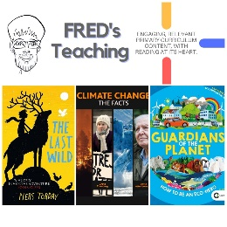 | 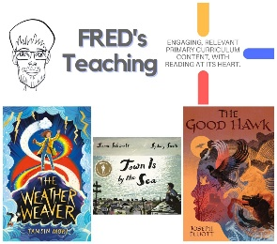 | 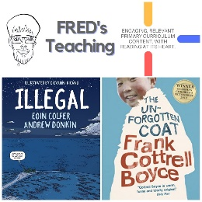 | 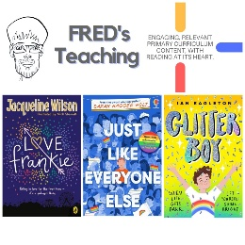 | 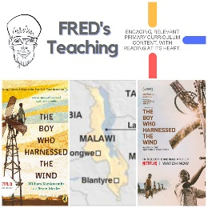 | 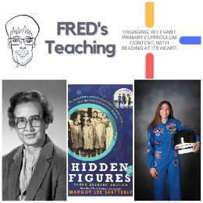 | 

